Contents

1 – Analysis 4

1.1 – Introduction 4

Background: 4

How the game will play: 5

The client/supervisor: 6

Project Scope: 6

Prospective users / target audience 7

Analysis plan 7

1.2 - Investigation 8

Existing games 8

Invisible inc: 8

User interface 8

Rules of the game: 9

Level design: 10

HUD design: 10

Conclusion: 12

The X-Com series: 12

User Interface: 12

Game Mechanics: 13

Level design: 13

HUD: 14

Enemy AI: 14

The Binding of Isaac: 15

Game Mechanics: 15

HUD: 16

Level design and procedural generation: 16

Enemy AI: 17

Questionnaire 17

Programming languages 23

Python: 23

JavaScript: 24

Prototyping 25

Maze Generation Algorithm (verbal): 25

Class diagram: 27

Data Flow Diagrams 28

Prototype showcase 28

Objectives / Constraints 29

Main objectives 29

Optional Objectives 29

2 - Design 30

2.1 High level overview 30

2.2 Description of game layout 33

2.3 Data/ data structures 34

2.4 Storage of data 38

2.4 Core algorithms 40

Maze generation algorithm: 40

Flowchart for grid creation: 41

Layers: 42

Snakes to create layer paths: 42

Overlap layer onto maze: 46

Notes on layer optimization: 46

Choose Direction algorithm: 47

Full maze generation as described before: 48

Efficiency improvements and maze sparsity improvements: 50

*Calculating player in line of sight:* 54

Render line of sight onto screen: 55

Mathematical calculation for intersection algorithm (as described) that each ray will use: 56

Ray prototype images: 57

Path finding algorithm: 60

Dijkstra / A star efficient path finding: 61

Matrix creation algorithm: 61

Dijkstra path finding algorithm: 62

3 – Technical solution 64

3.1. Pygame run file.py 64

3.2. Grid.py 83

3.3. Button.py 91

3.4. PQ.py 93

3.5. Player.py 94

3.6. Stack.py 96

3.7. Item.py 97

3.8. Enemy.py 98

3.9. Ray.py 104

3.10. Other Files 105

4 – Testing 106

YouTube link 115

Evidence of OBS and PyCharm creating lag throughout the recording of the game 115

5 - Evaluation 116

5.1. Main objectives 116

5.2. Optional Objectives 118

5.3. User Feedback 120

5.4. Potential improvements 120

5.5. Analysis and Conclusion 121

Bibliography 122

# 1 – Analysis

## 1.1 – Introduction

### Background:

I will be creating a strategy based stealth game that will use a top down view of a grid map where players must complete certain objectives by interacting with certain objects across each level to progress. It will follow a similar 2D top down game format to most arcade games.

The plan is to add different terrain types and have each level procedurally generated with enemies spawning randomly but in locations which will not make the game impossible (hence procedural).

Another aspect would be to create a “fog of war” effect over each level so that the player can only see what is in locations that are in direct view of the player or sections the player has already seen.

Enemies will likely have a line of sight algorithm implemented so that they are only activated if the player is in direct line of sight of the enemy. This can be achieved by “drawing” a segment of a circle that will be the enemy’s field of view, the radius being the max view distance.

It will be similar in some ways to games like Invisible inc. or Scotland yard where players must escape the enemies / collect a certain item and head to extraction to succeed.

When I have finished with this game, I will test it with fellow students (aged 17+), friends and family as well as conducting my own stress testing to see if I can break the game using boundary and extreme data. The game will only be runnable on windows however there may be portability to Linux depending on whether I have time by the end of this project.

I will be researching how to procedurally generate a maze and how to create line of sight and fog of war algorithms for games. This project will likely use Djikstra or A-Star efficient path finding algorithms (which find the shortest path from one location to another) since it is a point and click, turn and tile-based game.

I also need some market research to find out what my target audience is, what their preferences are and how to accommodate for them. Furthermore, I may need to find out whether I can cater to the feedback within my constraints.

### How the game will play:

The game, as mentioned before, will use a top down view of a grid-based map as shown below.

Screenshot from project prototype

Each map is procedurally generated (randomly with restrictions/ rules). Every position (node) on the grid must be reachable. This is to prevent players spawning inside a blocked of portion with the exit being outside.

A player is placed randomly on the map at a position. Enemies are also placed randomly with restrictions on the proximity to players. This is done to prevent games becoming impossible. Items such as upgrades and perks will be placed randomly and one or more randomly placed exit nodes (positions) will exist.

The game will be turn and tile based. Players will be restricted on the number of places they can travel (steps). The player will choose a location to travel to by clicking on the node (position) and by likely hitting a go button to confirm their decision. At the end of the players turn the sprite that resembles the player will move to that location taking the most efficient path. The player and enemies will have line of sight algorithms in place that calculate what the sprite can see directly in front of it (line of sight). This will be used to calculate what the player has seen and can see to remove the fog of war effect over areas that are or were visible. A fog of war effect is an effect that covers a map from users preventing them from seeing ahead.

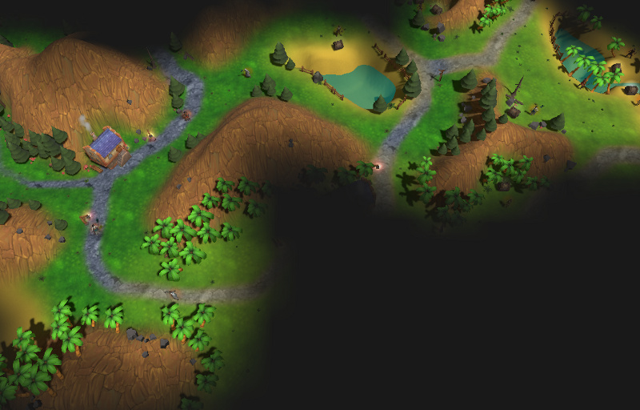 Figure 1 Fog of war effect source: <https://bit.ly/2MpXD81>

The enemy AI will then make their turns using the same rules as the player. Enemies can be in two states: searching and ambushing.

Whilst a player hasn’t passed the line of sight of an enemy the AI will follow a routine path around the map. This is to make them predictable so that players can calculate their next move.

If a player passes by the line of sight of an enemy, that enemy will be in the ambush state. The enemy will calculate the shortest path to player and take that path each turn (perhaps with some throw off variable to prevent the game being impossible to beat). The enemy may also fire projectiles at a player whilst they aren’t in cover. The player can either defeat the enemy by attacking or they can hide out of the line of sight of enemies for a while until the enemy is reset to the search state. The enemy will however travel towards the last seen location of the player until the player isn’t found within a radius of that position (again using line of sight that cannot pass through walls).

The aim is to get to the exit of each level and collect as much loot (points) as possible. Some levels may require the player to collect a key or some other item to unlock the exit.

This is subject to change however whilst I am programming (only minor changes to rules or improvements to the game).

## The client/supervisor:

The client will be (insert client here). I will discuss my progress on the project in intervals regularly.

## Project Scope:

I plan to finish this project at least two weeks before the deadline to a high standard which I consider to be complete. This gives me time to notice any errors I may have made. The following is a table with an outline of what I will do in order and the relative time it will take. This may be slightly different realistically, but it gives me a good guide on what to finish when.

|  |  |  |
| --- | --- | --- |
| # | Task | Duration |
| 1 | Introduction | 1 |
| 2 | Investigation | 3 |
| 3 | Constraints, requirements, limitations | 2 |
| 4 | Objectives | 1 |
| 5 | Proposed solution | 1 |
| 6 | Finish Analysis |  |
| 7 | Documented Design |  |

### Prospective users / target audience

The game will be targeted towards younger children and teenagers, the game will be somewhat strategic so it may not be appropriate for much younger players. However, it will have difficulty levels that may be able to compensate for this. The game must be easy to pick up and play therefore I will have some form of tutorial or guide to playing the game. The game will be turn based and point and click so the actual game mechanics shouldn’t be too hard to learn.

Analysis plan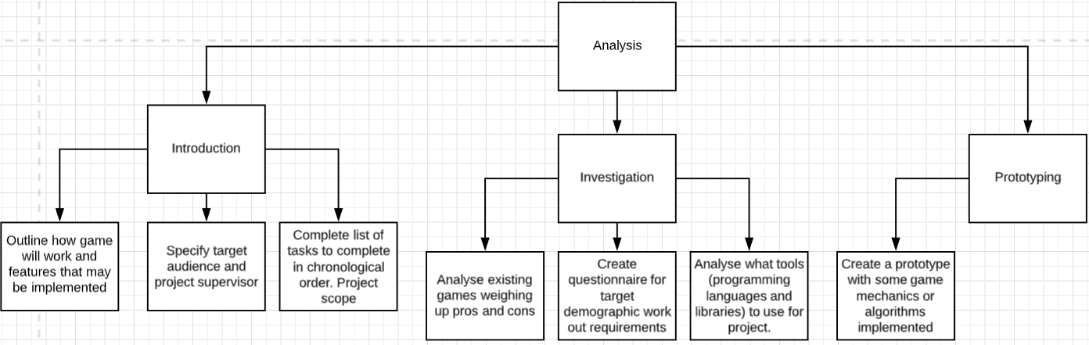

# 1.2 - Investigation

### Existing games

### Invisible inc:

Invisible inc is a turn-based strategy game that gets the player to traverse a grid-based map with multiple enemies and items/ tools which they need to interact with in order to finish the game.

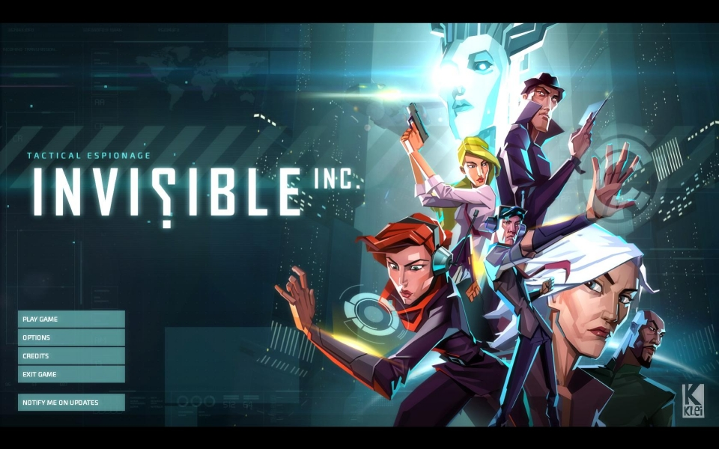

### User interface

At the very start, the game features a simple graphical user interface which gives the user four options: play game, options, credits and exit game. The UI on this start screen is basic and suitable for the game since it doesn’t confuse the player on how to start a game. From this I have determined that my project should have a similar user interface at the start to maintain a player’s interest in the game since anything that is too complex may deter the player. Another feature of the UI is that each button lights up when hovered over to give a pleasing visual aesthetic. This would be simple to code and would improve the project in a subtle way that a player may not notice but will have an impact on the players opinion on the game.

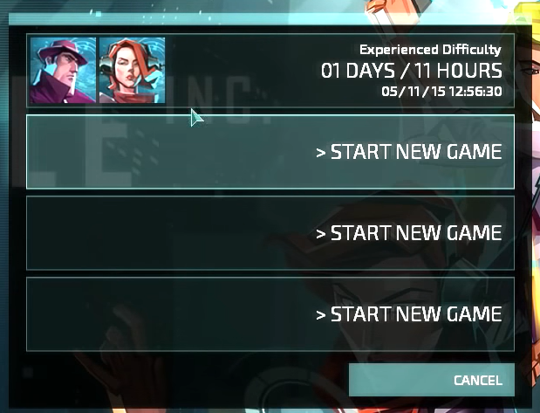The game also has save files that separate players (or one player with multiple runs of the game) can use to save the current game when finished and load the game when returning.

Character selection:

The game has multiple characters. Each character has different abilities and qualities. The 4 qualities are hacking, speed, strength and anarchy. The game also gives the player perks (as seen on the right side).

Each quality has 4 different levels that show how good a character is in each field. These qualities will influence the way the game plays and may make certain levels harder or easier which will give the player a reason to change characters to suite each level.

Verdict: From this I am considering adding abilities like Invisible inc to my own project that will influence how the game play for example by making it cost turns to perform certain actions based on each ability level. This will add variety to each playthrough and add a strategy element to the game.

The game starts out by giving the player an option of two characters to choose from and then allows for more powerful characters as the game progresses.

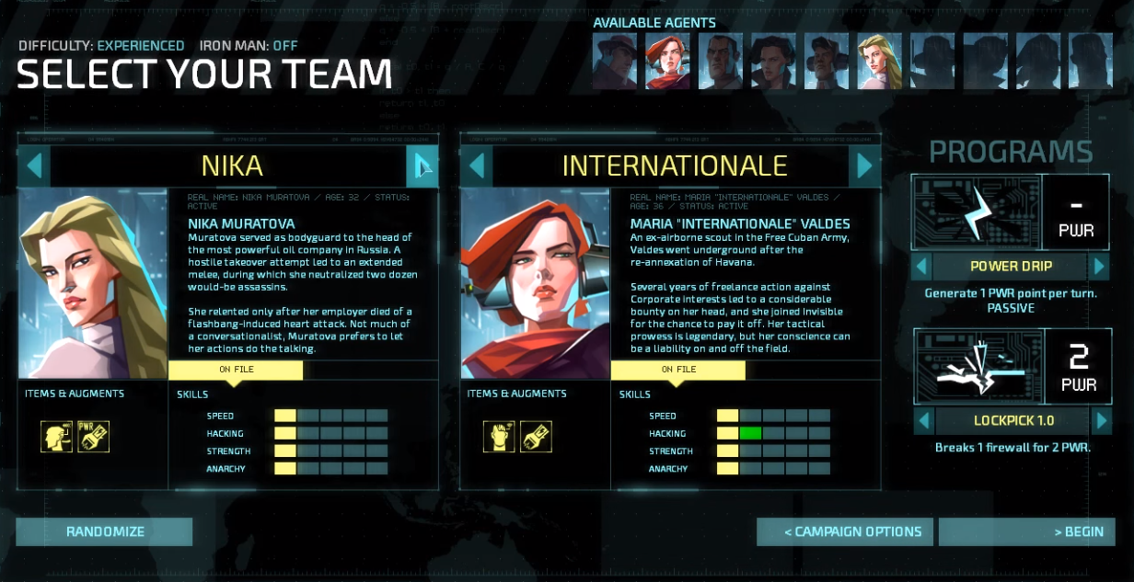

You play as two characters each level which allows for more complex strategies to be employed during each level. Despite this there is no multiplayer aspect to the game which seems like a missed opportunity.

Verdict: Consider adding a multiplayer element to the project where two players can co-ordinate to win.

### Rules of the game:

* Each character gets a certain number of tiles (steps) they can move to per turn
* Each character can only step on tiles which are not occupied, not too far away and can be visited by a path of adjacent tiles.
* If a room has not been visited it will not be shown on the screen (fog of war effect)
* During each turn a character moves, and all existing enemies move following their routine path after both characters have expended their turns.
* Opening doors and interacting with items uses steps (the number is based on the weighting of the interaction and ability level)
* Characters have two modes ambush or hide if a character is set to ambush, they will wait until an enemy visits a neighbouring tile and then neutralise them.
* There is a security level which dictates how easily alerted enemies are and whether new enemies will be introduced.
* There is an objective to complete and an extraction point which users must head towards.

### Level design:

Each level is designed by a grid. Each player can move several tiles and may interact with certain objects inside such as computers and cameras and terminals. Each action costs a certain number of movement points. There are multiple rooms in each level and an extraction point which characters must head to after completing their mission.

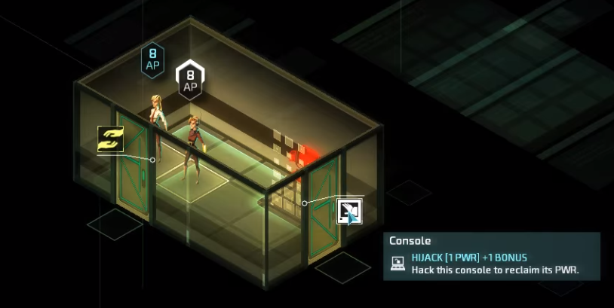

Any unvisited/ unseen areas will be masked by a fog of war and during enemy turns if the player can’t see the enemy through a camera or otherwise the enemy’s movement will be illustrated by a noise wave effect for each step they take.

### HUD design:

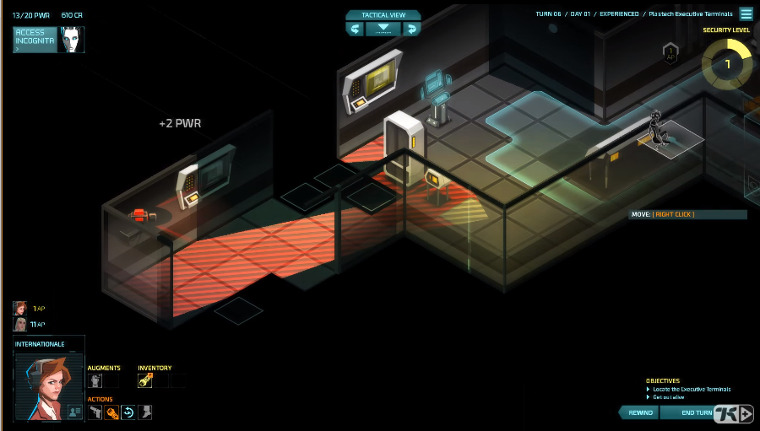A HUD (heads up display) is arguably the most important part of most games since it is what is interacted with the most and gives the game it’s “feel” or atmosphere as well as highlighting game mechanics. The HUD in Invisible inc is very minimal with little writing and features technological visual style. It also allows user to see which character is selected what their statistics are and their inventory status. It also shows objectives in small writing at the bottom right corner. Furthermore, it allows users to end their turn start their turn reset their move or switch between different tactical views which are angles at viewing the map (since it is somewhat 3D). It also displays the alertness level constantly, so players always know how difficult the level currently is. It shows what turn the player is on and allows the user to access an external menu that allows the user to quit or deal with options.

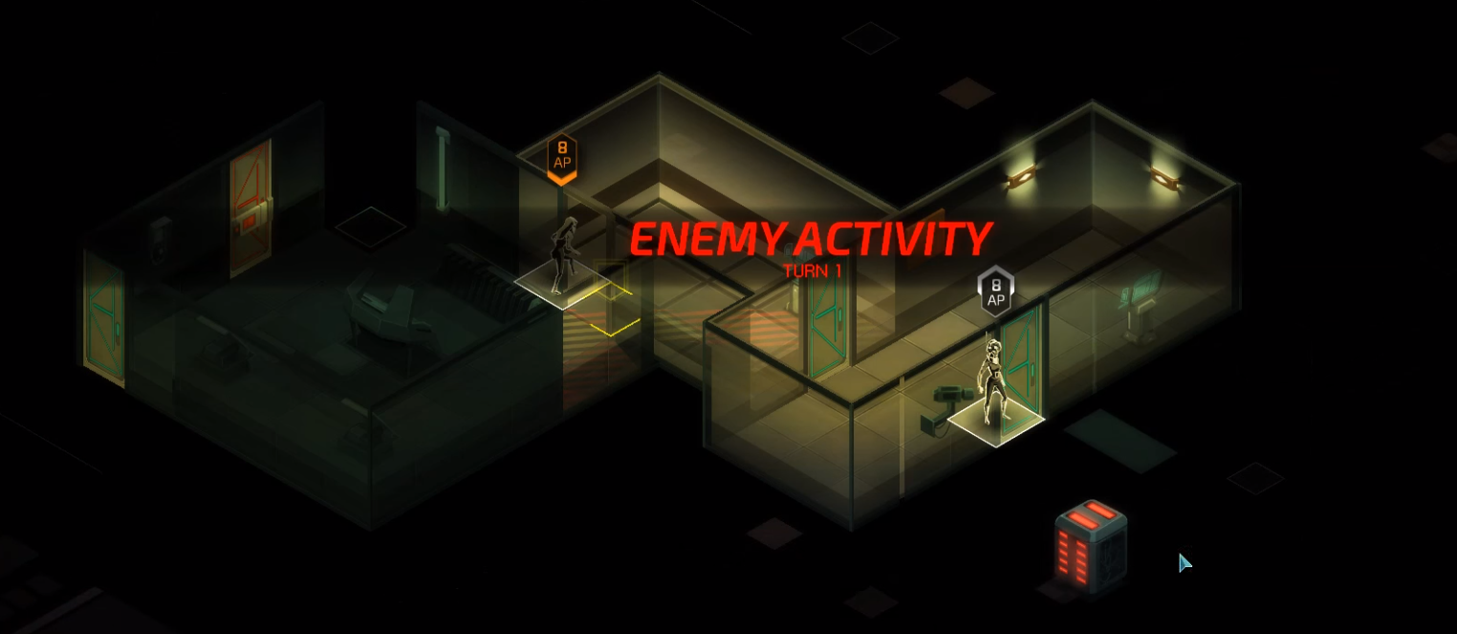

|  |  |
| --- | --- |
| Positives: | Negatives |
| The user interface is clear, simple and concise | There is no scoreboard / leader board to give a sense of competition in the game |
| The player gets objectives and missions to complete and rewards for those missions in the form of unlockable characters and perks | There is no multiplayer despite there being multiple characters in a level at once |
| The game has very intricate yet simple game mechanics which give the game a good polished feel and smooth gameplay | The first level introduces complex game mechanics right off the start that may overwhelm a player (although they are not required, they may become confusing) |
| Music adds tension to the game and will become intense depending on the situation | Objective is not clearly displayed on the screen so players that didn’t focus before the level may lose track of what they are doing |
| The game has a save feature which allows users to leave the game and return later | HUD can be said to be a little too minimal and perhaps too small which can create confusion and accessibility problems. |

### Conclusion:

Through my analysis of this system I have concluded that I should consider the following:

* A simple User Interface
* Multiple characters with different perks
* A turn-based movement system
* Weighting to tiles on the grid and to interactions
* Exit points to leave the level and objectives to complete
* An alertness level which indicates how difficult enemies will be
* A fixed number of moves each character can take
* Clear indication as to what the objective of each level is
* A multiplayer element to the game
* A simple HUD which shows the current game status and allows users to visit options and see inventory
* HUD accessibility settings to allow for font size increases or colour-blind modes

### The X-Com series:

X-Com is another turn based strategy game with less emphasis on stealth and more emphasis on tactics and strategy. The game has highly detailed graphics and many different weapons and environments to play with / in. It allows players to choose a squad (group of characters with different traits) and send them to a level. The players goal is to complete some sort of mission objective and safely leave. Maps are premade, however there is many maps with regular DLC which makes the game fresh and varied instead of being repetitive and monotonous. However, this has come at cost to the company designing the game and may not be an appropriate decision for my scenario since I will only release one version of the program (once completed). X-Com is available on multiple operating systems including most console, phone and desktop operating systems. This allows them to reach a much larger market.

### User Interface:

(Enemy Within) X-Com’s user interface is simplistic, featuring options to load games, play single player or multiplayer and options to tweak game settings (such as audio and graphics). The start screen also has an exit button (on PC builds of the game) which will make the game more accessible for users who don’t know how to close out of the game or for users with slow hardware (since forcing a game closed usually slows a pc down). The game has different difficulty levels that will set the quality of the characters you may be able to add to your squad and will also affect the strength and difficulty of the games main opposing AI.

### Game Mechanics:

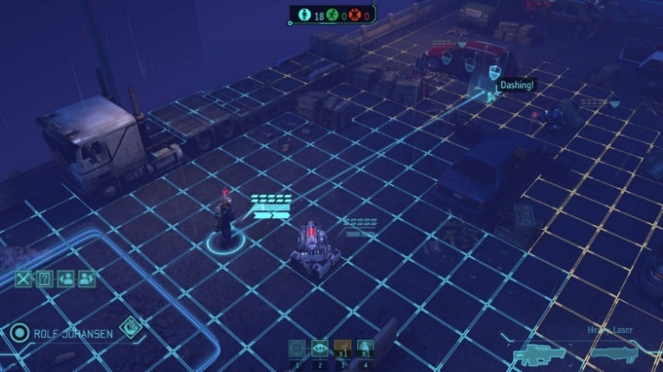The game itself is turn based with each turn giving the player the option to reposition their squad members and attack or take cover from enemy forces. Cover works in the form of obstacles such as cars walls or boxes and each one of these types of cover reduces the chance of getting hit by enemy fire the next turn by a different amount. That brings us onto another game mechanic which is chance. The game is heavily dependent on chance. Enemy AI is somewhat unpredictable and landing or missing shots is entirely random and based on the level of cover the target has. Each character can move a limited amount of spaces depending on their character traits/ skills and the chances of landing shots or dodging shots are also altered by this.

When a player clicks on a character (or selects them by some other means) the player will see the range of locations that character can visit (in blue and orange) and the amount of steps and shortest path to the location that is being hovered over in a blue line. It will also show the cover stats of that location as well as any other relevant information. Both the game AI and players have some form of path finding algorithm in place to calculate the shortest path to a point.

Although the game is designed in 3D the game is, in a basic form, two dimensional which means any 3D rendering is done only for the sake of making the game look better. This will likely not be a priority for my project.

The game mainly features ranged weapons and, though they do exist, melee weapons are rarely used outside of stealth missions. When attacking there is random number generation (RNG) involved reducing the games emphasis on strategy and making the game a little frustrating since each run is inconsistent.

### Level design:

Each level is unique and created by the developers and each level (or mission) has its own objectives that may change throughout the level. The map is covered by a fog of war preventing players from seeing where exactly the enemies are or will be coming from. Maps are made of a grid layout and there are usually multiple layers to the grid layout (3 dimensional). Furthermore, enemies are placed in strategic locations to make the game somewhat challenging and the quantity or difficulty of enemies is determined by the difficulty level of the game.

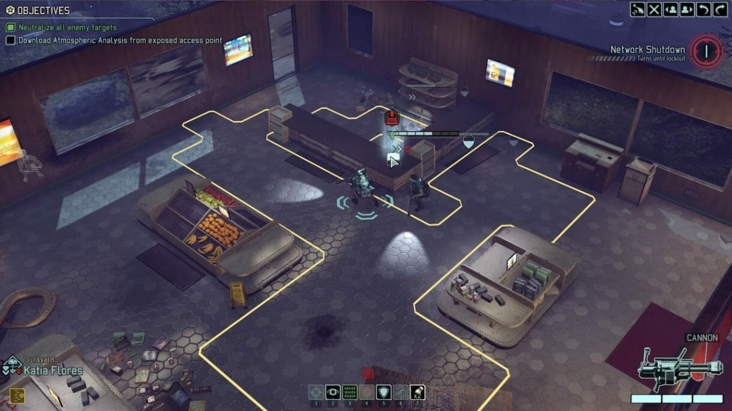

### HUD:

Objectives are listed at the top left corner of the screen allowing users to constantly be able to see what the goal of the level is and what completed or new goals have appeared. At the bottom right corner, the current characters health stats and weapon are displayed making it a lot easier for players to make better strategic decisions throughout the game. Options to change character or change angle of 3D view are available in the top right corner and all enemies that are visible to the squad or squad members have their stats highlighted above them. Also, at the bottom of the screen there are options to use character perks of the selected character. Each of these options / functions in the game are on the peripherals of the screen and are minimalistic and non-intrusive to the gameplay experience. This is an important design aspect because it prevents the HUD from being frustrating rather than useful. Also, interaction with the HUD using the mouse may reduce the pace of the game so the game has hotkeys in place (like 1,2,3,4) to allow users to efficiently play the game.

### Enemy AI:

Enemy AI moves strategically from cover to cover (however this will depend on difficulty and type of enemy) and will ambush attack or defend from enemy players. Enemies may also be unalerted at the start of levels until a squad member passes their line of sight which will cause enemies to be alerted of a player’s presence and may have them ambush or protect from players. The enemy AI will actively try to hinder a player’s progress by either attacking players or moving / protecting objectives (for example hostages).

|  |  |
| --- | --- |
| Positives | Negatives |
| Is strategy based and therefore is engaging due to the thought involved in playing the game | RNG is a heavy aspect of the game which means that playthroughs may be inconsistent. |
| Game AI is unpredictable yet predictable allowing users to improve at each level consistently yet keeping each playthrough fresh with new challenges or different play styles | Also, there are issues with players closing and reopening the game if they fail a mission allowing them to avoid the consequences of failure (in solo play) |
| Has simple game mechanics that are easy to pick up and easy to follow (such as hovering over grid positions will highlight the path taken so players can take evasive measures) | Game requires relatively strong hardware which may be too costly for some users (except in the case of android and IOS). |
| Has many levels and regular DLC which keeps the game fresh for very long times | No option to speed up game and pass through slow enemy turns |
| Has tutorial modes and accessibility settings and is available to most of the common operating systems allowing for appeal to a very broad audience. | Constant updates are costly to game developers when random map generation would have been a much more efficient option (like in Minecraft) |
| Has engaging graphics which makes users enjoy the game more than if it was plain |  |
| Has simple user interface; non-intrusive and easy to use via hotkeys |  |

### The Binding of Isaac:

The binding of Isaac is a 2D procedurally generated dungeon game (similar in many ways to my own project). It has smooth gameplay clean graphics and is polished to a high standard. It is rated highly among critics. It doesn’t require strong hardware to play and was relatively inexpensive to make despite its quality and popularity. The aim of the game is to defeat multiple stages and earn powerups that will help with the final boss battle. After this, the game goes into endless mode which allows players to achieve ever increasing high scores. One issue with the game is the high skill ceiling and variability which takes a lot of getting used to. Another problem is the rare occurrence of impossible to beat levels. Though this seems to have been patched well, this may be an issue I will run into.

### Game Mechanics:

At the start of each run you start with no weapons or perks other than the ability to fire tears. You must navigate through different rooms killing enemies along the way. There is a map that originally only contains the room you are in. As you progress previously visited areas will be shown on the map to prevent the player from running in circles. Each stage has a limited amount of rooms and the aim is to reach a golden door whilst carrying the key. The problem is that you don’t know in what direction the door is. This is repeated on multiple stages (each stage is accessible through the golden doors) until the boss stage is reached. Along the way you may encounter and pickup special perks or weapons that you can use to progress more easily. Enemies progressively get harder as you progress however enemy AI is simple and repetitive much like in early Zelda therefore it isn’t hard to learn patterns and use them to your advantage.

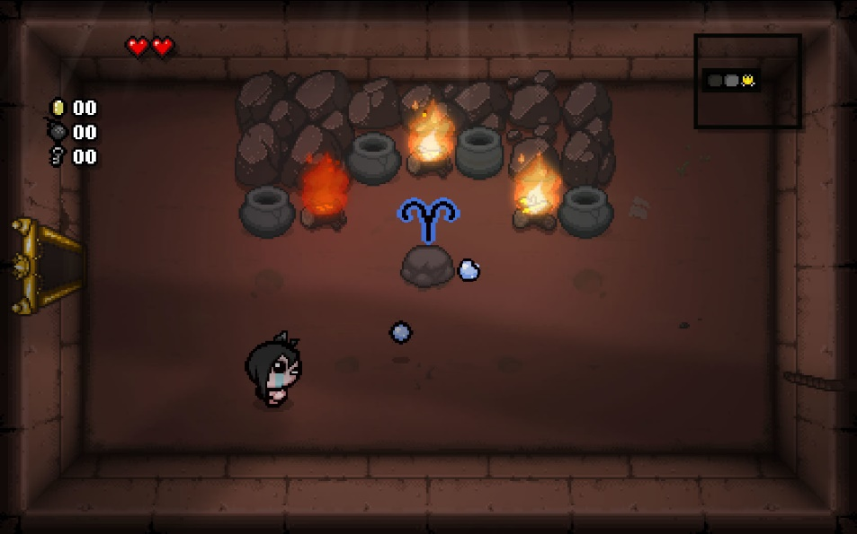

### HUD:

The HUD consists of three simple aspects; a mini-map, heart/health count, coins bombs and key count. This makes it a lot easier to find out your current stats and location in game which is crucial for a game as fast paced as this.

The game also has a very simple user interface with basic options such as volume gore settings and exit. Like with the previous games the game features a save option.

### Level design and procedural generation:

Levels are, like before, grid based with blocks as obstacles, pits or interactable objects. The game is procedurally generated so each room is random with random enemies within a threshold of AI difficulties and size. Furthermore, the game must be beatable, so the procedural generation accommodates for this.

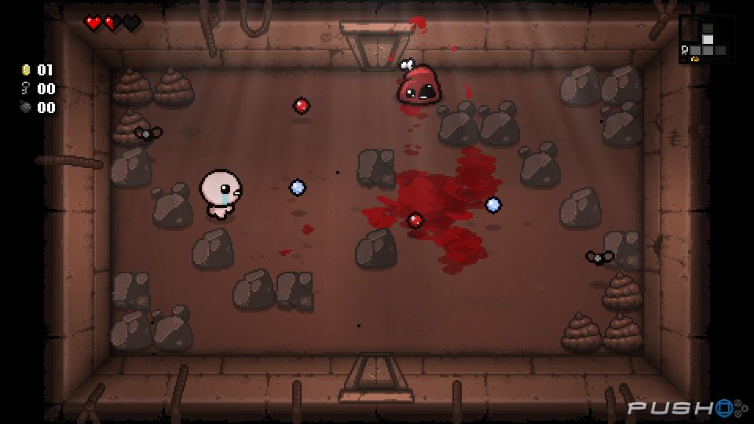There are different obstacle types each with different levels of breakability and each with a possibility of containing some item. Some objects are only affectable using certain perks or weapons. AI may also be able to affect the terrain of each level by creating pits, obstacles or by removing obstacles.

### Enemy AI:

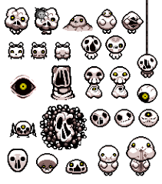There are multiple enemies each with different movement and attack patterns. Some enemies such as eyes fire lasers in straight lines periodically and just move left and right or up and down. Others bounce around randomly like spiders and haarder enemies usually explicitly target the player. The AI for this game isn’t particularly complex however this is made up for by the uniqueness and the relationships between different enemy types. Boss enemies are hard and can spawn other enemy types.

|  |  |
| --- | --- |
| Positives | Negatives |
| The game is procedurally generated which keeps the game fresh at relatively low cost and allows for unlimited replay-ability | There are issues with the game being unbeatable at some points which is due to bugs with the procedural generation |
| The game is simple to pick up and play and most of the controls are intuitive | Even at lower difficulties the game can become hard which creates high skill ceilings |
| The HUD is simple and has all information placed compact in the edges of the screen making it easy to find out current stats. | After death the game ends and players must restart which can make the game frustrating. This is easily fixed with a game mode. |
| Game has multiple difficulties and the game progressively gets harder as time goes on keeping the game challenging | There is no guidance on what various items do which makes the game difficult to learn creating a steep learning curve |
| Game isn’t taxing on hardware therefore it can be played on most devices including PC and console. | No accessibility settings for players with joint problems which means there is a lot of button mashing |
| The game allows players to copy and find out their seeds which keeps the game somewhat consistent if players desire | Ports to other devices don’t function well or as well as the original version. |

## Questionnaire

I wrote a questionnaire that was filled by several classmates and family members. I believe they are a good sample of my target market since this is a game for teens and younger. The questionnaire was designed to create a good idea on who my target audience may be and what their desires may be for a video game.

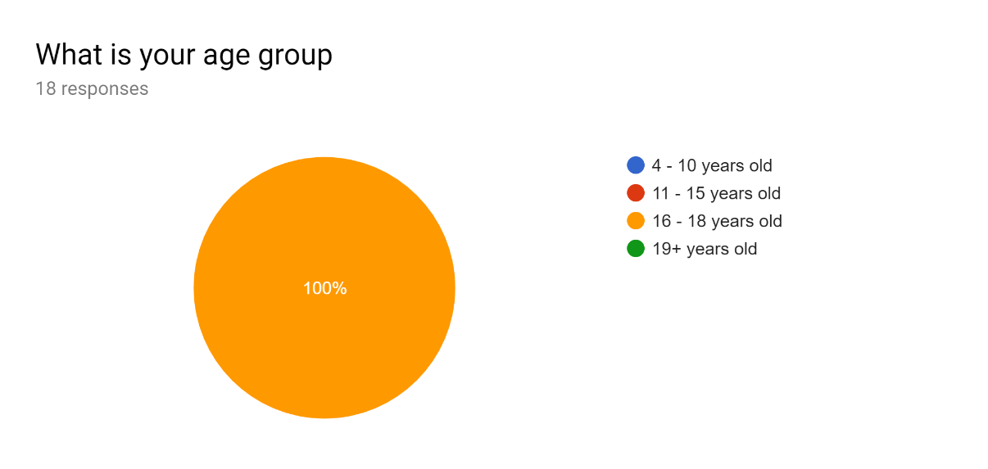

This question in particular wasn’t placed well since all of the responses have come from 16–18 year olds. The only deduction that can be made from this is that the responses in the questionnaire will be representative of this age demographic. Due to my target demographics age an assumption of affinity with technology would be reasonable.

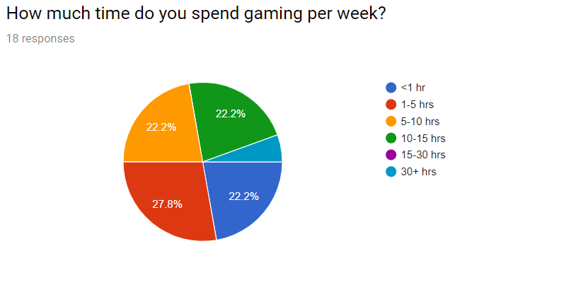

Exactly half of my sample clearly have a strong attraction to video games spending more than 5 hours a week gaming. This is also exaggerated by the fact that most of the subjects are also studying and preparing for university at the time this survey was published. There is also an equal proportion of responses that spend much less time per week gaming (<5 hours) this means my game will have to cater to many different experience levels. I will include a tutorial that beginners can use to learn the game mechanics. I will also make the tutorial optional so as not to annoy more experienced players. I will allow for control remapping since this is desirable among competitive gamers.

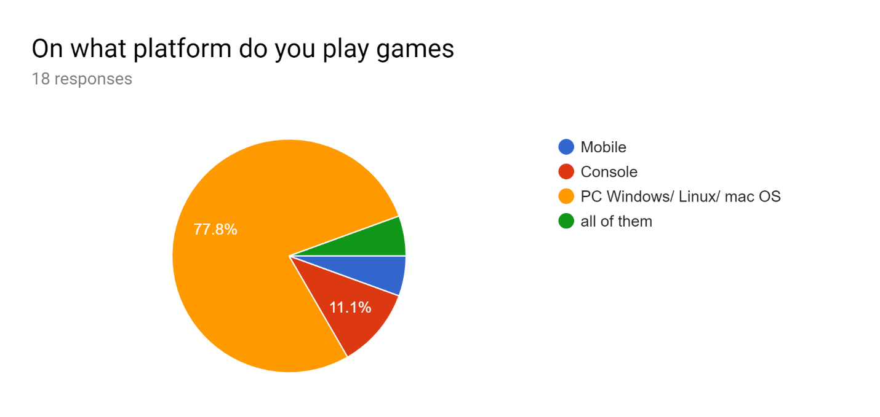

The overwhelming majority of subjects play games on the PC platform so my game will be designed for PC gaming (keyboard/ mouse input etc)

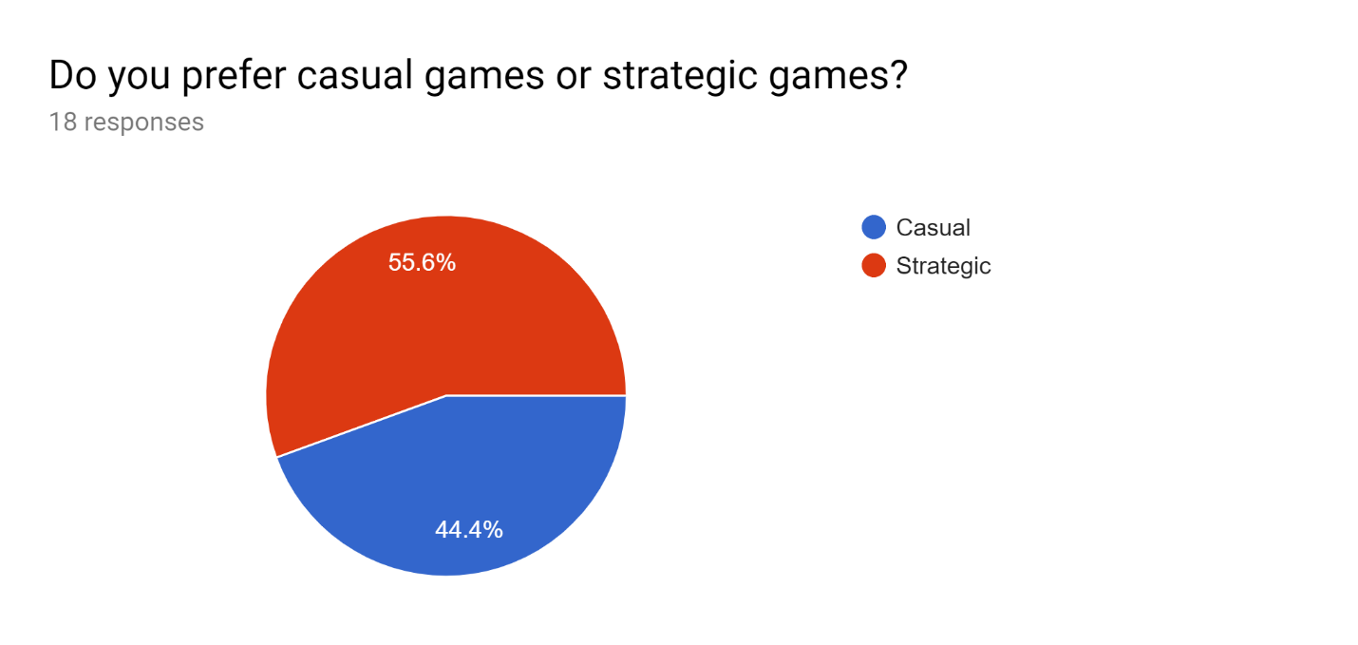

There is a near 50/50 split in responses to this question with the majority leaning in favour of more strategic games. 44.4% of responses say they prefer casual games. Some responses outline why below:

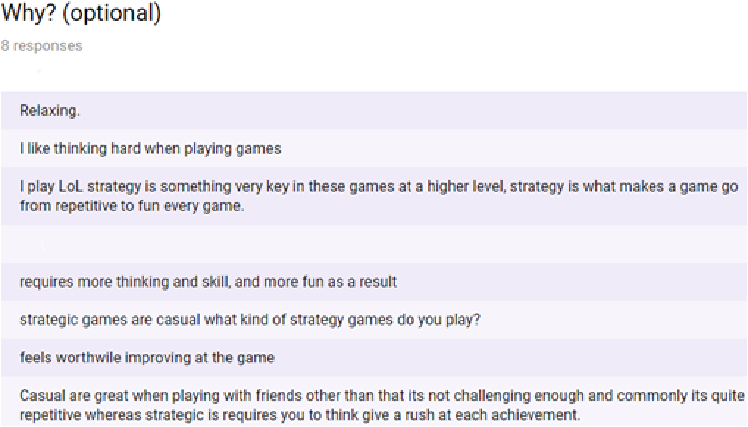

Due to the nature of the game (strategic) it will be hard to accommodate for casual players however I can still have different levels of difficulty in the game to make it easier for beginners and casual players and make the game harder for more advanced players. Another suggestion is the inclusion of achievements. Though this isn’t necessary it will add a challenge aspect to the game therefore I will try to incorporate this.

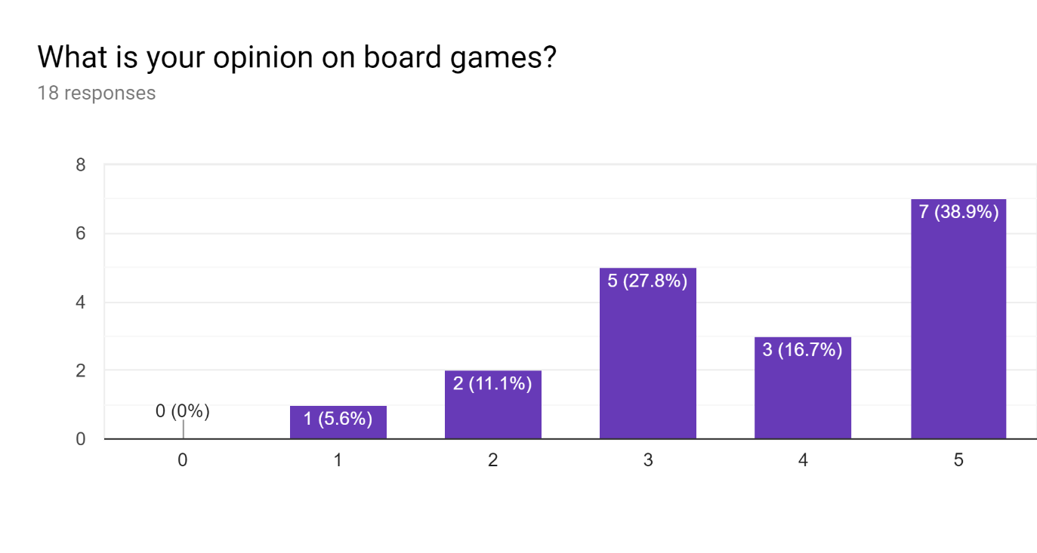

Since the nature of my project is similar to a board game and can be designed in a board game format, I thought it would be appropriate to ask about the user’s opinion on board games (on a scale from 0 to 5 or horrible - amazing). Most responses indicate a neutral to positive opinion on board games which means I will make the game a 2D top down game with characters clearly indicated. 83.3% of responses had a neutral to positive opinion so this is appropriate.

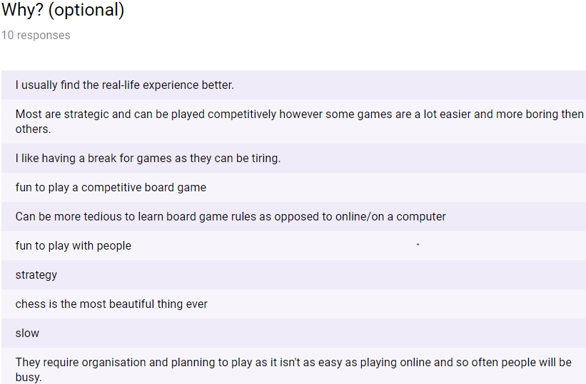

Within the verbal responses the difference between casual and competitive gamers is clear. Some gamers don’t want to put in the effort of learning the rules of a board game since it “Can be tedious to learn rules as opposed to on a computer”. One response in particular states that board games require setup which is time consuming. Fortunately, I can easily accommodate for this since a computer game will automatically setup my game. Another says they “like having a break”. This indicates to me that I should include save files and a pause option to allow players to rest in between play sessions.

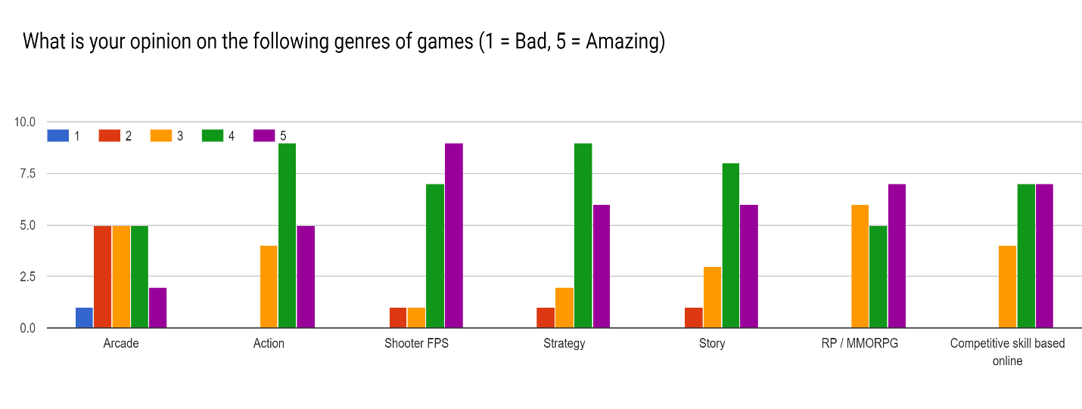

There is a consensus of positive opinion on these genres: action, strategy, story, RP/ MMORPG and competitive skill based online. There is a more median distribution of opinions on arcade games. This is a mainly desirable outcome since users have overwhelmingly positive opinion on competitive skill based and strategy games. This is the genre of game that I will be creating. Responses also express interest in massively multiplayer online and competitive online. Due to my time constraints there may not be enough time to create an online multiplayer game however there is a possibility of some ranking system be it online or arcade style. Furthermore, networking over LAN may be a possibility and should be taken into consideration.

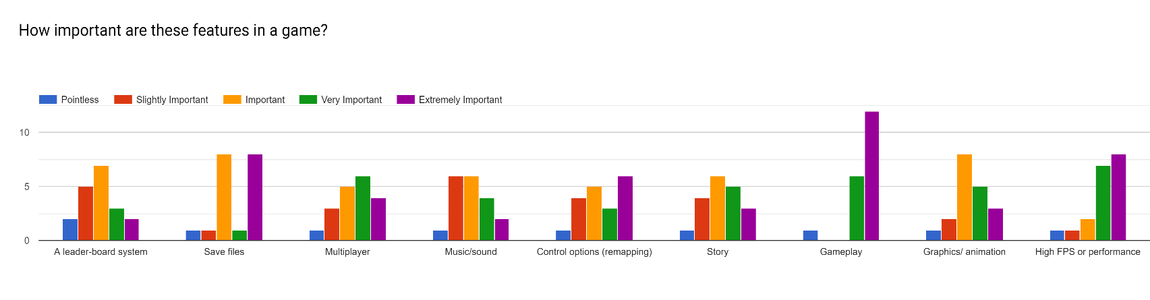

Responses to this question stress the importance of gameplay listing it as the most important aspect of a game. Save files were second most important which may be since players may want to be able to stop playing and do something else without compromising progress. This means having save files will be very important and gameplay should work and be efficient with no glitches. High FPS/ performance is also listed as a close third in important game aspects, though this may not be hard to do, having the game be runnable on most reasonable PC’s is very important and a must have if gameplay isn’t going to be compromised. Most other design aspects where considered just important as opposed to slightly or extremely important. This means that they should have some aspects such as controls remapping and a leader board system, however these are not considered to be as essential as the previously mentioned design aspects. Animation would be desirable, and I should add at least smooth sprite movement. The game could have a story however these isn’t really something that should have too much time devoted to it.

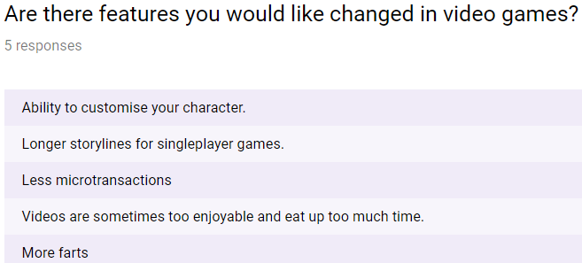

Subjects were asked if there are any other features or issues with video games they would like changed. This was asked to prevent me from adding features or omitting features that end users may deem to be important. Character customisation is an interesting design choice and the game could have this implemented. Other than this, responses were not relevant to my project except for perhaps not using videos for tutorials and have interactive tutorials.

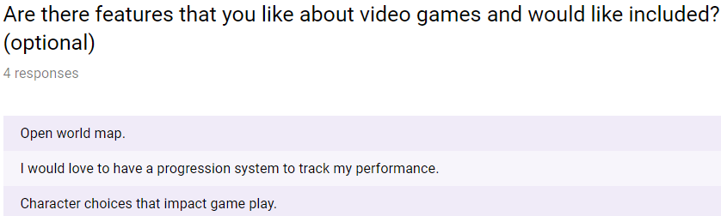

One user who was asked this question responded with a good suggestion to have an open world map. Though this is not possible within the constraints of my own abilities and time, I can have the game be procedurally generated to compensate for the endless exploration and endless possibilities aspect of open world games which may be the reason the user requested this.

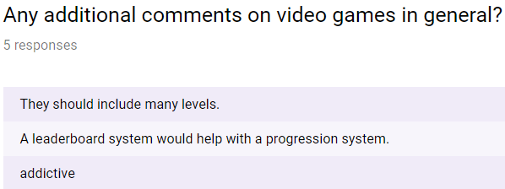

Another user asked for many levels and with procedural generation this can easily be achieved. A progression system was also requested, and this should be incorporated in the game in some way.

## Programming languages

### Python:

Python is a multi-paradigm programming language that can be imperative, procedural, object orientated and functional. However, strictly speaking python is mainly used for object oriented and imperative programming. The imperative programming paradigm is one where the program is written as a series of commands or calls to function that a program completes sequentially. Object oriented programming paradigm focus on what can be called “data structures” (but not really) known as objects. These objects have attributes which are essentially variables that are specific to that object and its class. The objects belong to classes that denote the nature of these objects and the different methods that can be used on them. They provide a framework for creation of objects. Methods are functions that are specific to an object and can be performed on an object of a class.

Python is very useful for rapid code development and has a very high amount of online support and resources that can be used to troubleshoot common problems and learn how to create programs. Furthermore, python has support for a library (or module) known as Pygame which provides much of the framework for game creation such as key press detection and surface (or canvas) creation. Pygame uses a programming paradigm known as event driven programming. In event driven programming programs work by having a main loop. During this loop the program will check for events. The events may come from the computer such as a certain time or random number or an event will more likely be user input such as mouse position change. Once the code detects an event the program will use selection statements to decide what to do in case off certain events. For example, if the escape key is pressed the program may cease running. This is particularly useful for games since the game needs to draw onto a canvas each frame and what it draws will depend on user input. I am already fluent in this programming language.

However, there is one major flaw with python, the program is very implicit. One example would be the fact that lists are passed by reference. This will cause problems when trying to troubleshoot code that doesn’t seem to work for any apparent reason. Furthermore, python has no built in option to restrict the type of variables (such as integer, float, string etc) and has no option to choose whether arguments are passed by reference or by value. There is also no option of making class attributes and methods private, public or static in python. This may lead to code that is unsustainable in the long run with many issues (when working in dynamic teams).

### JavaScript:

JavaScript is a programming language commonly used for web development. It mainly supports OOP and has support for procedural programming. This means that the program has built in support for surface/ canvas creation. It also has built in functionality for in-built buttons/ input boxes (from HTML). The programming language has built in integration with HTML and CSS which makes functionality such as login systems and multi-platform games much easier to create. Which brings us onto the next point, JavaScript is supported on virtually all browser environments and , due to the nature of the way the code is compiled (into intermediate code that is run on a virtual machine in the browser), it is also supported on all devices. This would make cross compatibility a given between devices which is a very big positive. Unlike python, JavaScript has private and public class attributes and does have type declaration for variables (which is useful for creating code in the long run as stated before). There is also a vast amount of online support for JavaScript as it is one of the more common programming languages. One interesting framework for JavaScript is Node.JS. This framework is highly efficient due to its usage of the chrome V8 engine (which compiles JS code directly into machine code) which has regular updates increasing efficiency (due to heavy Google investment). Node.JS is also open source so it would be free to use and has many different modes that can be bespoke to my problem. Also, code for the server back end and website front end is very easy to manage since they both use JavaScript.

However, JavaScript doesn’t have options for passing variables by reference or by value which may cause some issues since different copies of the same type of data (for example objects) will update with the original piece of data creating hard to find problems in code. Furthermore, code development in JavaScript is time consuming, especially for myself since I mainly have fluency in python. This unfortunately makes this language an unlikely option due to my time constraints (outlined in project scope (check contents).

## Prototyping

During the investigation phase of my project, I have created a prototype of my game that is entirely incomplete but has some features that will be in the game. I decided to use python to create the project since I already have extensive knowledge of the language and due to my time constraints, I cannot learn Node.JS in time (outlined in constraints and limitations).

I used pythons Pygame library since it provides functionality for creating canvases, surfaces and sprites etc. To program using the Pygame module the main approach (and the approach I will be taking) is to use event driven programming (this is explained in the programming language section under python).

I have created some flowcharts that describe how to solve some of the different problems before reaching the final solution. One such problem is maze generation.

I need to create a maze generation algorithm. The rules are as follows;

* The maze must have at least one path from each node to every other node (no nodes should be blocked off)
* Nodes can have walls in between each other facing North, West, East or South (NWSE compass)
* The maze must have loops (unlike a perfect maze which is why recursive backtracking isn’t used)

### Maze Generation Algorithm (verbal):

* Create a function that creates a grid of specified size (2D array)
* Create a function that will procedurally generate paths through that grid
* Create the stack data structure

How it will work:

* Grid (2d array) will be initialised using a for loop. The maze will contain an array of (1, 1, 1, 1) at every index representing NWSE walls (1 indicates a wall and a 0 indicates an open path). Let grid be called maze of width n
* Generate paths by creating a layer the same way the maze was created (stored in separate variable)
* Loop while there are unreachable positions in the maze i.e. (1, 1, 1, 1)
* Choose a random start position = current position and a fixed end position within the maze
* Loop until current position is the same as exit position.
* Calculate directions that you can take from current position (omit paths out of the maze and visited locations (using history stack))
* Randomly choose from these directions and change current position to the position corresponding to that direction
* “Break” the walls between the past node and the new node by changing numbers within the array from 0 to 1
* Add past node position (index format) to a history stack (called history from now on)
* If there are no directions to travel in follow the dead-end routine as outlined below
* While there are no possible directions to take do the following
* Calculate directions that you can take from current position (omit paths out of the maze and visited locations (using history stack))
* If there is no possible direction, then pop the last position of the stack History.
* Replace walls of last position (based on the direction you have travelled to get to last position) for example if you returned south replace (1,1,0,1) with (1,1,1,1) for current position and (0,1,1,1) with (1,1,1,1) for last position
* Change current position to last position
* Repeat the process until a valid direction to travel is found
* Once the current position is the same as the exit position overlap the current layer with the current state of the maze in a similar process as a bitwise AND operation (creating a mask)
* Repeat process above until there are no unvisitable nodes
* You now have a “maze” (more of a dungeon)

For this to work a stack is required therefore I have a class diagram

### Class diagram:

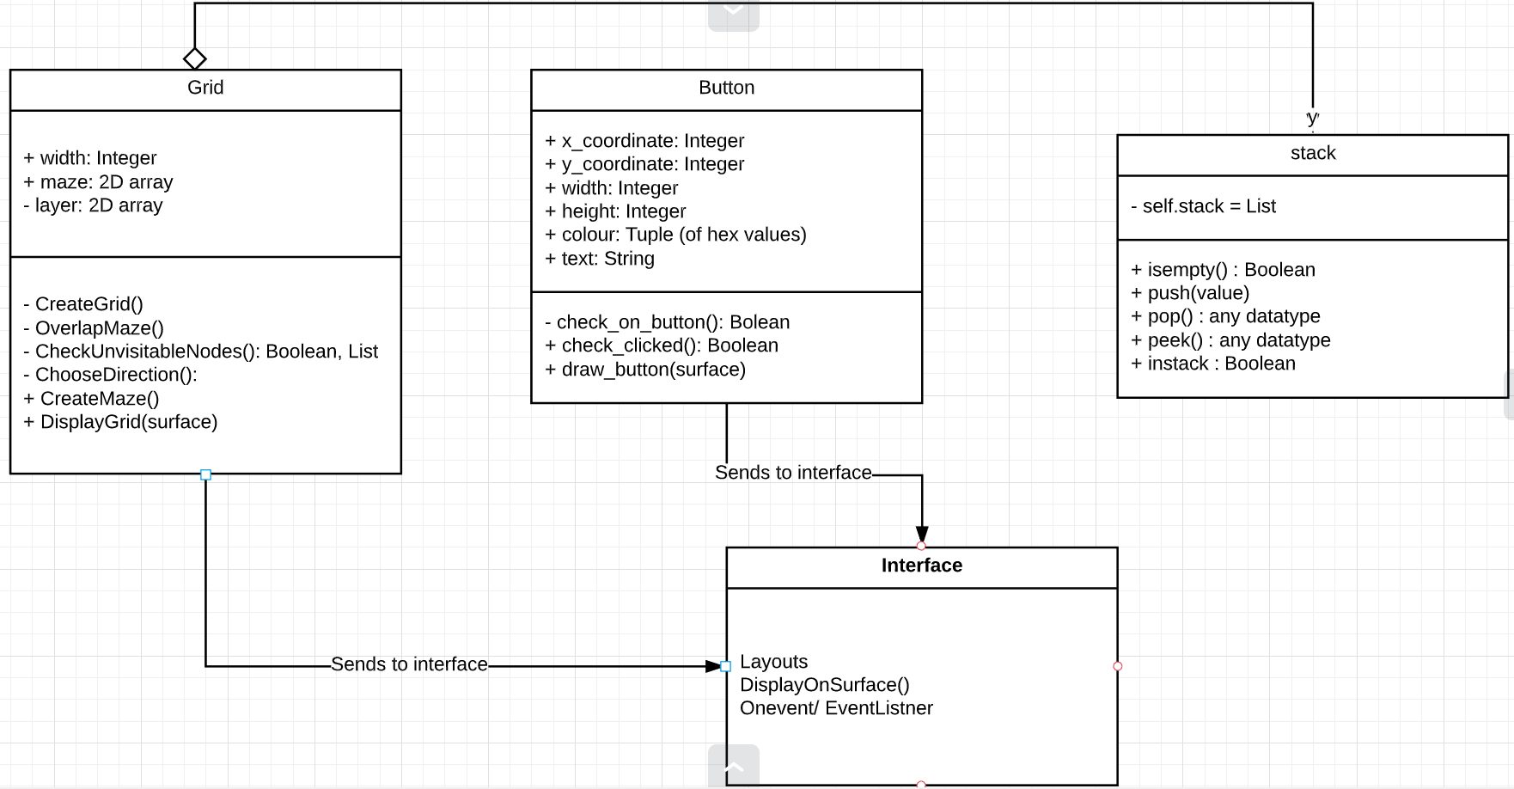

This is quite simple and works much like any other stack although you can check if a value is in the stack and you can see the data item at the top of the stack.

### Data Flow Diagrams

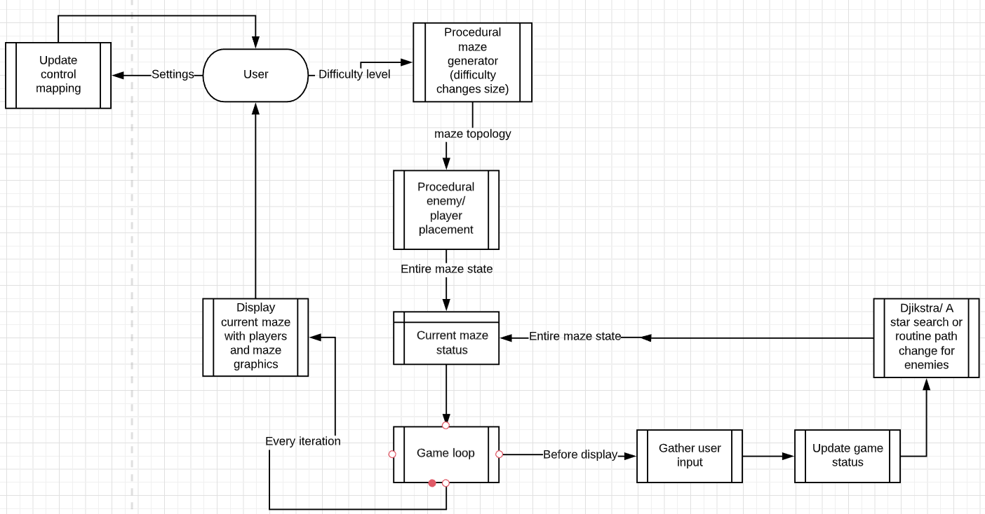

### Prototype showcase

Below is a screenshot of my procedural maze generation software (grid width of 30) for my prototype. A video that showcases the prototype at different maze sizes (as well as button showcase) is found via the link. The window is also resizable however this is hard to capture on video. 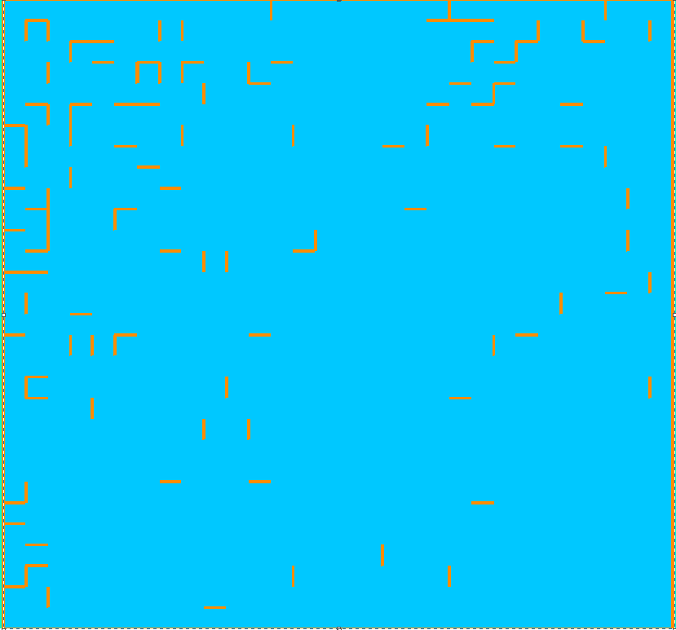

<https://youtu.be/nBSNnPqGkBs>

## Objectives / Constraints

My main constraint will be time. There may not be enough time to add all the features and functionality I may want to add. However, there should be enough time to complete the core functionality of the project. There are however limitations with Python such as the lack of cross platform availability or the implicitness of variable types and protected variables (outlined in programming language analysis).

Through communication with potential end users, and through investigation of similar projects I have created the following objectives:

### Main objectives

* A user interface (menu system and inventory / options / game control system)
* Turn based movement that works as intended
* Clear indication of game objectives / how to win and a win scenario in every level
* Working HUD
* Enemy AI that works and doesn’t make the game impossible to beat
* Multiple difficulty levels or some form of challenge the longer a game goes on
* Procedural map generation and enemy / player placement algorithms
* Low hardware requirements (Intel Pentium g4560) high performance
* No game breaking bugs / software issues
* Playable on at the very least a Windows 10 PC

### Optional Objectives

* Clear user interface
* Remappable controls
* Simple non-intrusive HUD (takes up small proportion of screen / concise)
* Tile weightings to increase strategic play
* Enemy alertness level to increase difficulty level as you play
* Smooth animation/ pleasing graphics
* Resizable window with scalability
* Cheating prevention
* Fog of war
* Save files / pause functionality
* Accessibility settings such as font resizing and colour changing
* Music and volume settings to go with that
* Leader board system / progression system

# 2 - Design

## 2.1 High level overview

Flowcharts shown here describe an overview of the way my project will work. As with most games and applications, when you launch the game you are met with a home screen. The home screen will have buttons that send them to different parts of the game. These locations may be options configuration, play game or quit. Each of these (bar quit) will be their own menus.

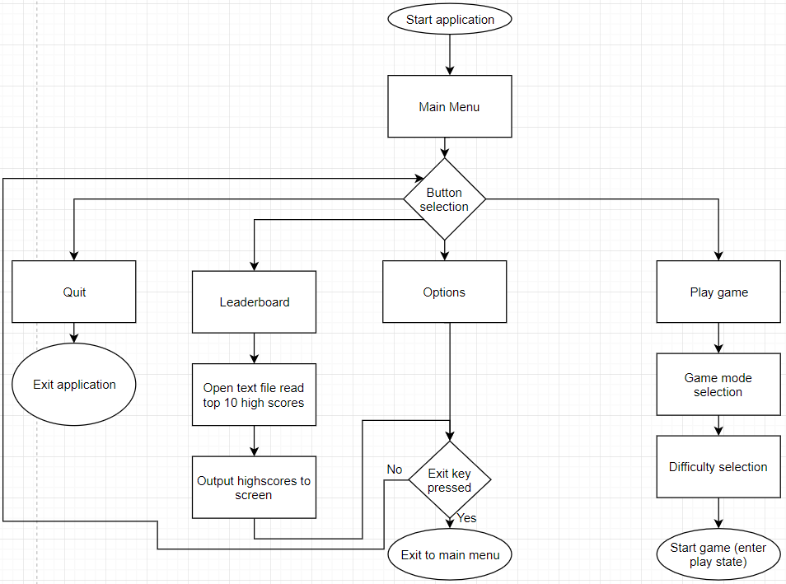**Menu:**

This is the flowchart design for the main menu screen. Players will be greeted by this screen when they start the application. It needs to be simple in nature so that users don’t become confused when trying to start the game.

**Options:**

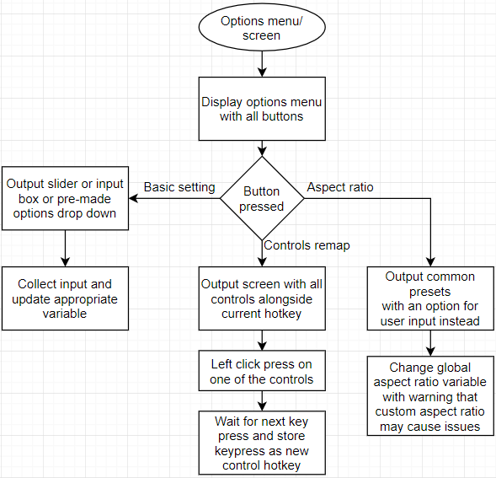

Due to the nature of Pygame as a library aspect ratio must be dealt with separately from other settings. Custom aspect ratios may cause issues since pixel positions are the main way most graphics are dealt with. Furthermore, controls remapping must be done in a specific so that any key on any keyboard can be mapped as a hotkey.

**Play state:**

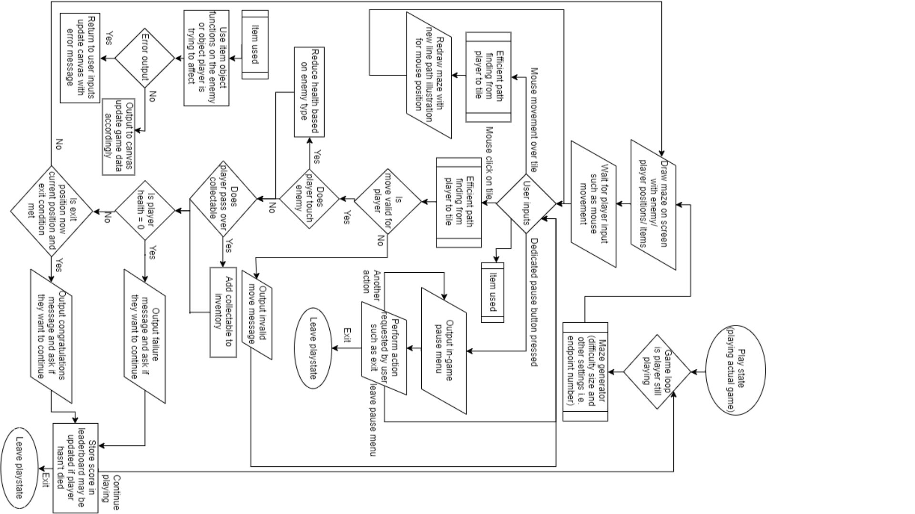

## 2.2 Description of game layout

This is a representation of the different screens that will exist within my game:

Main menu

Play

Game setup

Game screen

In game options overlay

Leaderboard

Full leaderboard

Options

In the game setup screen users are given a choice of difficulty level size enemy quantity and number of objectives. After the user confirms their choices the application will enter the play state in which the user is playing the game as shown in the play state diagram. Once the game is over the player can choose to either continue/ retry or leave. This decision will choose whether to remain in the play state or move back to the main menu state. In game options will be separate from normal options since users won’t want to be sent back to the main menu version in game. This means the game will be paused and a smaller “window” of sorts will be displayed above the game within the same surface. Once the user finishes with the in-game pause menu the game will no longer be paused and users can carry on playing. Users can also quit the game halfway through in which case the current state of the game will be stored.

Input/output/storage table

|  |  |  |  |
| --- | --- | --- | --- |
| Inputs | Processes | Storage | Outputs |
| - mouse clicks  - keyboard presses (based on current key mapping)  - Score and Username | Calculate most efficient path to maze position  Calculate enemy line of sight and player position  Sort high scores into top 10 and separate into csv format. | CSV file sorted by high score  CSV file storing game status after exiting the game | Draw player/ enemy position  Draw game maze  Sorted list of high scores |

## 2.3 Data/ data structures

My game will be programmed using event driven programming. This means that the game will be run from states. These states could be menu state, play state, options screen etc.

For my maze generation algorithm, I will need to use a stack to store the history of the positions visited whilst creating the maze. Below is design for the stack. The stack has an extra method when compared to a normal stack – instack(). This will check if an item is in the stack.

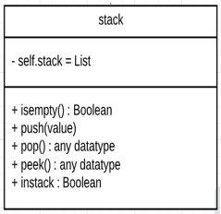

The stack will be used to store a history of positions visited during the execution of the maze generation software. This means that the program needs to be able to know whether it has visited a node or not. Recursive backtracking isn’t used here since that creates a perfect maze (one with no loops) and for my maze to be beatable there must be loops. The stack is used also to backtrack if the maze generation has run itself into a dead end. In this case the maze must go back to a previous position and try a different route. This is outlined in the flowchart for maze generation in more intense detail.

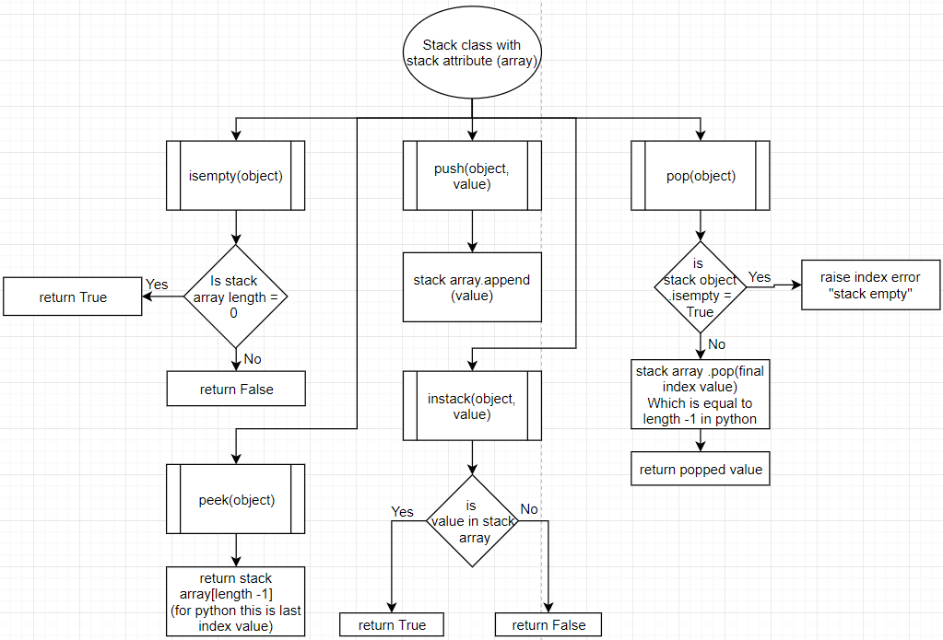

**Frequently used variables / data:**

* Colour variables (hex values in array) (global)
* Grid data structure (or class object/ maze array)
* History stack
* Enemy position array
* Player position array
* Powerup position array
* Entity layer grid array (used to describe player positions on the maze)
* Leader board cache array
* Screen width integer
* Screen height integer
* Button class object

**Heap / priority queue:**

Priority queues will be used multiple times throughout this project mainly to facilitate efficiency improvements. This is for algorithms such as Dijkstra pathfinding and ray casting to improve efficiency of execution.

Python (the language which I will be using) has a library specifically for priority queues. This implementation uses a minimum heap to store items in a priority queue. This implementation seems to function faster than a theoretically more efficient Fibonacci heap however this is likely a python specific phenomenon. Which mainly occurs for Dijkstra since more heappush() operations are performed in Dijkstra which are more efficient using heapq than a fib heap. A good article illustrating the differences:

<https://bit.ly/2RgRHlF>

A priority queue is a data structure that follows a first in first out principle (FIFO). This means that the first item to enter the queue is the first to leave. A priority queue is a more specific version of a queue data structure where every element in the queue is assigned a weighting and the element associated with the lowest weighting is released from the queue first.

For example:

A queue may look like this in order:

((1, “Jim”), (2, Sarah)ray, (15, Michael), (inf, Echo))

The first item in each tuple of this list is the weighting and the second is the value associated with that weighting. When popping off this list the first item returned is the item with the lowest weighting so in this case (1, “Jim”). This is known as a min heap (or queue). A max heap returns items in the opposite order from highest weighting to lowest.

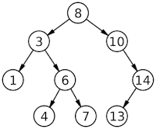This is particularly useful for Dijkstra since this would give the algorithm the shortest path from a node first increasing runtime efficiency. It is also useful for ray casting since rays will only be cast onto the closest walls first then the walls that are further away and would cast onto walls that are within a reasonable distance that are worth checking for an intersection. For ray casting in particular, a heap increased efficiency by a very large proportion; originally (for a 200 by 200 maze of walls) the time it took for 360 rays in a full circle from an enemy to be calculated took around 16 seconds. After utilising the heap, the calculation for all 360 rays took 0.2 seconds which is 80 times faster (disclaimer: a 200 * 200 maze will likely never be used in my game since it is simply too large a maze to be playable or fun).

A heap is an implementation of a priority queue that stores items in a traversable binary search tree used for sorting. The way this works can be visualised as shown in the image.

When storing items into, or pushing items onto the heap, the heap will store the first item as the root node of the tree. Assume this item has a weighting of 8 as shown above. The left and right nodes (or children) of any node (or root) in the tree will store an item smaller than the root and larger than the root respectively. So as before we only have one node in the tree, with weighting 8. Suppose we wish to add a node to the tree with a weighting of 10. 10 > 8 therefore the node with weighting of 10 will be the right child node of the root node with a weighting of 8. Now we wish to add a node with weighting 3. 3 < 8 therefore we would add this node as the left child node of the node with a weighting of 8. Any root node can only have 2 children therefore if we add a node with a weighting of 6 (6 < 8) would go to the left child node. Then we check the left child node against the node we are trying to push onto the heap. Since 6 > 3 the node with a weighting would be put onto the right child node of the node with a weighting of three. This is done for all nodes that are being pushed onto the heap.

A heap is an efficient implementation of a priority queue due to the way it sorts items in the heap. This improves efficiency since sorting is very efficient, all you have to do is place nodes into right or left child nodes of the root nodes which is much more efficient compared to a sort algorithm such as merge sort for searching the array (heaps don’t actually have to sort the items in the list). As a result, to find the smallest node all you must do is traverse to the left most root node. This is known as in order traversal. This has an O(nlog(n)) efficiency when searching for the smallest element. If we had to sort the list first this would take O(nlog(n)) efficiency as well however sorting must be done each time an item is added to the list which would make it not very useful for Dijkstra.

## 2.4 Storage of data

**Leader board storage:**

Data in the leader board will be stored in csv format. This is done because there will be no need to create a database for the leader board since there will only be two data entries stored in it. These two pieces of data are username and score.

In csv format these would be store like so:

Each entry is delimeted by a coma and the colon is used to help the program identify where a score starts and username ends.

**Save file storage:**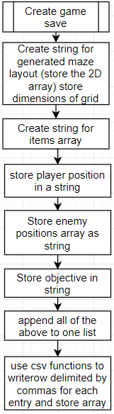

## 2.4 Core algorithms

### Maze generation algorithm:

The most important algorithm in my program is the maze generation algorithm. This is what the game is built on top of and if it doesn’t meet my requirements than my project isn’t complete. As a reminder the main objective for the maze generation is that it is created procedurally (randomly). The maze must also be beatable so must have loops so that players can avoid enemies. The maze will be created as a 2D array with each item in the array being another array containing 1 or 0.

1 means wall

0 means open path

A 2 by 2 grid of completely blocked off nodes would look something like this in array form:

[ [[1,1,1,1], [1,1,1,1]],

[[1,1,1,1], [1,1,1,1]] ]

Each index in the list would correspond to North West South East in order or NWSE

A 5*5 grid would look like this (with same conditions as before)

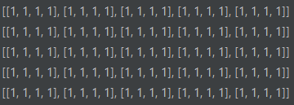

A grid like this is initialized so that the maze algorithm can work with to create a maze

### Flowchart for grid creation:

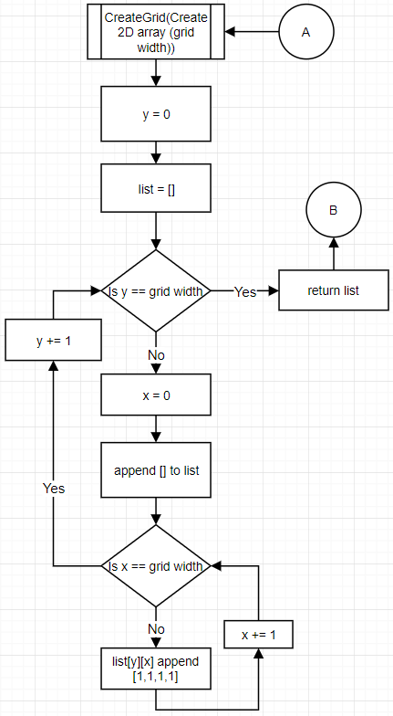

The maze generation algorithm will use multiple grids as shown above known as layers. These grids will be worked on and a path from a start node to the exit node will be created. These layers are overlapped onto the actual maze to create a full maze with paths leading from every node to another node.

### Layers:

A layer is a grid of the same size as the actual maze. The layer will have a single path leading from a node to the exit node. A layer for a 5*5 grid will look like this:

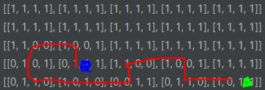

Blue is the start node and green is the exit node. Red is the path the algorithm took for this layer. As is shown above the path from the first node to the next is northward. This means that the 1st index of that positions array is a 0 indicating a path north. Also, the 3rd index of the next node is 0 indicating a path south. This connects the two nodes and every node from start to finish is connected in the same way.

### Snakes to create layer paths:

The best way to visualize a path creation is by using the imagery of a very strong snake. This snake is infinitely long. It is also capable of breaking through walls and it is trapped in the maze of nodes that are all blocked off. At the start it is only in one node. As in the array above, it starts as shown: (the spiral being the snake)

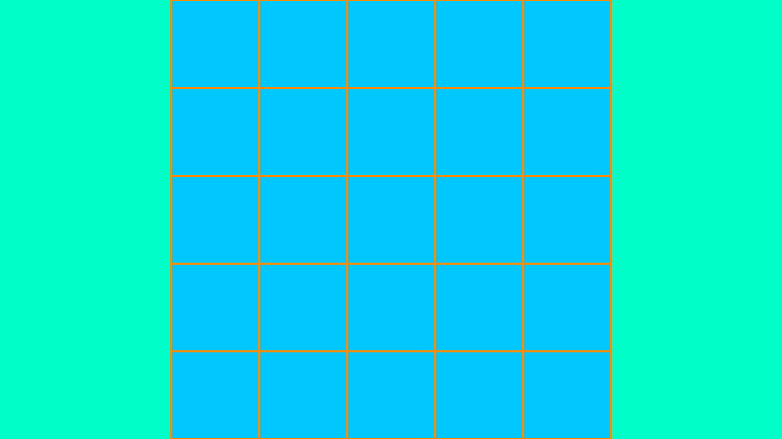

The snake is confined by a set of rules.

1. The snake cannot know where the exit is and therefore travels in random directions
2. The directions it chooses must not be to anywhere it has been before otherwise the snake will overlap itself and get tied up in a knot
3. The snake can backtrack but must rebuild any walls it has broken
4. Once the snake reaches the exit position the snake should not travel further.
5. Every position it visits must be recorded and if the position is backtracked away from the position must be removed from the record. (this is the history stack)

Say the snake decides to travel:

(West, North*2, East*4, North, West*4) with an exit position of the bottom right of the maze.

The path will look something like this:

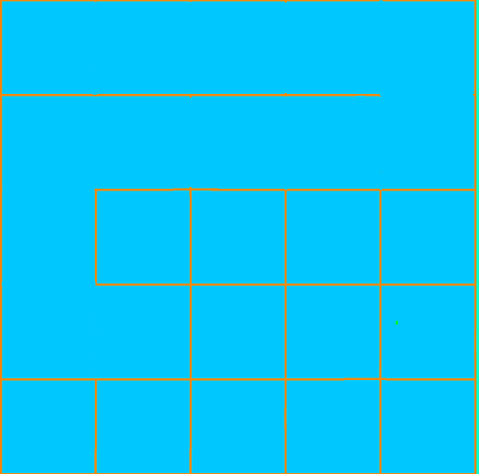

Clearly there is a problem; the snake can no longer travel anywhere other than where it has been before or it will be caught in a knot. So, the snake backtracks until there is a path it can take. In terms of data on the computer the history stack will be used to identify previous locations in order and once the snake backtracks successfully the location in the history stack (stored as an array of x and y co-ordinate) will be popped off striking it from the record.

After the snake backtracks it ends up here.

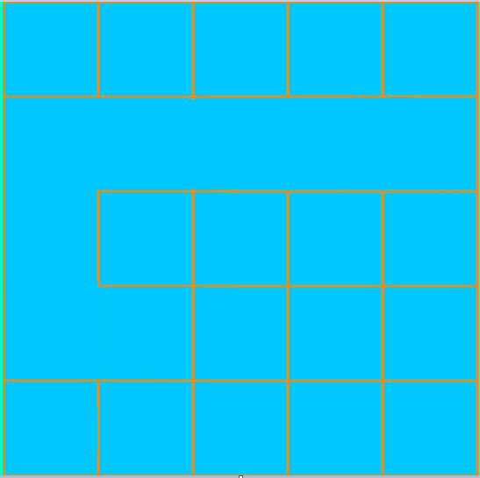

The snake is programmed to be somewhat intelligent so the first path it takes after it backtracks will be anything but in the direction that got the snake stuck. In this case that is south.

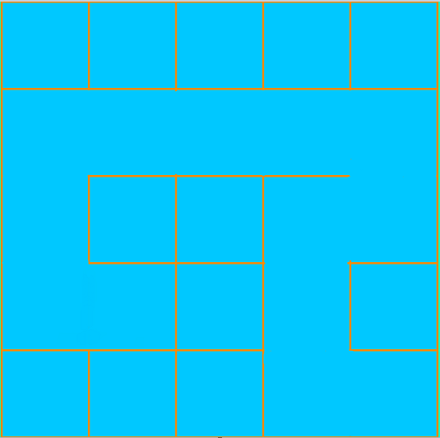 So, let’s say the snake goes:

South, West, South*2, East

The grid will look like this at the end and as a result we have a completed layer. This layer is overlapped onto the maze as shown in the next flowchart.

After the layer is overlapped onto the maze the layer is refreshed as a new grid and the maze generator creates a list of unvisitable positions in the grid (by storing positions of nodes with value [1,1,1,1] in the maze). A random node from this list is chosen as the new start position for the next layer to be created. This process is repeated until there are no more blocked off nodes in the maze array.

### Overlap layer onto maze:

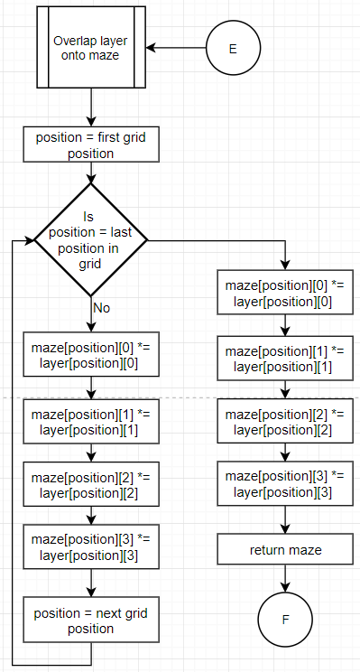This maze overlapping works in a similar way to a bitwise AND operation. Every open path is layered above a wall and overrides the wall creating a path on the actual maze.

### Notes on layer optimization:

Recently there have been efficiency improvements to this algorithm. Instead of creating a new width*width grid for each layer, it is much faster to store a template of a fresh layer and copy that onto layers. This reduces the amount of time it takes to generate the maze overall especially for larger mazes with many layers. This template will be stored as an attribute of the grid class called template.

### Choose Direction algorithm:

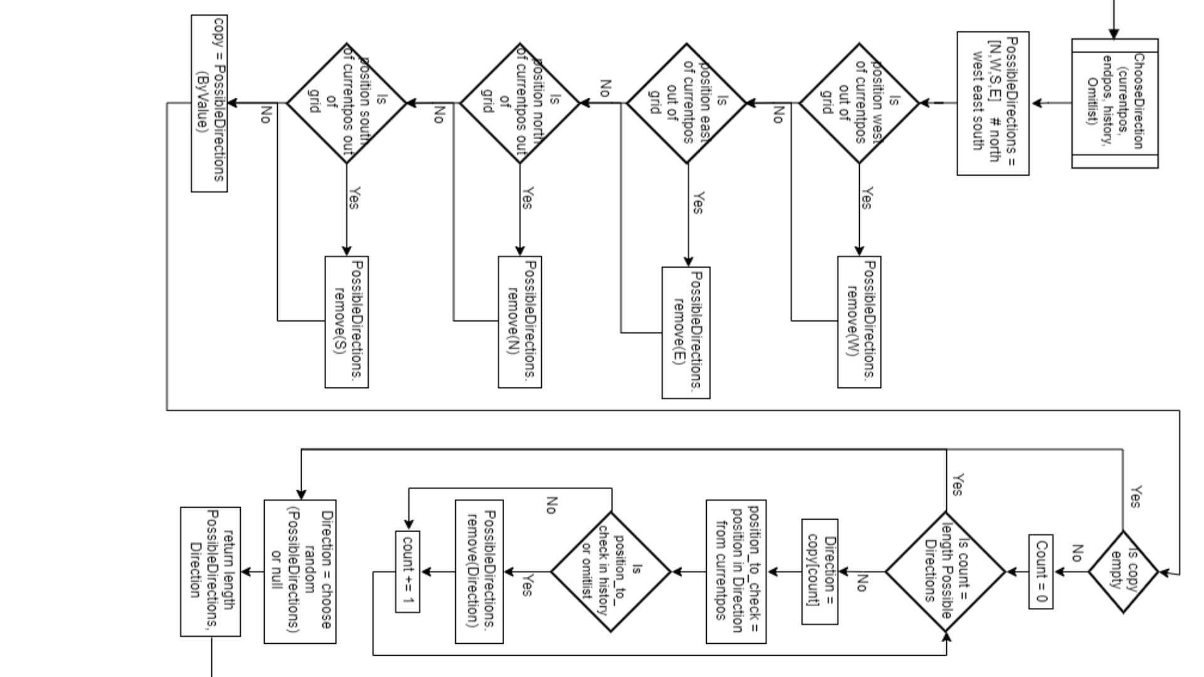

### Full maze generation as described before:

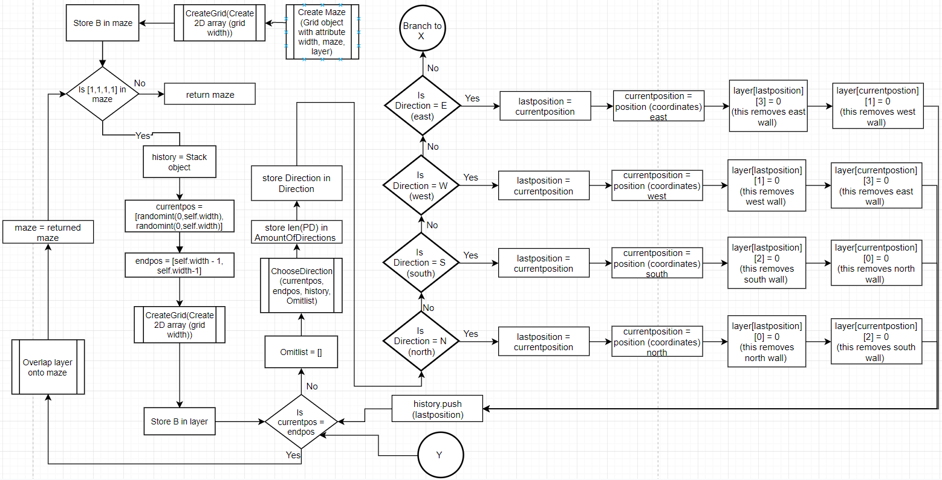

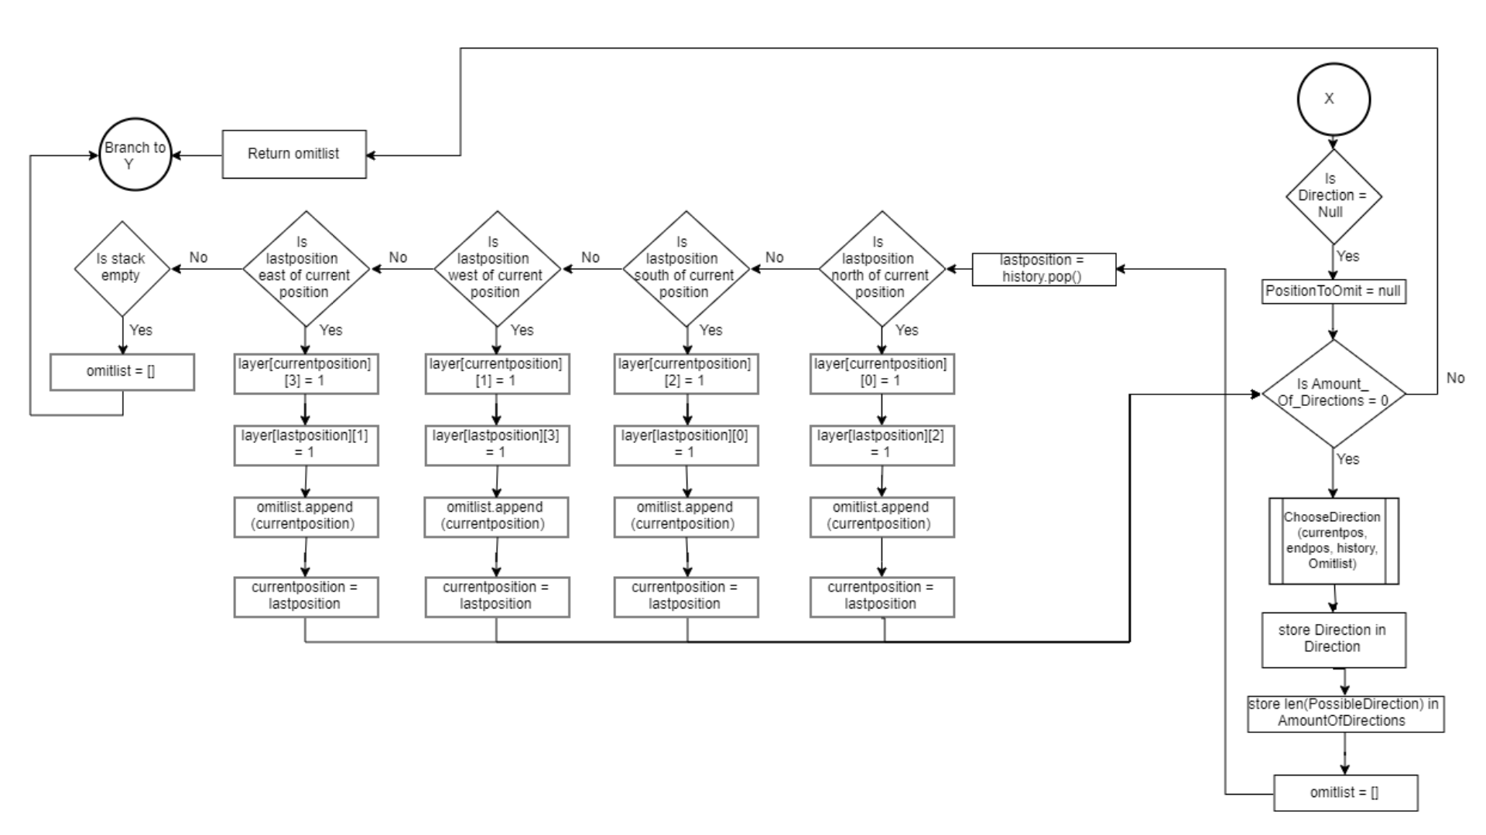

### Efficiency improvements and maze sparsity improvements:

An efficiency improvement has been made since creating the algorithm above. Now instead of only allowing a snake (as described before) to exit the maze once it reaches a specified exit point, now the snake will also exit if it hits a point in the maze that has already been visited once or twice (depending on how sparse you want the maze to be). This means that as shown before a second snake will create a path that looks something like this (blue represents first snake red represents second). 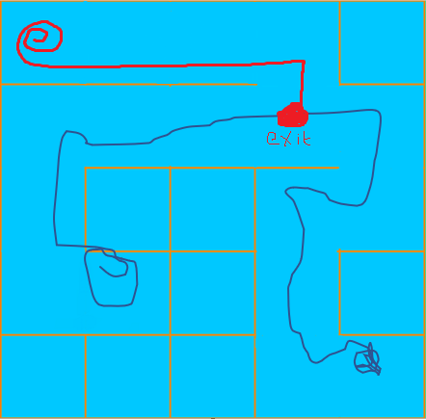

This new snake moves in random directions from its start point until it reaches a previously visited point on the maze by another snake (in this case a point which the blue snake has visited). This however would create a perfect maze which isn’t desirable since when the game is played it would be impossible to pass an enemy blocking the path to the exit by taking a different path (a perfect maze is a maze with no loops (only one path from a node to any given node)). To remedy this issue, we can manipulate this rule a bit to say that the snake can exit at a point where at least two snakes have been before.

**Line of sight algorithm:**

My line of sight algorithm uses a technique known as ray casting. It works by mathematically describing line segments from the observer (in this case the enemy) to its environment. The ray is used in a similar way to a sensor. Using mathematical calculations that utilize matrix calculations, all intersections between walls and the ray can be calculated to exist or not and the ray can also calculate the exact point of intersection. This can be used to generate 3D graphics (which could be a consideration of this project). It may also be used to calculate whether the closest intersection is the player and whether to set an enemy as having detected the player or not and at what location.

The mathematics behind calculating whether an intersection exists uses matrix mathematics. A summary of this calculation is shown below:

Start point of ray = (x1, y1)

End point of ray = (x2, y2)

Start point of wall = (x3, y3)

End point of wall = (x4, y4)

An extract from [Line–line intersection - Wikipedia](https://en.wikipedia.org/wiki/Line%E2%80%93line_intersection#cite_note-GGIII-2) or <https://bit.ly/2p7F8xu> summarizes this calculation pretty well:

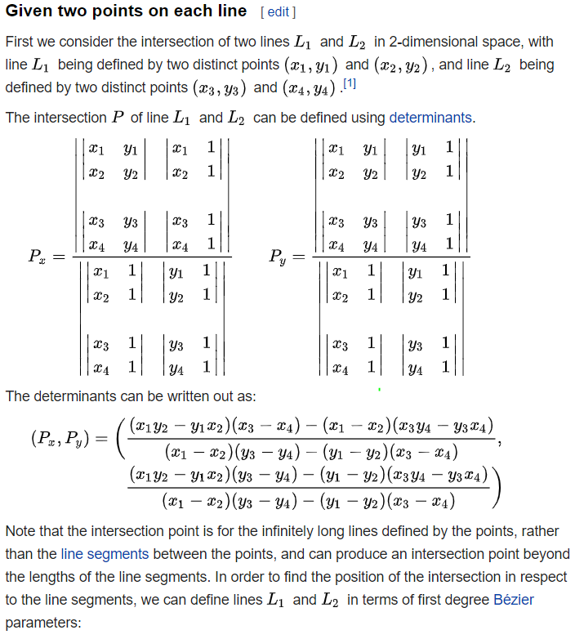

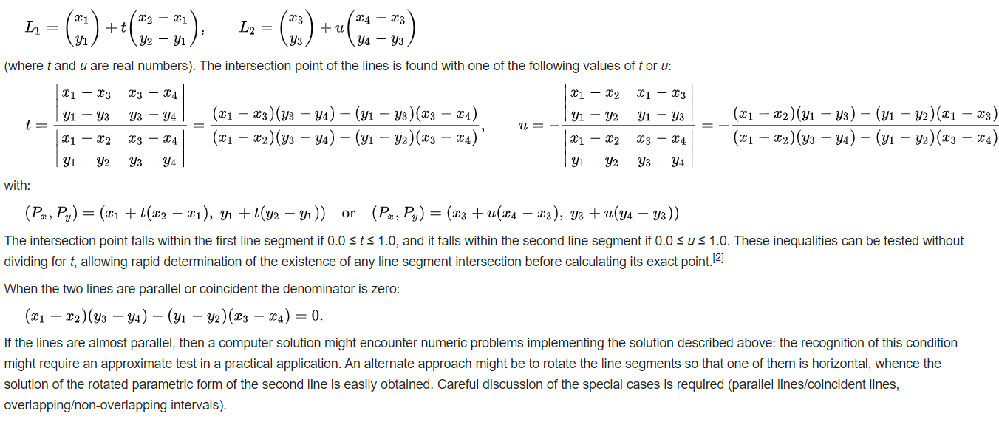

The main parts of this algorithm we are concerned with is:

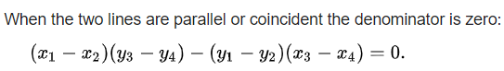

This calculation allows us to determine whether there is even an intersection between the ray and the wall. This uses the denominator of the values used to calculate point of intersection. If this equation is true, there is no possible intersection between the ray and the wall. Otherwise, there may be an intersection, but this may only be relative to the cartesian equation of the lines and it may not be within the bounds we are concerned with (so it may be beyond the end of the wall)

To work out whether the intersection is within our bounds we use the following values of t and u:

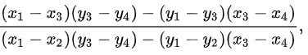t =

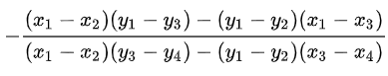

u =

Notice how the denominators are equal and the first calculation at the top of this page. If 0<= t <=1 and 0<= u <=1 then there is a point of intersection within our bounds

Now to work out the point we use this formula:



Or this formula:



Where Px and Py are the coordinates of the point of intersection (the notation relating to matrix multiplication which is beyond the scope of this project since it is used for 3D rendering).

This way of calculation is efficient since it doesn’t attempt to calculate the point before it determines the actual point. Ray casting is a technique used in the 1981 Wolfenstein for 3D rendering on weak machines of 4 MHz clock speeds.

Credit for this goes to Antonio, Franklin (1992). "Chapter IV.6: Faster Line Segment Intersection"

Flowchart for the algorithm used for line of sight calculating and rendering to screen:

### Calculating player in line of sight:

A single ray is used for efficiency since no other rays are needed (except for rendering to screen).

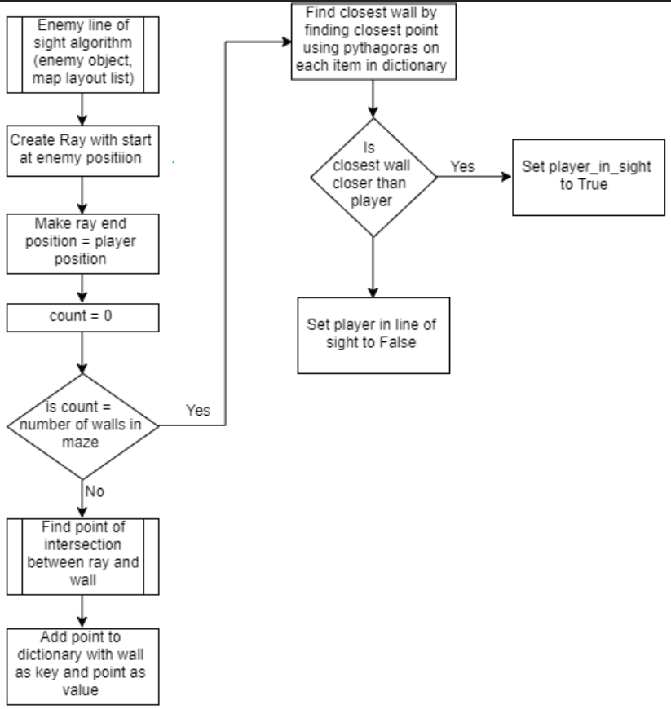This is only for determining whether the player is spotted or not.

### Render line of sight onto screen:

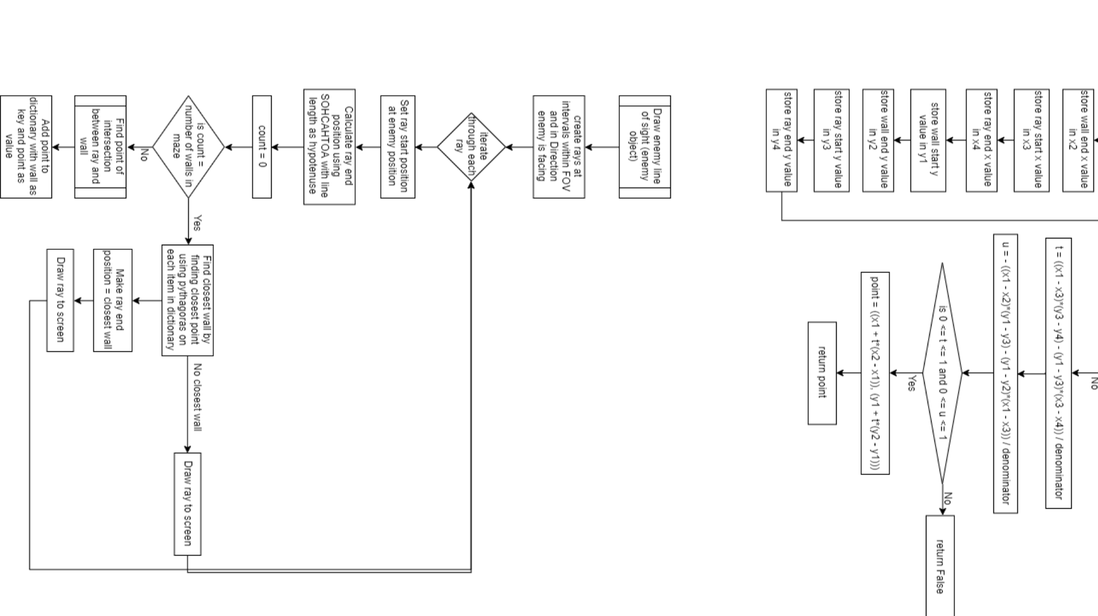

An enemy will have many rays that are used to render the line of sight so that the player can visualise the enemy’s range.

### Mathematical calculation for intersection algorithm (as described) that each ray will use:

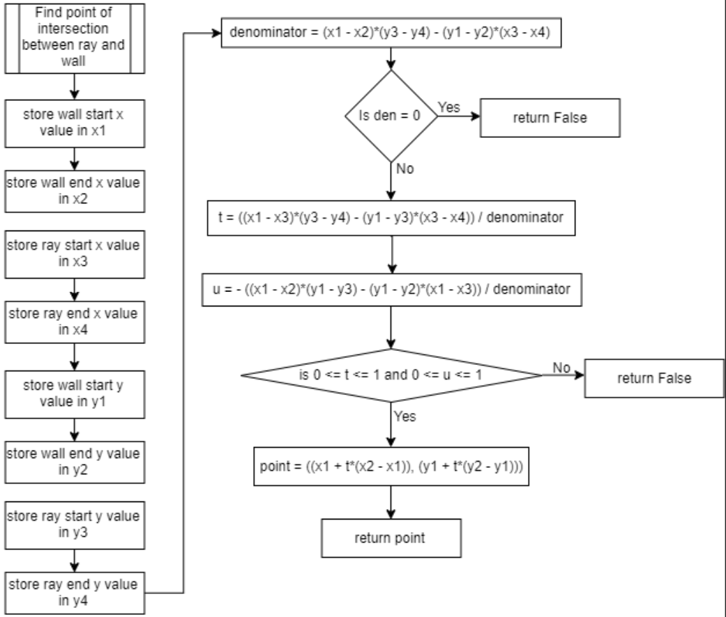

### Ray prototype images:

I have created a prototype for this algorithm to use as a proof of concept. The prototype only contains one wall and a ray that follows the mouse. Rays that are drawn to the screen are not removed so that the way the code works can be visualised better.

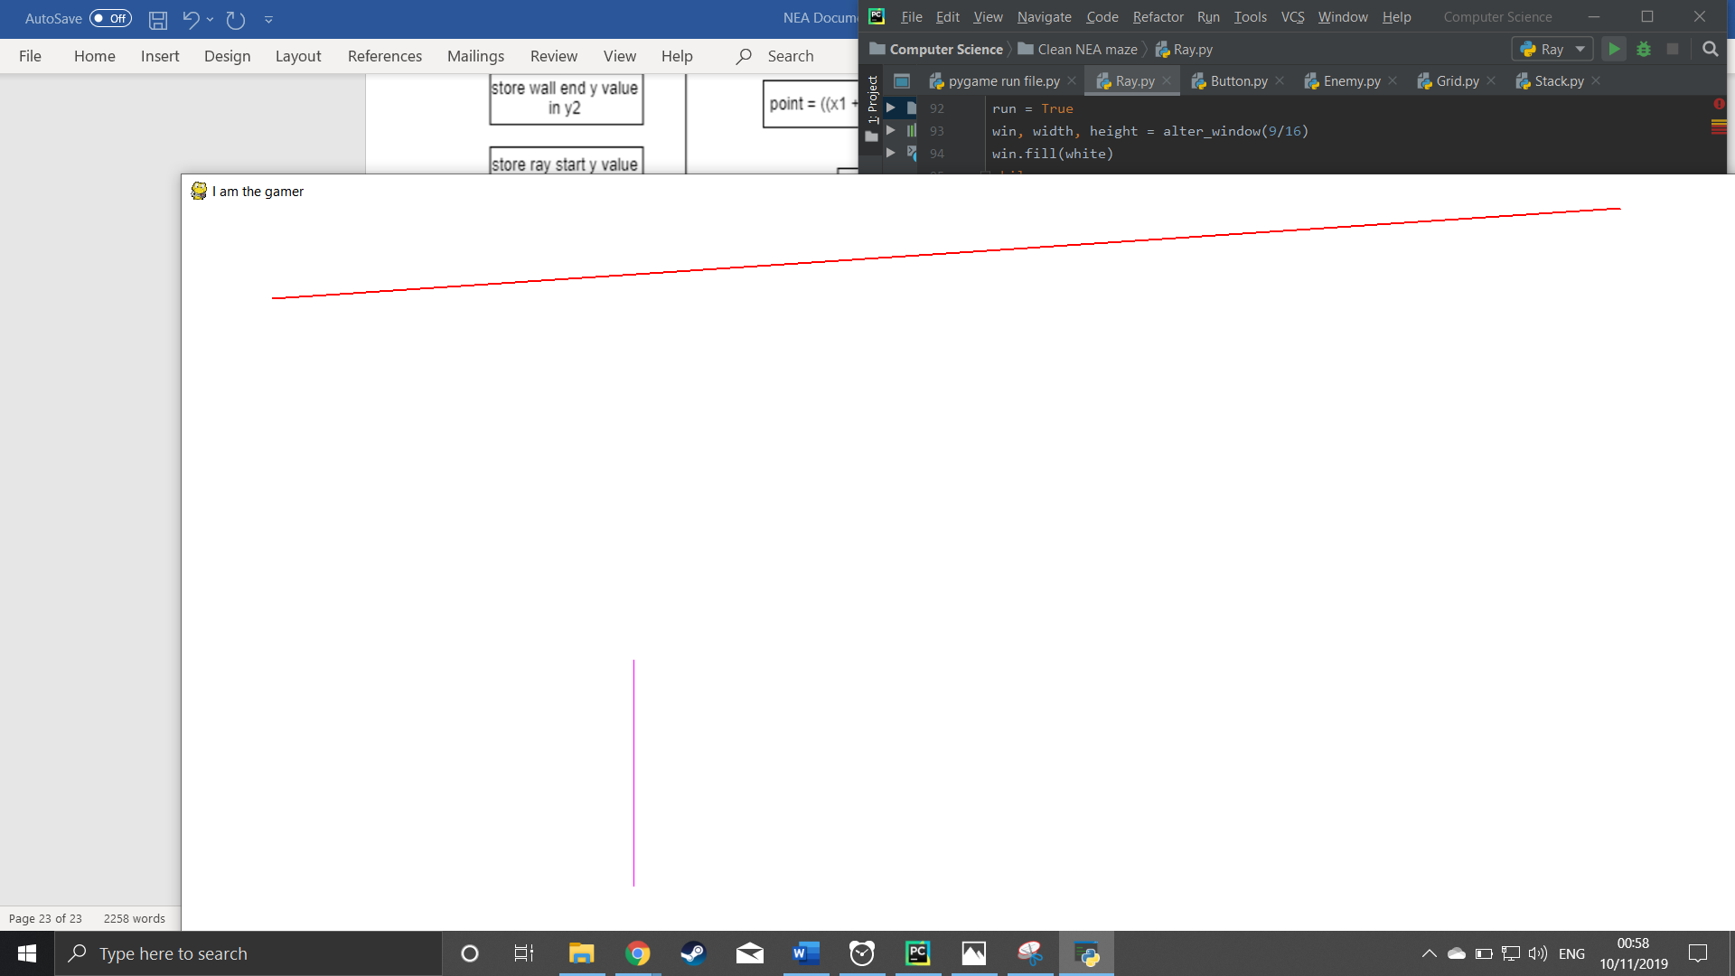

The red lines are the rays and the purple line is the wall. After sweeping behind the wall using my mouse a shadow is cast as shown below. This may be useful for creating shadows and perhaps even a working fog of war. It takes 0.23440074920654297 seconds to calculate 720 rays from 2 separate start points in a 20*20 grid with many walls. Since a simple mathematical calculation is used the efficiency of the code is very large. If there are issues with efficiency then a heap can be used to store walls by distance from ray start-point and only walls that are close enough are used to calculate the rays endpoint. However this is a consideration that may be implemented if there is enough time left to do so.

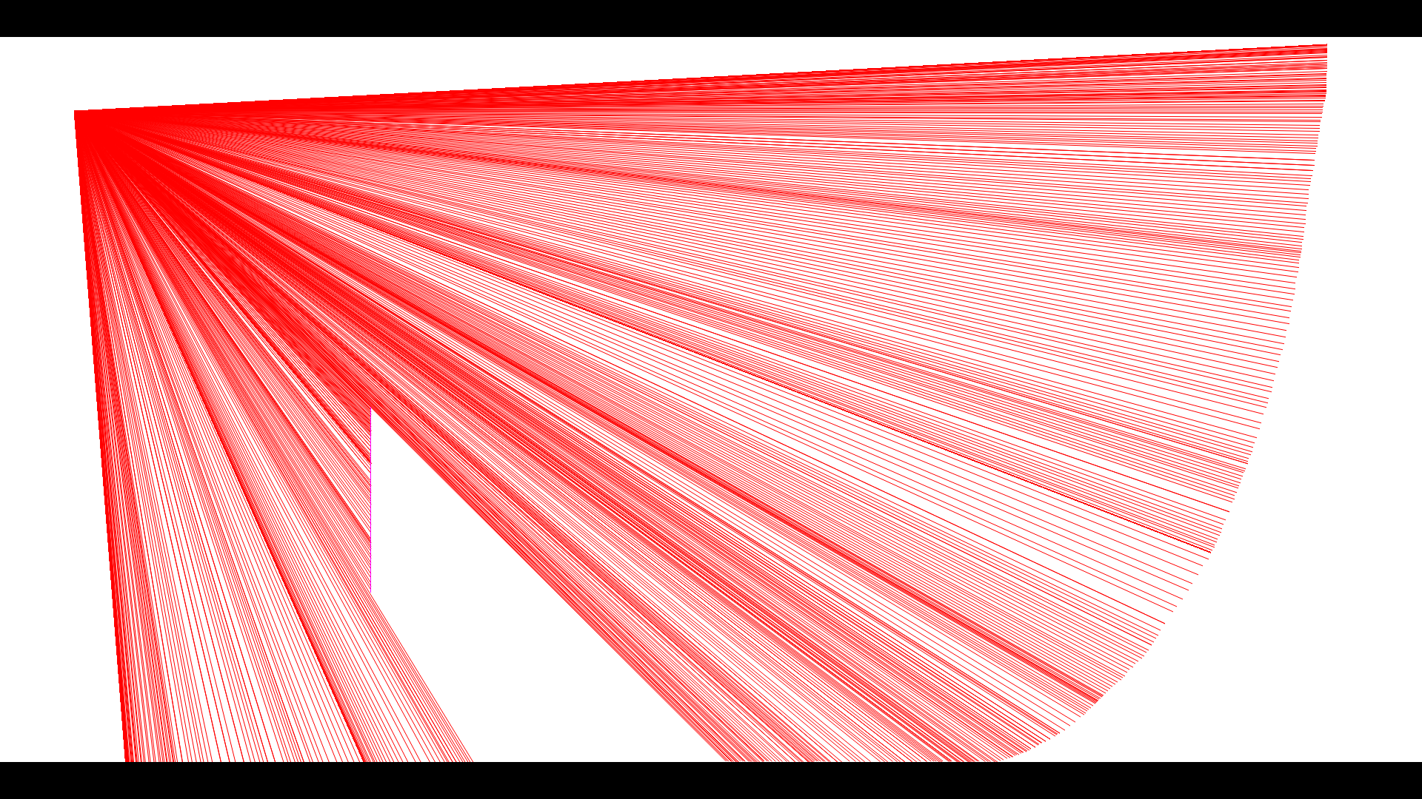

However, there is a problem here. Consider a 200 * 200 maze. If we draw rays from an enemy in any given position (say 360 one for each angle in a 360 degree FOV) and a ray has say a distance of 15 blocks then we have a fatal flaw here. Every ray must be checked for intersection with every possible existing wall in the maze whether it is more than 15 blocks away from the wall or not.

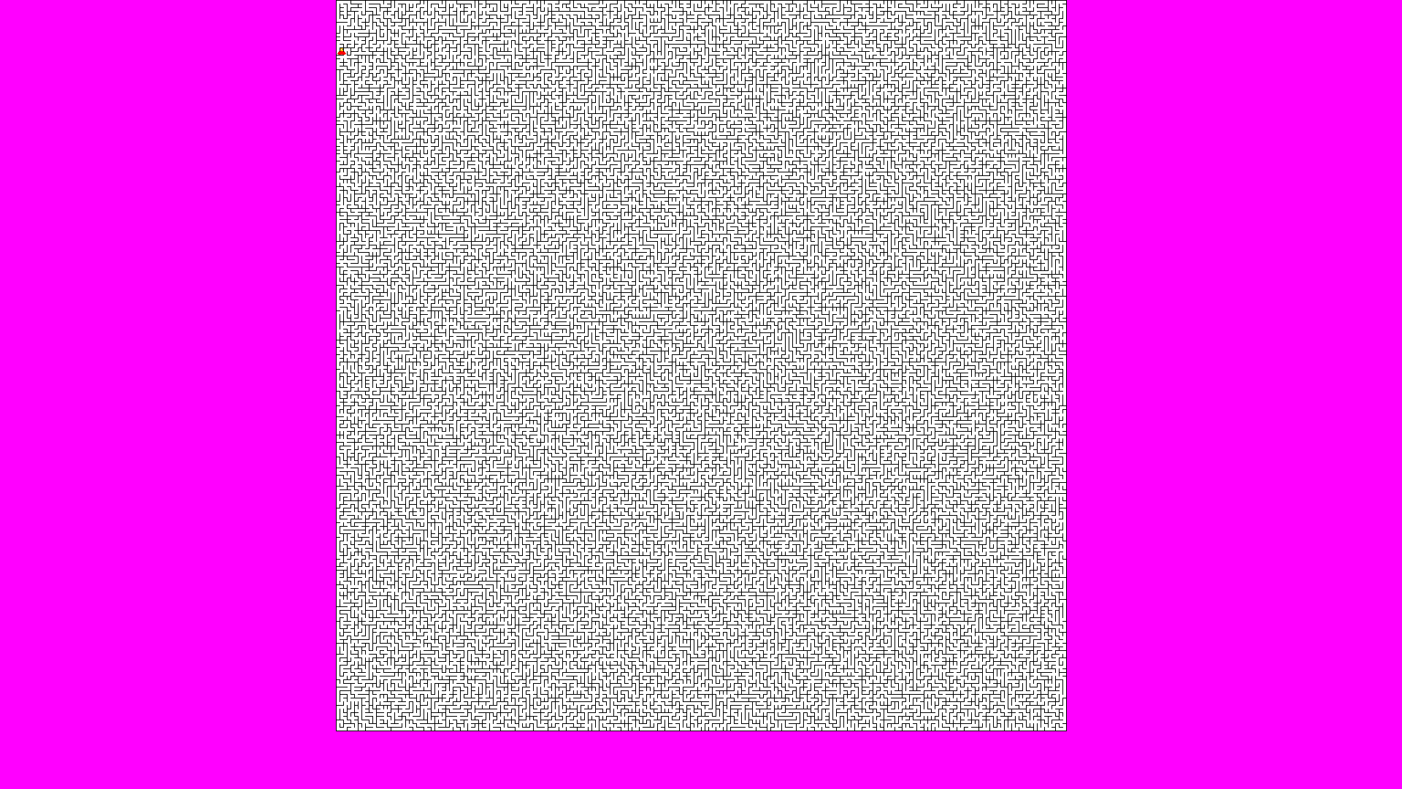

1 A perfect maze (mathematically speaking generated by my algorithm)

Through testing on a 200*200 maze (using pythons time.time() to calculate the amount of time it takes to calculate 360 degrees of rays) it takes around 16 seconds for all ray intersections to be calculated. As a result, the program becomes highly inefficient and very slow. A solution to this problem is the utilization of a heap that stores only walls that are within a reasonable distance from the start position of a ray. The red blob is the enemy’s rays drawn onto the grid. Using this method, it took 0.2 seconds to calculate all 360 rays.

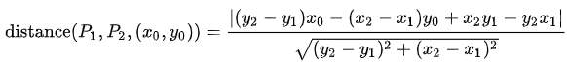A heap is explained previously in this documentation however the tl;dr of it is that it is a priority queue that returns an element with the smallest weighting. In this case the weighting is the smallest distance between a ray and a wall. This is calculated using the following formula ((x0, y0) is the rays start position and P2 and P1 is the line defined by its start and end points).

### Path finding algorithm:

For my path finding algorithm to work a graph data structure needs to be implemented. A graph is a data structure that consists of nodes and edges. A node in my implementation would be a position in a maze. A path between that node and the adjacent nodes will be the edges. Enemies need to be able to find the shortest path from one node to another in order to successfully ambush the player.

The graph doesn’t need to do much other than be used to find shortest path. An adjacency matrix will be used instead of a list because, although an adjacency matrix may be memory inefficient, the amount of memory it will use is insignificant for the sizes of maze I am using. Matrices will reduce the time complexity of my code compared to adjacency lists since looking up a connection between two nodes is as quick as requesting data from a location in memory without need for calculation.

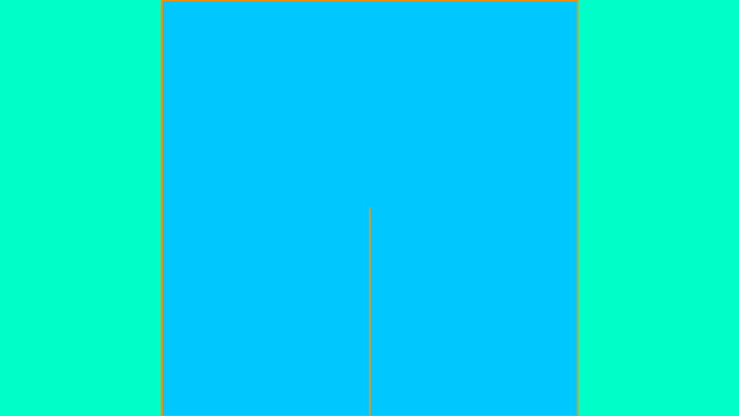A 2*2 maze would look like the chart below in memory as a graph represented by an adjacency matrix.

|  |  |  |  |  |
| --- | --- | --- | --- | --- |
| positions | (0,0) | (0,1) | (1,0) | (1,1) |
| (0,0) |  | 1 |  |  |
| (0,1) | 1 |  |  | 1 |
| (1,0) |  |  |  | 1 |
| (1,1) |  | 1 | 1 |  |

Every 1 in a box represents a connection with weight of 1 between the positions in the rows and columns. My game will have different terrain types that will be used to set weights to the edges.

I already have a rough implementation of this. Once a maze is created, an adjacency matrix should be calculated immediately and overwrite the previous matrix. This is to prevent the AI using an old matrix to calculate its movement path.

A 50*50 maze was tested to see how much time it would take to create the matrix and the times that were calculated averaged at around ½ a second. This isn’t much time at all especially because a matrix is only calculated once after a maze is generated and never again.

However, a 50*50 maze uses a lot of space as it is a 2500*2500 2D array in matrix form. Furthermore, most of this space is redundant as an undirected maze is symmetrical diagonally so there are repeated values. Also, there are very few connections between nodes. However, the space used is irrelevant compared to a (on average) 4GB stick of RAM. In future an adjacency list may be used so that the game can be played on much slower, smaller (in terms of main memory) devices.

### Dijkstra / A star efficient path finding:

My enemy AI will use A star search which is an extension of Dijkstra. Dijkstra’s algorithm is an algorithm that searches for the shortest path between two nodes (or locations on my maze). The algorithm needs to be able to handle unseen mazes since mazes are procedurally generated. Dijkstra will also be used to show the user the path they will take before they choose to move by drawing a line that follows the path given by Dijkstra. It should be noted that diagonal movement between two vertices (nodes or locations on a maze) is not possible.

Firstly, a matrix must be calculated along with the maze

### Matrix creation algorithm:

As said before, an adjacency is required for Dijkstra to be implemented. This is a data structure that allows me to store connections between any two positions in the maze. If there is no connection this will be stored as a connection with an infinite weighting (using pythons float(“int”)).

For this algorithm what needs to be understood is the way connections are illustrated in the maze at first. A connection between a node and another node depends on their location and whether there is a wall between them or not.

This is simple to figure out:

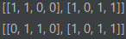

In the maze array shown above nodes are elements in the list. Each element is an array that stores connections North, West, South and East in that order (NWSE). 1 means there is a wall and 0 means it is open. In the example above the first node has a connection south and east. Therefore, for this node, the matrix would store a connection between the node and the neighbouring south and east node. For this entire maze (2*2) the matrix will look something like this each index representing a node.

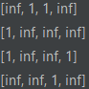**Maze as node indexes: Maze corresponding matrix:**

|  |  |
| --- | --- |
| **0** | **1** |
| **2** | **3** |

As said a matrix (graph representation of the maze) is created alongside the maze

### Dijkstra path finding algorithm:

Say you are given the following graph (edge weights are numbered next to lines) nodes labelled as circles

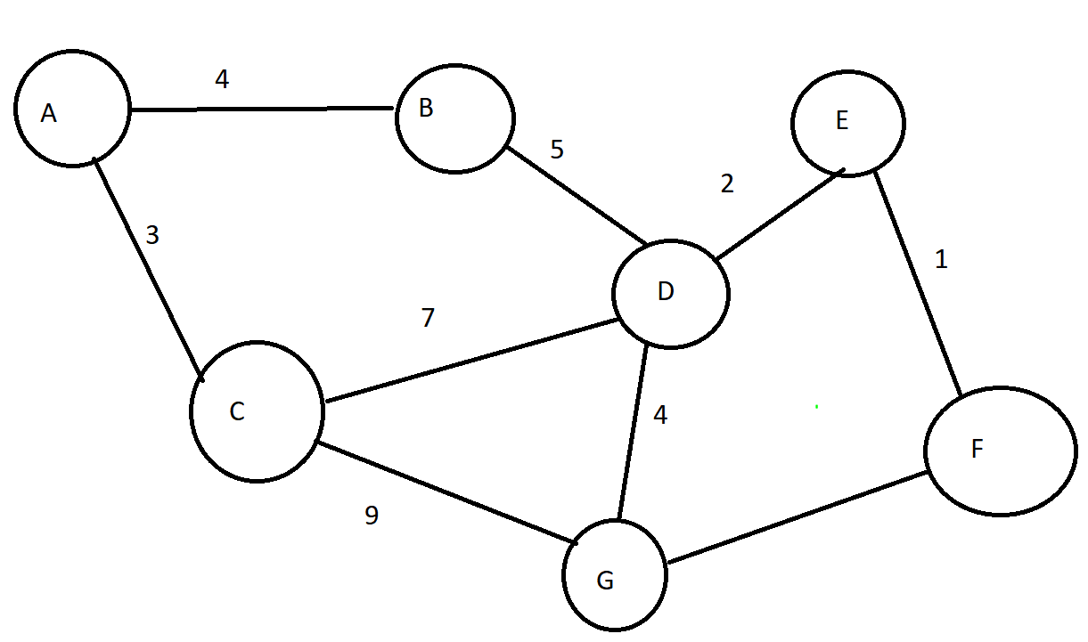

Your algorithm is tasked with finding the shortest path from A to F

Dijkstra tackles this by creating a priority queue containing every node alongside a source set as None and a weight from that source initially set as infinity. Except for the source node which has a weight of 0. This looks something like what is shown below:

|  |  |  |
| --- | --- | --- |
| source | node | Weight |
| None | A | 0 |

|  |  |  |
| --- | --- | --- |
| Source | Node | weight |
| None | B | infinite |

Etc etc…

All of these sets are stored in a priority queue ordered by weighting. The first node is taken from the priority queue (in this case A). And added to a visited queue

The neighbours of this node are all evaluated 1 by 1 with their weighting and source node updated to match the weighting from the source node to them. These are added to the visited queue.

Then the node with the next lowest weighting is taken from the visited queue to have its neighbours evaluated. The source node and weighting is evaluated the same way. If the neighbouring node being evaluated has a weighting that is higher than the new weighting, then the value is updated otherwise the value is not updated and kept the same.

This process is repeated all the way until the algorithm first reaches the exit node (F).

Now we have a visited queue containing all nodes that the algorithm has visited along with the node they came from and the weighting from that node.

So to create the path from this visited queue the algorithm has to go from the exit node backwards.

The exit node is removed from the queue and the weighting is added to a running total and the node is added to a list of nodes.

The source of this exit node is checked and removed from the visited queue and the process is repeated until the algorithm reaches the source node

At this point there is now a list of nodes in reverse order going from the exit node to the source node and we have the weighting of that entire path.

All that is left to do is to return the entire list in reverse and the weighting

And that was the Dijkstra algorithm.

This Dijkstra algorithm is used for player and enemy movement and so is crucial to this project

# 3 – Technical solution

Below is the technical solution to my project written in python using the pygame library.

## 3.1. Pygame run file.py

This is the file that is run to run the code

**import** pygame  
**from** pygame.locals **import** *  
**import** threading  
**import** random  
**import** Grid  
**import** Player  
**import** Button  
**import** Enemy  
**import** Item  
**import** math  
**from** pygame **import** mixer  
pygame.init()  
  
pygame.mixer.music.load(**"background.mp3"**)  
pygame.mixer.music.set_volume(0)  
pygame.mixer.music.play(-1) *# loads and starts the background music but turns off the volume and loops it*clock = pygame.time.Clock() *# used to regulate frames per second*darkred = (139, 0, 0)  
darkorange = (255, 140, 0)  
lightgreen = (0, 255, 127)  
whitegreen = (0, 255, 200)  
black = (0, 0, 0)  
red = (255, 0, 0)  
purple = (255, 0, 255)  
green = (0, 255, 0)  
blue = (0, 0, 255)  
lightblue = (0, 125, 255)  
whiteblue = (0, 200, 255)  
white = (255, 255, 255)  
pink = (255, 105, 180)  
gold = (255, 223, 0) *# colour variables global used to set colours of objects when drawing (in hex values)***def** Reverse(tuples): *# reverses tuples used to reverse coordinates in wrong format* new_tup = tuples[::-1]  
 **return** new_tup  
  
  
**def** text_objects(text, font): *# from pygame class used to draw text to the screen* text_surface = font.render(text, **True**, black)  
 **return** text_surface, text_surface.get_rect()  
  
  
**def** message_display(text, centre, win): *# draws the text to the screen* large_text = pygame.font.Font(**"freesansbold.ttf"**, 30)  
 text_surface, text_rect = text_objects(text, large_text)  
 text_rect.center = centre  
 win.blit(text_surface, text_rect)  
  
  
*# checks for events such as key presses or mouse presses used to quit from the game and to check if mouse clicked in game***def** check_events(run):  
 press = **False** keys = pygame.key.get_pressed()  
 **for** event **in** pygame.event.get():  
 **if** event.type == pygame.QUIT:  
 quit()  
 **elif** event.type == pygame.KEYDOWN:  
 **if** event.key == pygame.K_ESCAPE:  
 run = **False  
 elif** event.type == MOUSEBUTTONDOWN:  
 **if** event.button == 1:  
 press = **True  
 return** run, press  
  
  
*# draws a background onto the screen in circles (scalable for resolutions)***def** background(colour1, ratio, win):  
 x, y = win.get_size()  
 radius = int(x/(ratio*2))  
 **for** yratio **in** range(0, int(y/radius)):  
 **for** xratio **in** range(0, (ratio + 1)):  
 pygame.draw.circle(win, colour1, (int(x*xratio/ratio), 0 + yratio*radius*2), radius)  
  
  
*# this creates the window that is used to show the game (has parts to it that would have been used for scalability)  
# it takes an aspect ratio and creates a window based on that and the screen height and width***def** alter_window(aspect_ratio):  
 screen_info = pygame.display.Info()  
 screen_w = screen_info.current_w  
 screen_h = screen_info.current_h  
 **if** screen_w * aspect_ratio > screen_h:  
 width = int(screen_h / aspect_ratio)  
 height = int(screen_h)  
 **else**:  
 width = int(screen_w)  
 height = int(screen_w * aspect_ratio)  
 win = pygame.display.set_mode((width, height), FULLSCREEN)  
 pygame.display.set_caption(**"Dungeon Hunter"**)  
 **return** win, width, height  
  
  
*# collects pixel positions of every position in the maze (top left corner) and stores in a list called locations that is  
# 1 to 1 with grid.positions (coordinates list) useful when trying to move sprites in pixels and when drawing onto certain tiles  
# creates a wall list of all walls defined by their start and end locations used for ray casting and line of sight algorithm for enemies  
# returns square_width which just indicates how large a block on the maze is for drawing purposes***def** collect_locations(win, grid):  
 grid.walls = []  
 locations = []  
 width, height = win.get_size()  
 **if** width >= height:  
 square_width = (height / grid.width)  
 draw_point = (width - (square_width * grid.width)) / 2  
 **for** x **in** range(0, grid.width):  
 **for** y **in** range(0, grid.width):  
 top_right_x = (draw_point + (x * square_width))  
 top_right_y = square_width*y  
 locations.append((top_right_x, top_right_y))  
 **if** grid.maze[y][x][0] == 1:  
 grid.walls.append([(top_right_x, top_right_y), (top_right_x + square_width, top_right_y)])  
 **if** grid.maze[y][x][1] == 1:  
 grid.walls.append([(top_right_x, top_right_y), (top_right_x, top_right_y + square_width)])  
 **if** grid.maze[y][x][2] == 1:  
 grid.walls.append([(top_right_x, top_right_y + square_width), (top_right_x + square_width, top_right_y + square_width)])  
 **if** grid.maze[y][x][3] == 1:  
 grid.walls.append([(top_right_x + square_width, top_right_y), (top_right_x + square_width, top_right_y + square_width)])  
 grid.walls = list(set(map(tuple, grid.walls)))  
 **return** locations, grid.walls, square_width  
  
  
*# draws the back of the maze (one large rectangle) that indicates the map area***def** draw_back(grid, win):  
 width, height = win.get_size()  
 **if** width >= height:  
 square_width = (height / grid.width)  
 draw_point = (width - (square_width * grid.width)) / 2  
 pygame.draw.rect(win, whiteblue, (draw_point, 0, height, height))  
  
  
*# draws the walls of the generated maze (map or grid) onto the screen by drawing lines***def** draw_grid(grid, win):  
 width, height = win.get_size()  
 **if** width >= height:  
 square_width = (height / grid.width)  
 draw_point = (width - (square_width * grid.width))/2  
 line_width = 3  
 **for** x **in** range(0, grid.width):  
 **for** y **in** range(0, grid.width):  
 top_right_x = (draw_point + (x * square_width))  
 top_right_y = square_width * y  
 **if** grid.maze[y][x][0] == 1:  
 pygame.draw.line(win, black, (top_right_x, top_right_y), (top_right_x + square_width, top_right_y), line_width)  
 **if** grid.maze[y][x][1] == 1:  
 pygame.draw.line(win, black, (top_right_x, top_right_y), (top_right_x, top_right_y + square_width), line_width)  
 **if** grid.maze[y][x][2] == 1:  
 pygame.draw.line(win, black, (top_right_x, top_right_y + square_width), (top_right_x + square_width, top_right_y + square_width), line_width)  
 **if** grid.maze[y][x][3] == 1:  
 pygame.draw.line(win, black, (top_right_x + square_width, top_right_y), (top_right_x + square_width, top_right_y + square_width), line_width)  
  
  
*# draws enemy rays onto the screen (which is the feild of view) then draws the enemies onto the screen in their positions***def** draw_enemies(enemies, window):  
 **for** enemy **in** enemies:  
 draw_rays(enemy[0], window)  
 **for** enemy **in** enemies:  
 draw_enemy(enemy[0], window)  
  
  
*# creates enemies avoiding creating enemies on top of one another which helps spread the enemies evenly across the map***def** create_enemy(quantity, walls, difficulty, locations, square_width, grid):  
 enemies = []  
 used_spots = [**None**]  
 y = **None  
 if** difficulty == 1:  
 **for** ID **in** range(0, quantity):  
 **while** y **in** used_spots:  
 y = random.randint(0, (grid.width ** 2 - 1))  
 used_spots.append(y)  
 location = locations[y]  
 position = grid.positions[locations.index(location)]  
 enemy = Enemy.Enemy(ID, **"sprites/blob.png"**, int(square_width), difficulty, location, position, **"monkey"**, math.ceil(grid.width/3))  
 *# mathematical calculations in this instantiation of an enemy are used so that the enemies number of steps moved is based of the size of the maze (proportional to)* enemy.create_rays(walls) *# casts rays onto the walls of the maze* enemies.append((enemy, y))  
 **return** enemies  
  
  
*# draws enemies onto the screen in their location***def** draw_enemy(enemy, window):  
 enemy.draw(window)  
  
  
*# is used to work out where the mouse is (on what block it is on) when it is the players turn in game to draw the path the  
# player will go to if the player presses on that position***def** Coordinates(square_width, locations):  
 mouse_pos = pygame.mouse.get_pos()  
 block = **None** index = **None  
 for** i, location **in** enumerate(locations):  
 **if** (location[0] <= mouse_pos[0] < location[0] + square_width) **and** (location[1] <= mouse_pos[1] < location[1] + square_width):  
 block = location  
 index = i  
 **break  
 return** block, index  
  
  
*# draws the path up to the mouse using dijkstra and for efficiencies sake only draws the path and calculates it when  
# the mouse changes block coordinates***def** draw_to_mouse(grid, block, index, locations, square_width, win, prev_position, player):  
 path = **None  
 if** block **and** grid.positions[index] != prev_position:  
 path = get_path(grid, index, player)  
 draw_path(grid, path, locations, square_width, win)  
 **if** index **is not None**:  
 **return** grid.positions[index], path  
 **else**:  
 **return None**, path  
  
  
*# gets the path to the mouse and the weight of that path from the player and restricts that path to only the nodes that can be visited  
# within the amount of steps th player can take***def** get_path(grid, index, player):  
 path = grid.PathFinding(player.location, grid.positions[index])  
 restricted_path = [path[0][0]]  
 remaining_steps = player.steps  
 **for** index, location **in** enumerate(path[0]):  
 **if** index != 0:  
 weight = grid.matrix[grid.GetMatrixIndex(Reverse(path[0][index - 1]))][grid.GetMatrixIndex(Reverse(location))]  
 **if** remaining_steps - weight >= 0:  
 remaining_steps -= weight  
 restricted_path.append(location)  
 **return** restricted_path, (player.steps - remaining_steps)  
  
  
*# draws a path onto the screen that the player will take if mouse is clicked***def** draw_path(grid, path, locations, square_width, win):  
 **for** i, node **in** enumerate(path[0]):  
 location1 = locations[grid.positions.index(node)]  
 **try**:  
 location2 = locations[grid.positions.index(path[0][i+1])]  
 pygame.draw.line(win, purple, ((location1[0] + square_width/2), (location1[1] + square_width/2)), ((location2[0] + square_width/2), (location2[1] + square_width/2)), 3)  
 **except** IndexError:  
 **break***# creates the player avoiding positions of enemies on the maze so the player cannot spawn on top of an enemy  
# also checks if a player already exists (after continuing once the game is won) and moves over the health and collected items across***def** create_player(grid, locations, enemies, square_width, player):  
 unvisitable = []  
 **for** enemy **in** enemies:  
 unvisitable.append(enemy[0].location)  
 **while True**:  
 location = random.choice(grid.positions)  
 **if** location **not in** unvisitable:  
 **break  
 if** player **is None**:  
 player = Player.Player(**"sprites/player.png"**, square_width, location, math.ceil(grid.width/3) + 2, math.ceil(3*(len(enemies)/2)))  
 **else**:  
 collected_items = player.collected_items  
 *# remove dungeon key* **for** item **in** collected_items:  
 **if** item.type == **"key"**:  
 collected_items.remove(item)  
  
 health_remaining = player.health  
 player = Player.Player(**"sprites/player.png"**, square_width, location, math.ceil(grid.width/3) + 2, math.ceil(3*(len(enemies)/2)))  
 player.health = health_remaining  
 player.collected_items = collected_items  
 **return** player  
  
  
*# draws player onto screen (converts position in coordinates into pixel positions)***def** draw_player(grid, locations, player, win):  
 player.draw(locations[grid.positions.index(Reverse(player.location))], win)  
  
  
*# draws the enemy rays onto the screen***def** draw_rays(enemy, window):  
 enemy.draw_rays(window)  
  
  
*# using the path that was generated when moving the mouse the player is moved across the map using that path***def** animate_player(items, grid, locations, player, path, speed, enemies, exit, square_width, win):  
 **for** index, next_position **in** enumerate(path[0]):  
 pixel_location = locations[grid.positions.index(player.location)]  
 next_pixel_location = locations[grid.positions.index(next_position)]  
 **if** pixel_location[0] == next_pixel_location[0]:  
 distance = -(pixel_location[1] - next_pixel_location[1])  
 direction = **"y"  
 else**:  
 distance = -(pixel_location[0] - next_pixel_location[0])  
 direction = **"x"** *# this is where the animation begins and interpolation is done  
 # the distance and direction where calculated before and based on the distance and the speed value the player is  
 # moved a fraction of the distance in the direction of the next node and this is repeated until he reaches the node* **for** x **in** range(0, speed):  
 **if** direction == **"y" and** index != 0:  
 pixel_location = (pixel_location[0], pixel_location[1] + distance/speed)  
 win.fill(lightblue)  
 draw_back(grid, win)  
 draw_exit(exit, square_width, win)  
 draw_grid(grid, win)  
 display_turn(**"player"**, win)  
 display_player_health(player, win)  
 display_score_ingame(player, win)  
 draw_items(items, win)  
 player.draw(pixel_location, win)  
 draw_enemies(enemies, win)  
 clock.tick(60)  
 pygame.display.update()  
 **if** direction == **"x" and** index != 0:  
 pixel_location = (pixel_location[0] + distance/speed, pixel_location[1])  
 win.fill(lightblue)  
 draw_back(grid, win)  
 draw_exit(exit, square_width, win)  
 draw_grid(grid, win)  
 display_turn(**"player"**, win)  
 display_player_health(player, win)  
 display_score_ingame(player, win)  
 draw_items(items, win)  
 player.draw(pixel_location, win)  
 draw_enemies(enemies, win)  
 clock.tick(60)  
 pygame.display.update()  
 pygame.mouse.get_pressed()  
 player.location = next_position  
 player.check_for_items(items) *# checks for items that are on the players position and collects them* clock.tick(60)  
 pygame.display.update()  
 win.fill(lightblue)  
 draw_back(grid, win)  
 draw_exit(exit, square_width, win) *# this is all just re-drawing all assets onto the screen* draw_grid(grid, win)  
 display_turn(**"player"**, win)  
 display_player_health(player, win)  
 display_score_ingame(player, win)  
 draw_items(items, win)  
 player.location = Reverse(player.location)  
  
  
*# this animates the enemies based on a generated path in a similar way to before (as animate_player())***def** animate_enemies(items, grid, walls, locations, enemies, path, speed, player, exit, square_width, win):  
 **for** enemy, ID **in** enemies:  
 **for** index, location **in** enumerate(path[enemy]):  
 new_pixel_location = locations[grid.positions.index(location)]  
 **if** enemy.location[0] == new_pixel_location[0]:  
 distance = -(enemy.location[1] - new_pixel_location[1])  
 direction = **"y"  
 else**:  
 distance = - (enemy.location[0] - new_pixel_location[0])  
 direction = **"x"  
  
 for** x **in** range(0, speed):  
 **if** direction == **"x" and** index != 0:  
 enemy.location = (enemy.location[0] + distance/speed, enemy.location[1])  
 enemy.player_remembered()  
 **if** distance > 0:  
 enemy.direction = 1  
 **else**:  
 enemy.direction = 3  
 draw_back(grid, win)  
 draw_exit(exit, square_width, win)  
 display_player_health(player, win)  
 enemy.create_rays(walls)  
 player.draw(locations[grid.positions.index(Reverse(player.location))], win)  
 enemy.find_player(player, walls, locations, grid)  
 enemy.draw_rays(win)  
 enemy.draw(win)  
 draw_enemies(enemies, win)  
 draw_grid(grid, win)  
 display_turn(**"enemy"**, win)  
 draw_items(items, win)  
 pygame.display.update()  
 clock.tick(60)  
 **if** direction == **"y" and** index != 0:  
 enemy.location = (enemy.location[0], enemy.location[1] + distance/speed)  
 enemy.player_remembered()  
 **if** distance > 0:  
 enemy.direction = 0  
 **else**:  
 enemy.direction = 2  
 draw_back(grid, win)  
 draw_exit(exit, square_width, win)  
 display_player_health(player, win)  
 enemy.create_rays(walls)  
 player.draw(locations[grid.positions.index(Reverse(player.location))], win)  
 enemy.find_player(player, walls, locations, grid)  
 enemy.draw_rays(win)  
 draw_enemies(enemies, win)  
 enemy.draw(win)  
 draw_grid(grid, win)  
 display_turn(**"enemy"**, win)  
 draw_items(items, win)  
 pygame.display.update()  
 clock.tick(60)  
 pygame.mouse.get_pressed()  
 enemy.location = new_pixel_location[:]  
 enemy.player_remembered() *# checks if the enemy still remembers the location of the player at the end of the movement  
  
  
# remember last location that the player was spotted in (will move towards you for one turn after being spotted)  
# the code makes sure to only allow the player to move a certain number of steps towards you (set by enemy.steps)***def** move_enemies(grid, locations, enemies, walls, player):  
 paths = {} *# dictionary storing the enemy along with the path it takes in order to animate (stores enemy with path it will take)* **for** enemy **in** enemies: *# generates the enemies path using rule based ai and Dijkstra* path = [enemy[0].position]  
 steps = enemy[0].steps  
 **while** steps > 0:  
 new_position = **None** direction = **None** *# if the enemy is searching and hasn't seen you recently (exact rules explained in enemy class)  
 # then it will choose a random direction to move in and add that to the path for animation* **while** enemy[0].state == **"searching" and** steps > 0 **and** enemy[0].last_known_location == **None**:  
 direction = random.randint(0, 3)  
 **if** direction == 0:  
 new_position = (enemy[0].position[0], enemy[0].position[1] + 1)  
 **elif** direction == 1:  
 new_position = (enemy[0].position[0] + 1, enemy[0].position[1])  
 **elif** direction == 2:  
 new_position = (enemy[0].position[0], enemy[0].position[1] - 1)  
 **else**: *# direction == 3* new_position = (enemy[0].position[0] - 1, enemy[0].position[1])  
  
 **if** type(grid.GetMatrixIndex(Reverse(new_position))) == int:  
 weight = grid.matrix[grid.GetMatrixIndex(Reverse(new_position))][grid.GetMatrixIndex(Reverse(enemy[0].position))]  
 **if** weight != float(**"inf"**) **and** steps >= weight:  
 enemy[0].position = new_position  
 enemy[0].direction = direction  
 enemy[0].location = locations[grid.positions.index(enemy[0].position)]  
 path.append(new_position)  
 steps -= weight  
 enemy[0].find_player(player, walls, locations, grid)  
 **else**:  
 **"unvisitable"  
 else**:  
 **"out of map"** *# if the player is alert (which means the enemy can see you) then it will use Dijkstra to move towards you* **if** enemy[0].state == **"alert" and** steps > 0:  
 **if** enemy[0].location == locations[grid.positions.index(Reverse(player.location))]:  
 **break** path_to_player, weight = grid.PathFinding(Reverse(enemy[0].position), Reverse(player.location))  
 **if** weight <= steps:  
 **for** index, location **in** enumerate(path_to_player):  
 **if** index != 0:  
 path.append(location)  
 enemy[0].position = location  
 enemy[0].location = locations[grid.positions.index(enemy[0].position)]  
 enemy[0].player_remembered()  
 steps -= 1  
 **else**:  
 **for** location **in** path_to_player:  
 **if** steps + 1 > 0:  
 steps -= 1  
 path.append(location)  
 enemy[0].position = location  
 enemy[0].location = locations[grid.positions.index(enemy[0].position)]  
 enemy[0].player_remembered()  
  
 *# when an enemy sees you the location it sees you in is stored in its memory  
 # then if it cannot see you it will move towards the direction it last spotted you until it reaches that position  
 # or until it reaches the location it remembered you in then it wipes its memory of you* **if** enemy[0].last_known_location **is not None**:  
 **if** enemy[0].location == locations[grid.positions.index(Reverse(player.location))]:  
 **break** path_to_player, weight = grid.PathFinding(Reverse(enemy[0].position), grid.positions[locations.index(enemy[0].last_known_location)])  
 **if** weight <= steps:  
 **for** index, location **in** enumerate(path_to_player):  
 **if** index != 0:  
 path.append(location)  
 enemy[0].position = location  
 enemy[0].location = locations[grid.positions.index(enemy[0].position)]  
 enemy[0].player_remembered()  
 steps -= 1  
 **else**:  
 **for** location **in** path_to_player:  
 **if** steps + 1 > 0:  
 steps -= 1  
 path.append(location)  
 enemy[0].position = location  
 enemy[0].location = locations[grid.positions.index(enemy[0].position)]  
 enemy[0].player_remembered()  
 paths[enemy[0]] = path  
 enemy[0].position = path[0]  
 enemy[0].location = locations[grid.positions.index(enemy[0].position)]  
 enemy[0].player_remembered()  
 **return** paths  
  
  
*# displays players health onto screen***def** display_player_health(player, win):  
 width, height = pygame.display.get_surface().get_size()  
 message_display((**"Health: "** + str(player.health)), (width*15/192, height*5/108), win)  
  
  
*# creates items randomly onto the map and places them in random locations across them maze  
# guarantees a key will be made  
# items are stored in a list called items in the game_loop()  
# overlap of items is inconsequential and as a result is allowed***def** create_items(number_of_items, square_width, grid, locations):  
 *# create a key separately* items = []  
 index = random.randint(0, (grid.width ** 2) - 1)  
 position = grid.positions[index]  
 location = locations[grid.positions.index(Reverse(position))]  
 items.append(Item.Item(**"sprites/key.png"**, square_width, position, location, 300, **"key"**))  
  
 *# create loot randomly and scatter randomly across map* **for** x **in** range(0, number_of_items - 1):  
 sprite = random.choice([**"sprites/pile_o_coins.png"**, **"sprites/chest_o_coins.png"**, **"sprites/ruby.png"**])  
 index = random.randint(0, (grid.width**2)-1)  
 position = grid.positions[index]  
 location = locations[grid.positions.index(Reverse(position))]  
 item = Item.Item(sprite, square_width, position, location)  
 items.append(item)  
 **return** items  
  
  
*# draws items in their positions onto the screen***def** draw_items(items, win):  
 **for** item **in** items:  
 item.draw(win)  
  
  
**def** choose_exit(grid, locations): *# creates a list that stores values of exit tile such as matrix position grid position and pixel position* exit = []  
 location = random.choice(locations)  
 position = grid.positions[locations.index(location)]  
 exit.append(location)  
 exit.append(Reverse(position))  
 **return** exit  
  
  
*# draws the exit block in gold***def** draw_exit(exit, square_width, win):  
 pygame.draw.rect(win, gold, (exit[0][0], exit[0][1], square_width, square_width))  
  
  
*# game_loop the entire game runs here***def** game_loop(win, difficulty, player=**None**):  
 **if** difficulty == 1: *# maze is generated randomly with its matrix created alongside* grid = Grid.Grid(10)  
 grid.CreateMaze()  
 grid.CreateMatrix()  
 run = **True** *# used to break out of game loop or not* win.fill(lightblue)  
 locations, walls, square_width = collect_locations(win, grid)  
 *# creates locations (list of pixel coordinates corresponding to maze.position coordinates by index)  
 # creates a list of walls which are line objects defined by start and end positions* draw_back(grid, win)  
 enemies = create_enemy(math.ceil(grid.width / 2), walls, difficulty, locations, square_width, grid) *# creates enemies (quantity is based on the size of maze)  
  
 # This block of code prevents player from being in the same position as enemy by checking if enemy sees them and reinitialising if they can  
 # it prevents the player from starting in the line of sight of the enemy* checker = 1  
 **while** checker != 0:  
 player = create_player(grid, locations, enemies, square_width, player)  
 counter = 0  
 **for** enemy **in** enemies:  
 enemy[0].find_player(player, walls, locations, grid)  
 enemy[0].last_known_location = **None  
 if** enemy[0].state == **"alert"**:  
 counter += 1  
 checker = counter  
  
 items = create_items(int(grid.width*1.5), square_width, grid, locations) *# creates items randomly across map* exit = choose_exit(grid, locations) *# exit is in [location (pixels), position (co-ord)] format  
 # exit is chosen randomly and can only be accessed if you have the dungeon key you can walk over the exit without going through  
 # this allows the players to continue collecting loot if they wish without having to avoid the exit if they have the key* turn = **"player"** *# sets turn to player at first* draw_grid(grid, win)  
 display_turn(turn, win)  
 draw_items(items, win) *# draws onto the screen* mouse_position = **None** pressed = **False** turn = **"player"** path = [[player.location], 0] *# sets the path as a path leading nowhere from the player with a weight of 0 done to prevent an error of no path existing* **while** run:  
 display_player_health(player, win)  
  
 *# this chunk of code is here to check if the mouse has moved to a different block  
 # this is done to determine whether or not to run Dijkstra for efficiency sake  
 # it will draw the path to the screen as well* **if** pygame.mouse.get_rel() != (0, 0): *# if mouse has moved* block, index = Coordinates(square_width, locations)  
 **if** block **and** grid.positions[index] != mouse_position: *# if statements are here so that the dijkstra is only run when the cursor changes block for efficiency* draw_back(grid, win)  
 draw_exit(exit, square_width, win)  
 draw_grid(grid, win)  
 draw_items(items, win)  
 mouse_position, temp = draw_to_mouse(grid, block, index, locations, square_width, win, mouse_position, player)  
 **if** temp != **None**:  
 path = temp  
  
 *# this chunk of code is the players turn* **if** pressed **and** turn == **"player"**:  
 block, index = Coordinates(square_width, locations)  
 **if** index **is not None**:  
 path = get_path(grid, index, player) *# gets the path from the player to the mouse* animate_player(items, grid, locations, player, path, 8, enemies, exit, square_width, win) *# animates and moves the player along that path* turn = **"enemy"** *# sets turn to enemy because the players turn is done  
  
 # this chunk of code creates enemy movements for every enemy and animates all of the movements  
 # at the very end of their turn the enemies will deal damage to the player if the enemy and the player are in the same location* **elif** turn == **"enemy"**:  
 **if** index **is not None**:  
 path = get_path(grid, index, player)  
 enemy_paths = move_enemies(grid, locations, enemies, walls, player) *# creates enemy paths* pygame.time.wait(150)  
 animate_enemies(items, grid, walls, locations, enemies, enemy_paths, 3, player, exit, square_width, win) *# animates enemy path* draw_back(grid, win)  
 draw_exit(exit, square_width, win)  
 **for** enemy **in** enemies:  
 enemy[0].create_rays(walls)  
 enemy[0].position = enemy_paths[enemy[0]][-1]  
 enemy[0].location = locations[grid.positions.index(enemy[0].position)]  
 enemy[0].check_if_player_hit(player, locations, grid)  
 *# checks if by the end of the movement the enemy has hit the player if this is true then the player will lose health  
  
 # resets enemy paths* enemy_paths = **None** draw_enemies(enemies, win)  
 draw_grid(grid, win)  
 draw_items(items, win)  
  
 turn = **"player"** *# sets turn to player  
  
 # checks if player is visible for every enemy* **for** enemy **in** enemies:  
 enemy[0].find_player(player, walls, locations, grid)  
  
 draw_player(grid, locations, player, win)  
 draw_enemies(enemies, win) *# draws onto screen* pygame.display.update()  
  
 *# if the players health reaches 0 then the game is lost and the player is taken to the loss screen and the game loop stops running* **if** player.health <= 0:  
 game_over_screen(player, win)  
 run = **False** *# directly after this the player is sent back to the main menu* clock.tick(144)  
 win.fill(lightblue)  
 draw_back(grid, win)  
 draw_exit(exit, square_width, win)  
 draw_grid(grid, win) *# just draws onto screen all assets and collects events* draw_items(items, win)  
 draw_path(grid, path, locations, square_width, win)  
 display_turn(turn, win)  
 run, pressed = check_events(run) *# if escape is pressed the code exits. mouse presses are also collected* display_score_ingame(player, win)  
  
 *# checks if player has one and takes them to the you win screen if they decide not to continue then the program  
 # will go back to the menu  
 # if they choose to continue the dungeon key is removed from them and 300 points are lost but they have the  
 # opportunity to continue collecting loot and points* player_won = player.check_if_exit(exit)  
 **if** player_won:  
 you_win_screen(player, win)  
 run = **False** *# as an aside the player will always have 2 steps more than the enemy to make the game challenging but playable  
  
  
# displays score onto screen***def** display_score_ingame(player, win):  
 width, height = pygame.display.get_surface().get_size()  
 score = player.calculate_score()  
 message_display((**"Score:"** + str(score)), (width*15/192, height*20/108), win)  
  
  
*# shows turn on screen***def** display_turn(turn, win):  
 width, height = pygame.display.get_surface().get_size()  
 message_display((**"Turn: "** + turn), (width*15/192, height*30/108), win)  
  
  
*# takes the player to calculate the score  
# is a screen shown when a player leaves a maze  
# it fades in***def** you_win_screen(player, win):  
 width, height = pygame.display.get_surface().get_size()  
  
 time = pygame.time.get_ticks()  
 gold_val1 = 0  
 gold_val2 = 0  
 **while** pygame.time.get_ticks() - time < 11000:  
 win.fill((int(gold_val1), int(gold_val2), 0))  
 message_display(**"YOU WIN!!"**, (int(width/2) - int(width/50), int(height/2) - int(height/50)), win)  
 message_display((**"SCORE:"** + str(player.calculate_score())), (int(width/2) - int(width/50), int(height/2) + int(height/10)), win)  
 gold_val1 = (gold_val1 + 0.2) % 255  
 gold_val2 = (gold_val2 + 0.182745) % 233 *# this chunk of code gradually increases the gold hex value to create* pygame.display.update() *# a fade in effect for a set period of time* clock.tick(60)  
  
 *# button instantiation all buttons in this code is relative to the screen size (all of this nea)* continue_button = Button.Button(int(width/20), height*(12/15), int(width/3), int(height/10), white, black, **"Continue"**)  
 quit_button = Button.Button(int(12*width/20), height*(12/15), int(width/3), int(height/10), white, black, **"Quit"**)  
  
 *# gives the player two options after they beat a level; either quit or continue  
 # all of the remaining code is drawing the buttons onto the screen and waiting for the user input* run = **True  
 while** run:  
 win.fill(gold)  
 message_display(**"YOU WIN!!"**, (int(width / 2) - int(width / 50), int(height / 2) - int(height / 50)), win)  
 message_display((**"SCORE:"** + str(player.calculate_score())), (int(width / 2) - int(width / 50), int(height / 2) + int(height / 10)), win)  
  
 *# continue button* continue_button.check_on_button()  
 continue_clicked = continue_button.check_clicked()  
 continue_button.draw_button(win)  
 **if** continue_clicked:  
 continue_button.draw_button(win)  
 quit_button.draw_button(win)  
 pygame.display.update()  
 game_loop(win, 1, player)  
  
 *# quit button* quit_button.check_on_button()  
 quit_button_clicked = quit_button.check_clicked()  
 quit_button.draw_button(win)  
 **if** quit_button_clicked:  
 pygame.display.update()  
 **break** run = check_events(run)[0]  
  
 pygame.display.update()  
 clock.tick(60)  
  
  
*# a screen that fades in red and waits a while it shows the score and "YOU LOSE"  
# once this is done it will go back to the code it came from (in my game that is just straight to the menu screen)***def** game_over_screen(player, win):  
 width, height = pygame.display.get_surface().get_size()  
 time = pygame.time.get_ticks()  
 red_val = 0  
 **while** pygame.time.get_ticks() - time < 9000:  
 win.fill((int(red_val), 0, 0))  
 message_display(**"YOU LOSE"**, (int(width/2) - int(width/50), int(height/2) - int(height/50)), win)  
 message_display((**"SCORE:"** + str(player.calculate_score())), (int(width/2) - int(width/50), int(height/2) + int(height/10)), win)  
 red_val = (red_val + 0.2) % 255  
 pygame.display.update()  
  
  
*# an options menu containing the option to turn music on or off***def** options_menu(playing, win):  
  
 *# all buttons are instantiated the music button text is based on whether or not the music is playing or not* width, height = pygame.display.get_surface().get_size()  
 time = pygame.time.get_ticks()  
 run = **True  
 if not** playing:  
 music = Button.Button(int(width / 2.5), height * (12 / 15), int(width / 3), int(height / 10), white, black, **"Music: OFF"**)  
 **else**:  
 music = Button.Button(int(width / 2.5), height * (12 / 15), int(width / 3), int(height / 10), white, black, **"Music: ON"**)  
 back = Button.Button(int(width / 2.5), int(height * (8 / 15)), int(width / 3), int(height / 10), white, black, **"Go back"**)  
  
 *# checks for user input if user chooses to go back or to turn music on or off* **while** run:  
 pygame.display.update()  
 **if** (pygame.time.get_ticks() - time) % 2000 < 1000:  
 win.fill(whiteblue) *# this part literally just animates the background with an effect* background(lightblue, 10, win)  
 **else**:  
 win.fill(lightblue)  
 background(whiteblue, 10, win)  
  
 *# music button* music.check_on_button()  
 pygame.time.wait(50)  
 music_clicked = music.check_clicked()  
 music.draw_button(win)  
 **if** music_clicked:  
 back.draw_button(win)  
 **if not** playing:  
 pygame.mixer.music.set_volume(0.2) *# sets volume of music to 0.2 which starts the music essentially* playing = **True** music.text = **"Music: ON"  
 else**:  
 pygame.mixer.music.set_volume(0) *# turns music volume off* music.text = **"Music: OFF"** playing = **False** *# back button* back.check_on_button()  
 back_clicked = back.check_clicked()  
 back.draw_button(win)  
 **if** back_clicked:  
 music.draw_button(win)  
 pygame.display.update()  
 run = **False** pygame.display.update()  
 clock.tick(60)  
 run = check_events(run)[0]  
 **return** playing  
  
  
**def** menu(run):  
 *# instantiates the play options and quit buttons placing them relative to screen height and width (scalable)* win, width, height = alter_window(9/16)  
 *# buttons all in terms of height and width of screen* quit = Button.Button(int(width/20), height*(12/15), int(width/3), int(height/10), white, black, **"Quit"**)  
 play = Button.Button(int(width/20), int(height*(8/15)), int(width/3), int(height/10), white, black, **"Play"**)  
 options = Button.Button(int(width/20), int(height*(10/15)), int(width/3), int(height/10), white, black, **"Options"**)  
 time = pygame.time.get_ticks()  
 win.fill(whiteblue)  
 background(lightblue, 10, win)  
 playing_music = **False** *# sets music playing to false but this is changed in options menu  
  
 # checks for user input and draws buttons onto screen and based on input and performs actions based on those inputs* **while** run:  
 pygame.display.update()  
 **if** (pygame.time.get_ticks() - time) % 2000 < 1000:  
 win.fill(whiteblue)  
 background(lightblue, 10, win)  
 **else**:  
 win.fill(lightblue)  
 background(whiteblue, 10, win)  
 clock.tick(144)  
 run = check_events(run)[0]  
*# buttons  
 # play* play.check_on_button()  
 play_clicked = play.check_clicked()  
 play.draw_button(win)  
 **if** play_clicked:  
 quit.draw_button(win)  
 options.draw_button(win)  
 pygame.display.update()  
 game_loop(win, 1)  
  
 *# options* options.check_on_button()  
 options_clicked = options.check_clicked()  
 options.draw_button(win)  
 **if** options_clicked:  
 quit.draw_button(win)  
 playing_music = options_menu(playing_music, win)  
  
  
 *# quit* quit.check_on_button()  
 quit_clicked = quit.check_clicked()  
 quit.draw_button(win)  
  
 *# event actors* **if** quit_clicked:  
 pygame.display.update()  
 run = **False  
 return** run  
  
  
loading = **True**running = **True**running = menu(running) *# this small part of code is where the entire program starts*pygame.quit()

## 3.2. Grid.py

**import** random  
**import** Stack  
**import** PQ  
  
  
**def** Reverse(tuples): *# Some coordinates used are in (y,x) due to the way lists work as result a function that reverses tuples* new_tup = tuples[::-1]  
 **return** new_tup  
  
  
**class** Grid:  
 **def** __init__(self, width=0):  
 **if** type(width) != int **or** int(width) == 0: *# this line checks if width is 0 and sets the grid size to 1* self.width = 1  
 **else**:  
 self.width = int(width)  
 self.positions = [] *# positions are like indices on the grid 2d array and these match 1 to 1 with locations ("ordinally") with locations (pixel co-ords) from pygame run file* self.walls = **None** self.maze = [] *# a 2D array containing the maze layout (this begins as a grid of completely blocked of nodes and has layers overlapped onto it to make a full maze)* self.layer = [] *# As described in documented design a layer has a path created onto it (a single path that passes from one location to another with no loops) this is overlapped onto the maze* self.template = [] *# used for efficiency better to copy a template of an all blocked off grid then to recreate it every time you run the code. Looks like a maze where no nodes are connected* self.matrix = **None** *# this is the matrix representation of the maze (graph data type) (a 2d array storing weightings of connection between nodes)* self.matrix_map = **None** *# a dictionary used to map coordinates in (y, x) format to their indexes on the matrix. maps nodes to indexes* **def** CreateTemplate(self):  
 self.template = []  
 **for** x **in** range(0, self.width):  
 self.template.append([])  
 **for** y **in** range(0, self.width):  
 self.template[x].append([1, 1, 1, 1])  
 *# creates a template of a completely blocked off grid (no nodes (which are positions on the grid) are connected)* **def** OverlapMaze(self):  
 **for** y **in** range(0, self.width):  
 **for** x **in** range(0, self.width):  
 **for** nwse **in** range(0, 4):  
 **if** self.layer[y][x][nwse] == 0:  
 self.maze[y][x][nwse] = 0  
 *# function takes a layer with a single path and overlaps it onto the maze (by removing walls that don't exist on the layer)* **def** CreateGrid(self):  
 self.maze = self.template.copy()  
 *# makes the maze into a completely blocked off maze (no nodes connected) (only done when initially before generating an actual maze)* **def** CreateGridCopy(self):  
 self.layer = self.template.copy() *# Need mutable array (fixed size) for this can only get immutable tuple #In format NWSE (compass) [N,W,S,E] walls #indexes in (y,x) format (for graphical output)* **def** ChooseDirection(self, current_position, history, omit, omitlist):  
 PossibleDirections = [0, 1, 2, 3] *# this is an array containing the directions the maze snake (refer to documented design maze generation) can take legally without breaking its rules* **if** (current_position[0] - 1) < 0:  
 PossibleDirections.remove(0)  
 **if** (current_position[1] - 1) < 0:  
 PossibleDirections.remove(1)  
 *# checks north and west of the snake to see if the snake is going out of the map (grid) in those directions removes these from the possible directions snake can travel  
 # no index error since python allows for negative indexes* **try**:  
 self.layer[current_position[0] + 1][current_position[1]]  
 **except** IndexError:  
 PossibleDirections.remove(2)  
 **try**:  
 self.layer[current_position[0]][current_position[1] + 1]  
 **except** IndexError:  
 PossibleDirections.remove(3)  
 *# checks south and east to see if the snake is going outside the map in those directions and removes those from possible directions snake can travel  
 # (if there is an index error the index is outside the map)* copylist = PossibleDirections[:]  
 *# copylist is used since if an item is removed from a list you are currently  
 # iterating through then the next item in that list after the removed item is skipped and not iterated on  
  
 # Check for previously visited paths using history Stack that stores previously visited nodes by the snake and remove those nodes so the snake doesn't go over itself  
 # this is necessary to allow the maze to create a perfect maze or an imperfect maze rather than just imperfect* **for** direction **in** copylist:  
 **if** direction == 0:  
 **if** history.instack([current_position[0] - 1, current_position[1]]) **or** [current_position[0] - 1, current_position[1]] **in** omitlist:  
 PossibleDirections.remove(direction)  
 **elif** direction == 1:  
 **if** history.instack([current_position[0], current_position[1] - 1]) **or** [current_position[0], current_position[1] - 1] **in** omitlist:  
 PossibleDirections.remove(direction)  
 **elif** direction == 2:  
 **if** history.instack([current_position[0] + 1, current_position[1]]) **or** [current_position[0] + 1, current_position[1]] **in** omitlist:  
 PossibleDirections.remove(direction)  
 **elif** direction == 3:  
 **if** history.instack([current_position[0], current_position[1] + 1]) **or** [current_position[0], current_position[1] + 1] **in** omitlist:  
 PossibleDirections.remove(direction)  
 copylist = PossibleDirections[:]  
 **if** omit **in** copylist:  
 PossibleDirections.remove(omit)  
  
 *# Return random direction from the directions that are left over after all illegal directions are removed* **if** len(PossibleDirections) != 0:  
 direction = PossibleDirections[random.randint(0, len(PossibleDirections) - 1)]  
 **return** len(PossibleDirections), direction *# if there is somewhere that the snake can visit then return the amount of directions and the chosen direction* **else**:  
 **return** len(PossibleDirections), 4  
 *# if there is nowhere the snake can go then return the direction 4 which (corresponds to error no direction) and the amount of legal directions* **def** CheckUnvisitedNode(self):  
 coordinates = []  
 unvisitable_nodes_exist = **False  
 for** y **in** range(0, len(self.maze)):  
 **for** x **in** range(0, len(self.maze[y])):  
 **if** self.maze[y][x] == [1, 1, 1, 1]:  
 coordinates.append([y, x])  
 unvisitable_nodes_exist = **True  
 return** unvisitable_nodes_exist, coordinates  
 *# checks every node in the maze (the final maze which is used) to see if there are any nodes which are [1,1,1,1] which means the node is impossible to visit  
  
 # this creates the entire maze of self.width * self.width size  
 # there are many references to snake in this code refer to documented design if any confusion arises* **def** CreateMaze(self):  
 self.CreateTemplate() *# initialise a template of an entirely blocked off maze used for efficiency (better to create once and copy then create over and over)* self.CreateGrid() *# initialise the maze as an entirely blocked of maze (only done here) walls are removed to create the maze in the end* **if** self.width != 1: *# checks if the maze is only 1 block long (really only here for consistency sake)* history = Stack.Stack() *# Note that data in the History stack should be in [y,x] format* Omit = **None** *# if the snake gets stuck in a dead-end then once the snake has backed out of the dead-end far enough it will avoid going in that direction again using this variable* OmitList = [] *# list of directions to omit just in case the snake gets stuck between more than one dead-end that it created for itself* UnvisitableNodesExist = **True** *# variable is used to check if the maze is complete or not (if there are locations that cannot be visited)* Position = [int(self.width/2), int(self.width/2)] *# sets the position of the snake initially as the center of the maze but stores the location of the snake's head* Exit = [int(self.width/2), int(self.width/2)]  
 *# Exit sets the exit position initially which is the position that the snake has to reach before the layer is  
 # overlapped onto self.maze set as bottom corner initially but is changed to a random unvisited node that isn't adjacent to the snake's starting  
 # position (to prevent 2 nodes connected that are blocked off)* **while** UnvisitableNodesExist: *# while there are unvisitable nodes in the actual maze* break_now = **False** *# variable used to break the snake out of its loop and copy the template onto the maze once to make a maze more or less sparse* self.CreateGridCopy() *# creates a layer of blocked off nodes for the snake to create a path on that will eventually be overlapped onto the full maze* **while** Position != Exit: *# while snake isn't at the exit position that was designated (while it is creating the path)* AmountOfDirections, Direction = self.ChooseDirection(Position, history, Omit, OmitList) *# Directions in order correspond to NWSE Choose random direction* **if** self.maze[Position[0]][Position[1]].count(1) < 3:  
 break_now = **True** *# by changing the value checked against for this if statement, you can control how sparse the maze will be  
 # the snake will no longer generate a path once it reaches a location that already has x open walls  
 # on it where x is the number checked against in the if statement. This is used for both efficiency  
 # maze sparsity and choosing between mathematically perfect and imperfect mazes* Omit = **None** *# Break walls, change snake position, add last position to stack based on the direction randomly chosen* **if** Direction == 0:  
 self.layer[Position[0]][Position[1]][0] = 2  
 self.layer[Position[0] - 1][Position[1]][2] = 0  
 history.push(Position)  
 Position = [Position[0] - 1, Position[1]]  
 **elif** Direction == 1:  
 self.layer[Position[0]][Position[1]][1] = 0  
 self.layer[Position[0]][Position[1] - 1][3] = 0  
 history.push(Position)  
 Position = [Position[0], Position[1] - 1]  
 **elif** Direction == 2:  
 self.layer[Position[0]][Position[1]][2] = 0  
 self.layer[Position[0] + 1][Position[1]][0] = 0  
 history.push(Position)  
 Position = [Position[0] + 1, Position[1]]  
 **elif** Direction == 3:  
 self.layer[Position[0]][Position[1]][3] = 0  
 self.layer[Position[0]][Position[1] + 1][1] = 0  
 history.push(Position)  
 Position = [Position[0], Position[1] + 1]  
  
 *# Repeats until a route that hasn't been explored is used by snake (code below)  
 # (It may go back through the old path over and over until the new path is randomly chosen)  
 # this occurs only if snake has nowhere to go and will use the stack to go back on the locations the  
 # snake has previously been to to check for alternative paths* **elif** Direction == 4:  
 PositionToOmit = **None  
 while** AmountOfDirections == 0:  
 AmountOfDirections, Direction = self.ChooseDirection(Position, history, Omit, OmitList)  
 Omit = **None  
 try**:  
 LastPosition = history.pop()  
 **if** LastPosition[0] == Position[0]:  
 **if** LastPosition[1] == Position[1] + 1:  
 *# East* self.layer[Position[0]][Position[1]][3] = 1  
 self.layer[LastPosition[0]][LastPosition[1]][1] = 1  
 Omit = 1  
 *# West* **elif** LastPosition[1] == Position[1] - 1:  
 self.layer[Position[0]][Position[1]][1] = 1  
 self.layer[LastPosition[0]][LastPosition[1]][3] = 1  
 Omit = 3  
 **elif** LastPosition[1] == Position[1]:  
 *# South* **if** LastPosition[0] == Position[0] + 1:  
 self.layer[Position[0]][Position[1]][2] = 1  
 self.layer[LastPosition[0]][LastPosition[1]][0] = 1  
 Omit = 0  
 *# North* **elif** LastPosition[0] == Position[0] - 1:  
 self.layer[Position[0]][Position[1]][0] = 1  
 self.layer[LastPosition[0]][LastPosition[1]][2] = 1  
 Omit = 2  
 PositionToOmit = Position  
 Position = LastPosition  
 **except** IndexError:  
 OmitList = []  
 AmountOfDirections = 4  
 OmitList.append(PositionToOmit)  
 **if** break_now:  
 **break** *# once the layer has been created (a single path is created by the snake) then the layer is overlapped onto the maze* self.OverlapMaze()  
 history = Stack.Stack() *# history stack is reset for a new snake* Omit = **None** *# direction to omit and directions to omit are reset to none and empty for the new snake* OmitList = []  
 UnvisitableNodesExist, UnvisitedNodes = self.CheckUnvisitedNode() *# the actual maze is checked to find any unvisitable nodes  
 # if there aren't any then the maze is generated and the loop is done so we break out of it* **if** UnvisitableNodesExist **is False**:  
 **break** Position = random.choice(UnvisitedNodes) *# otherwise a new exit and start position are chosen from the list of unvisitable nodes* **def** CreateMatrix(self): *# creates the matrix representation of the maze (a graph data-type used for Dijkstra path-finding)* matrix = []  
 matrix_map = {}  
 index = 0  
 y = 0  
 **for** row **in** self.maze:  
 x = 0  
 **for** node **in** row:  
 matrix_map[(y, x)] = index  
 self.positions.append((y, x))  
 x += 1  
 index += 1  
 y += 1  
 **for** k **in** range(0, self.width**2):  
 matrix.append([])  
 **for** i **in** range(0, self.width**2):  
 matrix[k].append(float(**"inf"**))  
 x = 0  
 y = 0  
 **for** row **in** self.maze:  
 **for** node **in** row:  
 current_index = matrix_map[(y, x)]  
 **if** node[0] == 0:  
 target_index = matrix_map[(y - 1, x)]  
 matrix[current_index][target_index] = 1  
 matrix[target_index][current_index] = 1  
 **if** node[1] == 0:  
 target_index = matrix_map[(y, x - 1)]  
 matrix[current_index][target_index] = 1  
 matrix[target_index][current_index] = 1  
 **if** node[2] == 0:  
 target_index = matrix_map[(y + 1, x)]  
 matrix[current_index][target_index] = 1  
 matrix[target_index][current_index] = 1  
 **if** node[3] == 0:  
 target_index = matrix_map[(y, x + 1)]  
 matrix[current_index][target_index] = 1  
 matrix[target_index][current_index] = 1  
 x += 1  
 x = x % self.width  
 y += 1  
 y = y % self.width  
 self.matrix_map = matrix_map  
 self.matrix = matrix  
 *# this peice of code (above) checks every node in the maze (generated) and checks it against every other node in  
 # the maze to see if there is a connection between them or not if there is a connection then that connection is assigned a weighting of 1  
 # a matrix map is created alongside this to link positions in the maze ((y,x) co-ordinates) to indexes in the matrix  
  
 # this is used in path finding to link locations in co-ordinates to their matrix indexes used in pygame run file to* **def** GetMatrixIndex(self, location): *# location looks like (y, x)* **try**:  
 **return** self.matrix_map[location]  
 **except** KeyError:  
 **return False  
  
 def** GetMazeLocation(self, index): *# gets the position in (y,x) format off of the index in the matrix* **for** key, value **in** self.matrix_map.items():  
 **if** index == value:  
 **return** key  
  
 *# gets all neighbours of a node (y,x) used for Dijkstra path finding (all nodes that you can visit from that node)* **def** GetNeighbours(self, node):  
 index = self.GetMatrixIndex(node)  
 neighbours = PQ.Heap()  
 **for** finder **in** range(0, self.width**2):  
 **if** self.matrix[index][finder] != float(**"inf"**):  
 neighbours.push(self.matrix[index][finder], self.GetMazeLocation(finder))  
 **return** neighbours  
  
 *# Dijkstra path finding algorithm that takes a source and an exit node and based off of that creates a path between  
 # them of shortest weighting refer to documented design for an explanation of this* **def** PathFinding(self, source, exit):  
 exit = Reverse(exit)  
 **if** source == exit:  
 **return** [[Reverse(source)], 0]  
 unvisited = PQ.Heap()  
 visited = PQ.Heap()  
 *# create queue filled with unvisited nodes* **for** location **in** self.positions:  
 unvisited.push(float(**"inf"**), location)  
 unvisited.edit(0, source, **None**)  
  
 **while not** visited.InQueue(exit) **and not** unvisited.empty():  
 current_node = unvisited.pull()  
 visited.push(current_node[0], current_node[1][1], current_node[1][0])  
 neighbours = self.GetNeighbours(current_node[1][1])  
 **while not** neighbours.empty():  
 neighbour = neighbours.pull()  
 **if not** visited.InQueue(neighbour[1][1]):  
 distance_to = current_node[0] + neighbour[0]  
 unvisited.edit(distance_to, neighbour[1][1], current_node[1][1])  
  
 path = []  
 weight = visited.queue[-1][0]  
 path.append(exit)  
 current_node = visited.queue[-1][1][0]  
 **while** current_node != source:  
 **for** item **in** visited.queue:  
 **if** item[1][1] == current_node:  
 path.append(item[1][1])  
 current_node = item[1][0]  
 **break** path.append(source)  
 path.reverse()  
 path = list(map(Reverse, path))  
 **return** path, weight

## 3.3. Button.py

**import** pygame  
  
darkorange = (255, 140, 0)  
lightgreen = (0, 255, 127)  
whitegreen = (0, 255, 200)  
black = (0, 0, 0)  
red = (255, 0, 0)  
purple = (255, 0, 255)  
green = (0, 255, 0)  
blue = (0, 0, 255)  
lightblue = (0, 125, 255)  
whiteblue = (0, 200, 255)  
white = (255, 255, 255)  
pink = (255, 105, 180) *# global variables of colour hex values  
  
  
# creates a text object***def** text_objects(text, font):  
 text_surface = font.render(text, **True**, black)  
 **return** text_surface, text_surface.get_rect()  
  
  
*# displays text to screen***def** message_display(text, centre, win):  
 large_text = pygame.font.Font(**"freesansbold.ttf"**, int((win.get_size()[0])*(1/20)))  
 text_surface, text_rect = text_objects(text, large_text)  
 text_rect.center = centre  
 win.blit(text_surface, text_rect)  
  
  
*# this is all my own code and creation since buttons don't exist in pygame***class** Button:  
 **def** __init__(self, x, y, width, height, colour, border, text=**""**):  
 self.x = x  
 self.y = y  
 self.border = border  
 self.width = width  
 self.height = height  
 self.colour = colour  
 self.text = text  
  
 *# draws button onto the win (screen) in their positions as defined by the attributes* **def** draw_button(self, win):  
 pygame.draw.rect(win, self.colour, (self.x, self.y, self.width, self.height))  
 message_display(self.text, (self.x + int(self.width / 2), self.y + int(self.height / 2)), win)  
  
 *# checks if the mouse is on top of the button by checking using maths  
 # if it is on the button the colour of the button is changed to dark green  
 # otherwise it is set to light green* **def** check_on_button(self):  
 current_pos = pygame.mouse.get_pos()  
 **if** (self.x <= current_pos[0] <= self.x + self.width) **and** (self.y <= current_pos[1] <= self.y + self.height):  
 self.colour = lightgreen  
 **return True** *# true is returned if mouse is on button* **else**:  
 self.colour = whitegreen  
 **return False** *# false is returned if its not  
  
 # if button is clicked the button colour is changed to a dark shade of green indicating a button press  
 # a value true is returned if the mouse is on the button and it is pressed  
 # otherwise false is returned* **def** check_clicked(self):  
 on_button = self.check_on_button()  
 **if** on_button:  
 mouse = pygame.mouse.get_pressed()  
 **if** mouse[0]:  
 self.colour = green  
 **return True  
 return False**

## 3.4. PQ.py

**import** heapq  
  
  
*# this is a heap (an efficient form of a priority queue) that is set up  
# to make processes like Dijkstra and ray casting more efficient***class** Heap:  
 **def** __init__(self):  
 self.queue = [] *# stored like so: Q[0] = (weighting, (source, (x,y)) )* heapq.heapify(self.queue)  
  
 *# checks if the heap is empty* **def** empty(self):  
 **if** len(self.queue) == 0:  
 **return True  
 else**:  
 **return False** *# checks if a value is in the heap* **def** InQueue(self, node):  
 **for** item **in** self.queue:  
 **if** item[1][1] == node:  
 **return True  
 return False** *# pushes a value onto the queue* **def** push(self, weighting, node, source=**None**):  
 heapq.heappush(self.queue, (weighting, (source, node)))  
  
 *# pulls a value from the queue* **def** pull(self):  
 **return** heapq.heappop(self.queue)  
  
 *# edits the weightings and source of an item in the heap* **def** edit(self, weighting, node, source):  
 **for** item **in** self.queue:  
 **if** item[1][1] == node:  
 **if** item[0] > weighting:  
 self.queue.remove(item)  
 heapq.heapify(self.queue)  
 self.push(weighting, node, source)  
 **break**

## 3.5. Player.py

**import** pygame  
  
darkorange = (255, 140, 0)  
lightgreen = (0, 255, 127)  
whitegreen = (0, 255, 200)  
black = (0, 0, 0)  
red = (255, 0, 0)  
purple = (255, 0, 255)  
green = (0, 255, 0)  
blue = (0, 0, 255)  
lightblue = (0, 125, 255)  
whiteblue = (0, 200, 255)  
white = (255, 255, 255)  
pink = (255, 105, 180)  
  
  
**def** Reverse(tuples):  
 new_tup = tuples[::-1]  
 **return** new_tup  
  
  
**class** Player:  
 **def** __init__(self, sprite, size, location, steps=10, health=10): *# default values for health and steps are overwritten usually in code* self.max_health = health  
 self.health = health  
 self.collected_items = []  
 self.location = location *# in x,y coordinate format when represented graphically* self.sprite = pygame.image.load(sprite)  
 self.size = size  
 self.steps = steps  
  
 *# checks if the player is on the same location as loot and picks up the items and stores them in collected_items* **def** check_for_items(self, items):  
 remove = []  
 **for** item **in** items:  
 **if** self.location == Reverse(item.position): *# there is a special case in python that means that removing an* remove.append(item) *# item from a list whilst iterating through causes the next item to be skipped* **for** item **in** remove:  
 self.collected_items.append(item)  
 items.remove(item)  
  
 *# calculates the players score by basing it off the players health and the items that the player has in their collected_items  
 # each item has a value attribute which is added to the total score and the score is returned* **def** calculate_score(self):  
 score = int(self.health/self.max_health * 500)  
 **for** item **in** self.collected_items:  
 score += item.value  
 **return** score  
  
 *# checks if the player is on the exit and also has the key in their collected_items* **def** check_if_exit(self, exit):  
 key_found = **False  
 for** item **in** self.collected_items:  
 **if** item.type == **"key"**:  
 key_found = **True  
 if** self.location == exit[1] **and** key_found:  
 **return True  
 else**:  
 **return False** *# reduces the players health by the damage dealt (by an enemy)* **def** lose_health(self, damage):  
 self.health -= damage  
  
 *# draws the player onto the screen using its coordinates and converting them into pixel coordinates and drawing those onto the screen* **def** draw(self, pixel_location, window):  
 self.sprite = pygame.transform.scale(self.sprite, (int(self.size), int(self.size)))  
 window.blit(self.sprite, pixel_location)  
 pygame.draw.circle(window, green, (int(pixel_location[0] + 1/2*self.size), int(pixel_location[1] + 1/2*self.size)), 3, 3) *# This is the part of you the enemy can see (green circle look closely)*

## 3.6. Stack.py

*# stack to store the maze generations snake history while moving through the maze and creating a path***class** Stack:  
 **def** __init__(self):  
 self.stack = []  
  
 *# checks if stack is empty* **def** isempty(self):  
 **return** len(self.stack) == 0  
  
 *# pushes an item onto the stack* **def** push(self, value):  
 self.stack.append(value)  
  
 *# removes an item and returns it from the stack* **def** pop(self):  
 **if not** self.isempty():  
 top = self.stack.pop(len(self.stack)-1)  
 **return** top  
 **else**:  
 **raise** IndexError(**"Stack empty"**)  
  
 *# returns the top item of the stack without removing it* **def** peek(self):  
 **return** self.stack[len(self.stack) - 1]  
  
 *# checks if a value is in the stack* **def** instack(self, value):  
 **if** value **in** self.stack:  
 **return True  
 return False**

## 3.7. Item.py

**import** pygame  
  
darkred = (139, 0, 0)  
darkorange = (255, 140, 0)  
lightgreen = (0, 255, 127)  
whitegreen = (0, 255, 200)  
black = (0, 0, 0)  
red = (255, 0, 0)  
purple = (255, 0, 255)  
green = (0, 255, 0)  
blue = (0, 0, 255)  
lightblue = (0, 125, 255)  
whiteblue = (0, 200, 255)  
white = (255, 255, 255)  
pink = (255, 105, 180)  
  
  
*# item class that stores the values positions sprites and types of item***class** Item:  
 **def** __init__(self, sprite, size, position, location, value=50, kind=**"loot"**):  
 self.sprite = pygame.image.load(sprite)  
 self.value = value  
 self.position = position  
 self.size = size  
 self.location = location  
 self.type = kind  
  
 *# used to draw item to the screen* **def** draw(self, window):  
 self.sprite = pygame.transform.scale(self.sprite, (int(self.size), int(self.size)))  
 window.blit(self.sprite, self.location)

## 3.8. Enemy.py

**import** pygame  
**import** random  
**import** Ray  
**import** heapq  
**import** math  
  
darkorange = (255, 140, 0)  
lightgreen = (0, 255, 127)  
whitegreen = (0, 255, 200)  
black = (0, 0, 0)  
red = (255, 0, 0)  
purple = (255, 0, 255)  
green = (0, 255, 0)  
blue = (0, 0, 255)  
lightblue = (0, 125, 255)  
whiteblue = (0, 200, 255)  
white = (255, 255, 255)  
pink = (255, 105, 180)  
  
  
**def** Reverse(tuples):  
 new_tup = tuples[::-1]  
 **return** new_tup  
  
  
*# converts radians to degrees***def** to_degree(angle):  
 **return** angle*(180/math.pi)  
  
  
*# calculates the distance between two coordinates***def** calculateDistance(coordinate1, coordinate2):  
 dist = math.sqrt((coordinate2[0] - coordinate1[0])**2 + (coordinate2[1] - coordinate1[1])**2)  
 **return** dist  
  
  
*# calculates the angle between two coordinates in terms of nwse where south is 0 degrees  
# east is 90 degrees***def** find_angle_given_coordinates(coordinate1, coordinate2):  
 **if** coordinate1 == coordinate2:  
 **return** 0  
  
 **if** coordinate1[0] == coordinate2[0]:  
 **if** coordinate1[1] < coordinate2[1]:  
 **return** 0  
 **else**:  
 **return** 180  
 **elif** coordinate1[1] == coordinate2[1]:  
 **if** coordinate1[0] < coordinate2[0]:  
 **return** 90  
 **else**:  
 **return** 270  
 **else**:  
 x_difference = coordinate2[0] - coordinate1[0]  
 y_difference = coordinate2[1] - coordinate1[1]  
 angle_x_axis = to_degree(math.atan(abs(y_difference/x_difference)))  
 **if** y_difference > 0:  
 **if** x_difference > 0:  
 angle = 90 - angle_x_axis  
 **else**:  
 angle = 270 + angle_x_axis  
 **else**:  
 **if** x_difference > 0:  
 angle = 90 + angle_x_axis  
 **else**:  
 angle = 270 - angle_x_axis  
 **return** angle  
  
  
  
**class** Enemy:  
 **def** __init__(self, id, sprite, size, difficulty, location, position, breed, steps, damage=2):  
 self.ID = id  
 self.state = **"searching"** self.damage = damage  
 self.breed = breed  
 self.location = location *# location in pixels* self.position = position *# position in coordinates* self.difficulty = difficulty  
 self.sprite = pygame.image.load(sprite)  
 self.last_known_location = **None** *# last known player location in pixels* self.steps = steps  
 self.ray_size = 10  
 self.rays = []  
 self.size = size  
 self.direction = random.randint(0, 3)  
 self.fov = 60  
  
 *# creates a heap of walls ordered by the distance from the player  
 # this heap is used to calculate ray intersections because if the rays are calculated against the closest walls first  
 # then as soon as an intersection is found the code breaks out of calculating intersections* **def** create_heap(self, walls):  
 wall_q = []  
 heapq.heapify(wall_q)  
 **for** wall **in** walls:  
 x1 = wall[0][0]  
 y1 = wall[0][1]  
 x2 = wall[1][0]  
 y2 = wall[1][1]  
 x3 = self.location[0] + self.size / 2  
 y3 = self.location[1] + self.size / 2  
 *# check if wall is even worth calculating (this is an efficiency improvement) (checks if distance is within the ray length of enemy)* shortest_distance = abs((y2 - y1) * x3 - (x2 - x1) * y3 + x2 * y1 - y2 * x1) / (((y2 - y1) ** 2) + ((x2 - x1) ** 2)) ** (1 / 2.0)  
 **if** shortest_distance <= self.size * (self.ray_size + 1.5):  
 heapq.heappush(wall_q, (shortest_distance, wall))  
 **return** wall_q  
  
 *# draws a ray from the enemy to the player and calculates whether or not that ray hits walls in between reaching the player  
 # also checks if the ray is within the enemies field of view in the direction the enemy is facing  
 # it should be noted that the player is only spotted if the centre of the player is visible to the enemy* **def** find_player(self, player, walls, locations, grid):  
 **if** locations[grid.positions.index(Reverse(player.location))] == self.location: *# if player is in the same location as the player* self.state = **"alert"** self.last_known_location = locations[grid.positions.index(Reverse(player.location))]  
 self.player_remembered()  
 **return** *# breaks out of code for efficiency  
  
 # creates the ray up to the player* ray = Ray.Ray((self.location[0] + self.size/2, self.location[1] + self.size/2), self.size * (self.ray_size + 0.5), 0)  
 ray.end = (locations[grid.positions.index(Reverse(player.location))][0] + self.size/2, locations[grid.positions.index(Reverse(player.location))][1] + self.size/2)  
 distance = calculateDistance(ray.start, ray.end) *# calculates the distance to the player* **if** distance > self.size * (self.ray_size + 0.5): *# if the player is too far away for the ray to reach then the enemies state is set to searching* self.state = **"searching"  
 return** *# breaks out of code for efficiency  
  
 # creates the heap of walls and casts the ray onto the walls to find the closest intersection (this changes the rays end point)* wall_q = self.create_heap(walls)  
 ray.cast(wall_q)  
 *# if the ray end point is no longer the players position then the ray doesn't reach the player so the player isn't detected* **if** ray.end != (locations[grid.positions.index(Reverse(player.location))][0] + self.size/2, locations[grid.positions.index(Reverse(player.location))][1] + self.size/2):  
 self.state = **"searching"  
 return** *# breaks out of code for efficiency  
  
 # here the player is visible to the enemy but the enemy may not be facing the player so now we are calculating  
 # the angle to the player from the enemy* **else**:  
 angle = find_angle_given_coordinates(ray.start, ray.end) *# calculates angle between player and enemy  
  
 # if the field of view is greater than 360 then the player is definately visible* **if** self.fov >= 360:  
 self.state = **"alert"** self.last_known_location = locations[grid.positions.index(Reverse(player.location))]  
 self.player_remembered() *# adds the players location to last_known_location so player is still  
 # being tracked when enemy no longer sees player  
  
 # all of this is checking to see if the enemy is facing the player and the player is within the field of view* **if** self.direction == 0:  
 **if** angle >= (360 - self.fov/2) **or** angle <= (self.fov/2):  
 self.state = **"alert"** self.last_known_location = locations[grid.positions.index(Reverse(player.location))]  
 self.player_remembered()  
 **else**:  
 self.state = **"searching"  
 elif** self.direction == 1:  
 **if** self.fov/2 >= 90:  
 **if** angle >= (360 - ((self.fov / 2) - 90)) **or** angle <= (90 + self.fov / 2):  
 self.state = **"alert"** self.last_known_location = locations[grid.positions.index(Reverse(player.location))]  
 self.player_remembered()  
 **else**:  
 self.state = **"searching"  
 else**:  
 **if** 90 - (self.fov / 2) <= angle <= 90 + (self.fov / 2):  
 self.state = **"alert"** self.last_known_location = locations[grid.positions.index(Reverse(player.location))]  
 self.player_remembered()  
 **else**:  
 self.state = **"searching"  
 elif** self.direction == 2:  
 **if** (180 - self.fov / 2) <= angle <= 180 + (self.fov / 2):  
 self.state = **"alert"** self.last_known_location = locations[grid.positions.index(Reverse(player.location))]  
 self.player_remembered()  
 **else**:  
 self.state = **"searching"  
 else**:  
 **if** self.fov / 2 >= 90:  
 **if** angle >= 270 - self.fov / 2 **or** angle <= ((self.fov / 2) - 90):  
 self.state = **"alert"** self.last_known_location = locations[grid.positions.index(Reverse(player.location))]  
 self.player_remembered()  
 **else**:  
 self.state = **"searching"  
 else**:  
 **if** (270 - self.fov / 2) <= angle <= 270 + (self.fov / 2):  
 self.state = **"alert"** self.last_known_location = locations[grid.positions.index(Reverse(player.location))]  
 self.player_remembered()  
 **else**:  
 self.state = **"searching"** *# creates the enemies rays with a start point from the player and end point radiating around the field of view* **def** create_rays(self, walls):  
 self.rays = []  
 wall_q = self.create_heap(walls)  
 qty = 1  
 **if** self.difficulty == 1:  
 start_angle = (self.direction * 90) - (self.fov/2)  
 **for** angle **in** range(0, int(self.fov)*qty):  
 ray = Ray.Ray((self.location[0] + self.size/2, self.location[1] + self.size/2), self.size * (self.ray_size + 0.5), angle/qty + start_angle)  
 ray.cast(wall_q)  
 self.rays.append(ray)  
  
 *# checks if enemy is on the players last seen location  
 # if the enemy is on the location then the last_known_location is set to None  
 # this prompts the enemy to move randomly* **def** player_remembered(self):  
 **if** self.last_known_location **is not None**:  
 **if** self.location == self.last_known_location:  
 self.last_known_location = **None** *# checks if the enemy is on the player and if so deals damage to the player* **def** check_if_player_hit(self, player, locations, grid):  
 **if** self.location == locations[grid.positions.index(Reverse(player.location))]:  
 player.lose_health(self.damage)  
  
 *# draws the enemy onto the window (screen)* **def** draw(self, window):  
 self.sprite = pygame.transform.scale(self.sprite, (self.size, self.size))  
 window.blit(self.sprite, self.location)  
  
 *# draws rays onto the screen* **def** draw_rays(self, window):  
 **for** ray **in** self.rays:  
 **if** self.state == **"alert"**:  
 pygame.draw.aaline(window, red, ray.start, ray.end)  
 **elif** self.last_known_location != **None**: *# colour of rays is made orange if the enemy spotted you but can't see you* pygame.draw.aaline(window, darkorange, ray.start, ray.end)  
 **else**:  
 pygame.draw.aaline(window, blue, ray.start, ray.end)

## 3.9. Ray.py

**import** math  
**import** pygame  
**import** heapq  
**import** copy  
  
pygame.init()  
  
clock = pygame.time.Clock()  
  
darkorange = (255, 140, 0)  
lightgreen = (0, 255, 127)  
whitegreen = (0, 255, 200)  
black = (0, 0, 0)  
red = (255, 0, 0)  
purple = (255, 0, 255)  
green = (0, 255, 0)  
blue = (0, 0, 255)  
lightblue = (0, 125, 255)  
whiteblue = (0, 200, 255)  
white = (255, 255, 255)  
pink = (255, 105, 180)  
  
  
**def** to_rad(angle):  
 angle = angle*(math.pi/180)  
 **return** angle  
  
  
*# class that creates rays with a start point end point and angle and length***class** Ray:  
 *# angle is in absolute value north being 180 degrees* **def** __init__(self, start_pos, length, angle):  
 self.length = length  
 self.start = start_pos  
 self.angle = to_rad(angle)  
 self.end = (start_pos[0] + length * (math.sin(self.angle)), start_pos[1] + length * (math.cos(self.angle)))  
  
 *# this cast the rays onto the walls of the maze relies on enemy class for creating  
 # a wall queue but this increases efficiency drastically* **def** cast(self, wall_q):  
 wall_points = {}  
 walls = copy.copy(wall_q)  
 heapq.heapify(walls)  
 **for** index **in** range(0, len(walls)):  
 **try**:  
 wall = heapq.heappop(walls)[1]  
 **except** IndexError:  
 **break** x1 = wall[0][0]  
 y1 = wall[0][1]  
 x2 = wall[1][0]  
 y2 = wall[1][1]  
  
 x3 = self.start[0]  
 y3 = self.start[1]  
 x4 = self.end[0]  
 y4 = self.end[1]  
  
 den = (x1 - x2)*(y3 - y4) - (y1 - y2)*(x3 - x4)  
 **if** den != 0:  
 t = ((x1 - x3)*(y3 - y4) - (y1 - y3)*(x3 - x4)) / den *# using a vector math formula utilising matrices* u = - ((x1 - x2)*(y1 - y3) - (y1 - y2)*(x1 - x3)) / den *# the ray can be cast onto walls* **if** 0 <= t <= 1 **and** 0 <= u <= 1:  
 point = ((x1 + t*(x2 - x1)), (y1 + t*(y2 - y1)))  
 wall_points[wall] = [point, ((((self.start[0] - point[0]) ** 2) + ((self.start[1] - point[1]) ** 2))  
 ** (1 / 2))] *# pythagorean theorem* **else**:  
 point = **None** wall_points[wall] = [point, **None**]  
 **else**:  
 point = **None** wall_points[wall] = [point, **None**]  
  
 closest = [**None**, **None**]  
 **for** wall **in** wall_points:  
 **if** closest[0] **is None**:  
 closest = wall_points[wall]  
 **elif** (wall_points[wall])[1] **is not None**:  
 **if** closest[1] > (wall_points[wall])[1]:  
 closest = wall_points[wall]  
 **if** closest[0] **is not None**:  
 self.end = closest[0]  
 **return** closest[0]  
 *# closest wall intersection coordinate is returned and this is the end point of the ray*

## 3.10. Other Files

There are 6 images required for the game stored in a folder called sprites:

* player.png
* pile_o_coins.png
* key.png
* chest_o_coins.png
* blob.png
* ruby.png

There is also an mp3 file stored alongside the program:

Background.mp3

# 4 – Testing

The following tests are all tests used to evaluate the functionality of the game. It will test various aspects such as maze generation, ray casting, path finding player and enemy placement, enemy AI, win conditions, loss conditions etc...

*Note: The words maze grid dungeon and map are interchangeable and reference the map the game is played on*

|  |  |  |  |  |  |
| --- | --- | --- | --- | --- | --- |
| # Test No. | Description of test | Expected outcome | Actual outcome | How the aspect is tested | Time stamp  (YouTube)  (min:sec) |
| 1 | Test to see if background animation works as intended | Background alternates between colours periodically | Test successful | The game is loaded and observed on menu screen and options screen | (0:50) |
| 2 | Test to see button responsiveness when hovering over them pressing them and leaving them | Colour of button changes based on each event happening over button  And the buttons perform the actions when pressed | Test successful | The game is loaded, and cursor is passed over buttons and each button is pressed on menu and options screens | (1:03) |
| 3 | Test to see if music can be turned on and off and whether music plays when the music is turned on and off in options the game is run to see if music persists throughout game until turned off | Music should be turned on and off and should continue playing in game if turned on | Test successful | Game loaded head to options click music button wait to hear music  Click again  Wait for music to stop click again and enter a game | (1:39) |
| 4 | Test to see if maze is generated at different sizes with no blocked off nodes  One test to check if a (mathematically perfect) maze can be generated. Also, to see RANDOM maze generation | Maze should be generated with no unvisitable nodes present at all sizes that are tested  Then a perfect maze should be generated with no issues | Test successful  Mathematically perfect maze successful | Generate mazes in succession changing the size gradually increasing  Then change sparsity value and generate perfect maze | (2:26) |
| 5 | Test to see if player is placed in line of sight of enemies at start of games or on enemies and test to see if enemies are placed on each other | Player placed outside of line of sight of all enemies and enemies not placed on top of one another | Test successful | Alongside the maze generation testing (4) the map will be observed to see if the conditions are met | (6:17) |
| 6 | Test to see if items are scattered randomly across the map with the inclusion of one dungeon key in each map | When maps generated loot is placed randomly in the map and a dungeon key is somewhere to be found | Test successful | Alongside the maze generation testing (4) the map will be observed to see if the conditions are met | (8:03) |
| 7 | Test to see if path is drawn from player to mouse restricted by the number of steps the player can take | When mouse is moved over locations in game a path is drawn from the player to the position of the mouse restricted by number of steps the player can take | Test successful | Game is loaded play is hit then mouse is moved around the map to see if a path is generated and drawn | (8:33) |
| 8 | Mouse is pressed in game on positions to see if player follows intended path towards the location and to see if the turn changes after player has moved | Player should move towards the intended location following the path chosen restricted by the number of steps and turn is changed to enemy | Test successful | Move mouse to select location and press the left mouse button after checking the drawn path | (9:20) |
| 9 | When player is moving the animation is watched to see if the animation is smooth and consistent for the player | Player should appear to slide following the path it is moving in. An illusion of smooth movement | Test successful | Play the game and watch the player movement. | (10:00) |
| 10 | Clicking outside map to see if the player moves when this is done or if any bugs occur | Player should not move and the last path that was drawn to the screen must be shown. | Test successful | Play the game and click out of the play area. Then click on the map (resulting in movement) then repeat | (10:18) |
| 11 | Check if player can pick up items they move over.  Also check if player picks up items they are on at the start of the movement and end. | Items should be collected in the players turn as soon as the player moves over them or away (if spawning on the items). | Test successful | Start game and re-run until player spawns on item once they do spawn on items move over to more items while trying to get items in the path | (10:50) |
| 12 | Test hitting the escape button to see if the game exits from the current screen it is on | The program should go back one screen whether in game or in options  And the game should completely quit if escape is pressed whilst in main menu screen | Test successful | Begin program  Start at menu screen and hit escape. Then restart the game go into menu and hit escape. Then in game as soon as it starts then play the game for a bit and hit escape | (12:35) |
| 13 | Test player movement without moving mouse to see if player continues to move towards mouse or if they follow previous path | The player should move closer and closer to the mouse’s position every turn and eventually reach without moving again | Test successful | Start game move mouse far away from player and press repeatedly until player reaches mouse  Once reached press again | (12:52) |
| 14 | Test to see if turn is skipped when pressing on oneself | Player shouldn’t move when pressed on itself | Test successful | Start game and press on yourself a couple of turns | (13:08) |
| 15 | Test to see if items the player spawns on are collected when pressing on yourself | Items under the player should be collected when pressing on yourself | Test successful  (got unlucky in testing video so see this video [https://youtu.be/](https://youtu.be/672WRAsxaNE)  [672WRAsxaNE)](https://youtu.be/672WRAsxaNE) | Regenerate game until player spawns on items then press outside game window followed by the player | (13:45) |
| 16 | Test music button in options to see if the music when music is playing the button displays ON and when it isn’t it displays OFF | Button should show ON when music is playing and OFF when it isn’t | Test successful | Start program go to options click music button then click again  Then leave and re-enter when music is playing and when it isn’t. | (14:16) |
| 17 | Test enemy spawn count at different maze sizes | The number of enemies in the game should vary based on the grid size | Test successful | Play game and count enemies at default size  Then increase and repeat then increase size and repeat | (14:52) |
| 18 | Test item spawn in various grid sizes | The number of items in the game should vary based on the grid size | Test successful | Play game and count enemies at default size  Then increase size and repeat then increase and repeat | (14:52) |
| 19 | Test to see if player spawns on or spawns in view of enemies | The player should spawn out of the line of sight of the enemy and not on the same position as any enemies | Test successful | Run game at least 5 times and check to see if player spawns on or in line of sight of enemies | (through  out video) |
| 20 | Test to see if enemy spawn on top of one another | Enemies should spawn separated from one another | Test successful | Run game at least 5 times and check to see if any enemies spawn on top of one another by clicking to start their turn | (16:41) |
| 21 | Test to see if enemy movement is smooth (animated smoothly) between tiles | Enemies should move smoothly across tiles appearing to glide | Test successful | Run game and play game to see if enemy movement is smooth during their turns | Through  out video |
| 22 | Test to see if enemies rays are drawn onto screen following path and the direction they are facing during that turn and are accurate against walls | Enemy rays should follow the direction the enemy is facing during their turn (which is the way that they are moving) | Test successful | Start game and watch enemies rays as they move. They should appear to move with the enemies | (17:24) |
| 23 | Test to see if enemies move randomly a fixed number of steps each turn when player isn’t visible | Enemies should move randomly a fixed number of steps each turn when player isn’t visible | Test successful | Start game move enemy to a good hiding position and skip turn watching enemies move | (17:51) |
| 24 | Test to see if enemy rays change colour based on whether or not the player is visible and whether or not they should remember the player | Enemy rays should appear blue when player is not visible  Red when the player is visible  And orange when the players location is remembered | Test successful (partially- there is one bug enemy rays represent their final state at first but is accurate beyond this) | Start game and hide  Let enemies take a turn  Then move into their line of sight out of reach  Then move out of line of sight and let them move | (18:34) |
| 25 | Test to see if HUD on the side of the game is accurate and updated | The HUD should update players health when the player is damaged and as well as the score when items are collected or health is lost | Test successful | Play game collecting items and taking damage to see if  HUD is updated | (19:51) |
| 26 | Test to see if damage is given to the player when enemies are on top of the player by the end of their turn | Players health should fall if an enemy is on top of a player by the end of their turn. | Test successful | Play game moving into enemies line of sight and being damaged by them. Repeat this changing enemy damage value  And attempt to get more than one enemy on top of you | (20:30)  Through  out video |
| 27 | Test enemy AI to see if they move towards you when you are seen and keep moving towards you taking an efficient path | Enemy should move towards player when the player is spotted and continue to do so for as long as the player is spotted | Test successful | Play game and move into enemies line of sight and out of reach to see if enemy reaches you | (20:38) |
| 28 | Test to see if enemy continues to move to the location you were last spotted in when outside of their line of sight | Enemy should move towards the players last spotted location when player is no longer visible | Test successful | Play the game move into line of sight then move out of line of sight and wait for enemy to move to that last remembered location | (22:09) |
| 29 | Test to see if enemy goes back to moving randomly after reaching the last remembered location | Enemy rays should go back to blue after reaching players last remembered location and enemy should move randomly from there unless player is spotted | Test successful | Play the game move into line of sight of an enemy but out of reach then move away and allow the enemy to reach the position and continue skipping turns after | (22:09) |
| 30 | Test to see if enemy follows the player after damaging the player and the player moves out of their line of sight | Enemy should forget player after damaging them unless the player doesn’t move or moves into their line of sight | Test successful | Play the game get enemy to damage you once  Then skip your turn  Then move into line of sight | (22:36) |
| 31 | Test to see if exit position is placed randomly | Exit position should be placed randomly in any position in the map | Test successful | Start game and exit around 5 times checking the exit position each time | (24:17) |
| 32 | Test to see if game lags beyond a playable rate when enemies are moving across map (small map size) (due to ray casting efficiency testing) | The game should continue running somewhat smoothly whilst enemies are moving despite recalculating all rays every movement turn | Test successful  (no lag due to ray casting rendering lag caused by OBS recording software mainly) | Start game and play the game checking enemy movement during the enemies turn for too much lag and slowness in game | (24:42)  Through  out video |
| 33 | Test to see if there is always a dungeon key somewhere in the map for the player to collect and exit | Every playthrough there should be a dungeon key somewhere for the player to pick up | Test successful | Start game and run several times each time checking for a dungeon key | (25:00) |
| 34 | Test to see if players health increases and decreases based on the number of enemies on the map | Players health should increase and decrease based on the number of enemies on the map (the exact number isn’t really relevant but should be consistent) | Test successful | Start game and run the game at different maze sizes checking the number of enemies and player health each time | (25:26) |
| 35 | Test to see if player can exit the game without the dungeon key | The player shouldn’t be able to beat the level without the dungeon key to exit  When landing on or walking over the exit | Test successful | Start game and move to the exit without the dungeon key being collected on the way and end the turn on the exit | (26:55) |
| 36 | Test to see if player that has collected the dungeon key wins when passing over the exit without landing on it | The player shouldn’t win when passing over the exit with the key collected (to allow players to collect items blocked by exit for more points) | Test successful | Start game collect the key and then move towards the exit but pass over it when reaching it  (make sure that situation is possible by rerunning) | (28:12) |
| 37 | Test to see if player wins when landing on the exit with the dungeon key | The player should be taken to the win screen when landing on the exit with the key | Test successful | Start game collect key and land on the exit | (29:32) |
| 38 | Test to see if a you win screen is displayed when the player reaches the exit with the key and if the screen displays the score | When the game is beaten the you win screen should appear and show the players score for that game | Test successful  Though you cannot see me actually reach the exit because of OBS the screen does work | Start game beat game and watch the you win screen | (29:40) |
| 39 | Test to see if you win screen slowly fades in at first then shows two options continue and quit and these stay on screen until a decision is made | When the game is beaten the you win screen should fade in then show a continue or quit option and the game should remain on that screen until a decision is made | Test successful  Same issue as test 38 | Start game beat game then wait for the you win screen to fade in and wait a little while longer to see if the game waits for a decision | (29:40) |
| 40 | Test both win screen decisions to see if they function properly along with buttons and escape key | The buttons should work as they say they should work and the escape key on the keyboard should show the same result as pressing quit | Test successful | Start game and beat the game and test to see if buttons work (repeating the process as much as needed) and if escape works as intended | (30:41) |
| 41 | Test continue to see if the game continues from there retaining the players health and their score | Pressing continue should generate a new map and retain the health of the player from the last map and also have the same score (-300 for dungeon key as penalty) | Test successful  (not very clear in video but check the HUD to see that health from last level is retained and score is 300 less) | Start game collect a small amount of items then win  Then click continue and win  And repeat one more time | (29:32) |
| 42 | Test to see if reaching 0 health results in the game being lost | Reaching 0 health should display the you lose screen with score shown | Test successful | Start game and allow enemies to damage you until you lose | (32:10) |
| 43 | Test to see if the you lose screen fades in for a short time then returns the player to the main menu screen | Losing should result in a you lose screen fading in with score shown then after a short time a return to the main menu screen | Test successful | Start game lose and watch the you lose screen for a while | (32:10) |
| 44 | Test maze sparsity by regenerating a reasonably large maze a couple of times changing sparsity value | Maze should vary in sparsity of walls going from very open to perfect maze with only one path from A to B | Test successful | Run game multiple times changing maze sparsity value and checking maze generation a couple times to see effects | (34:13) |
| 45 | Test to see if the game continues running as normal after losing and after winning by performing tasks that seem to fit with normal usage of the application | The game should run fine after losing or winning the same as if it has first been opened with no weird bugs | Test successful  (partially there is one issue where it will take you back to the previous you win screen (you won’t be able to play)) | Play game win and lose and see if the game continues running fine after these things occur | (35:45) |

## YouTube link

The testing can be found on YouTube via this link (do watch at 2x speed it is 40 minutes long):

https://youtu.be/x6Hemqt1Xj8

## Evidence of OBS and PyCharm creating lag throughout the recording of the game

Ram is eaten up by PyCharm and OBS uses a lot of CPU when recording especially on my lightweight laptop 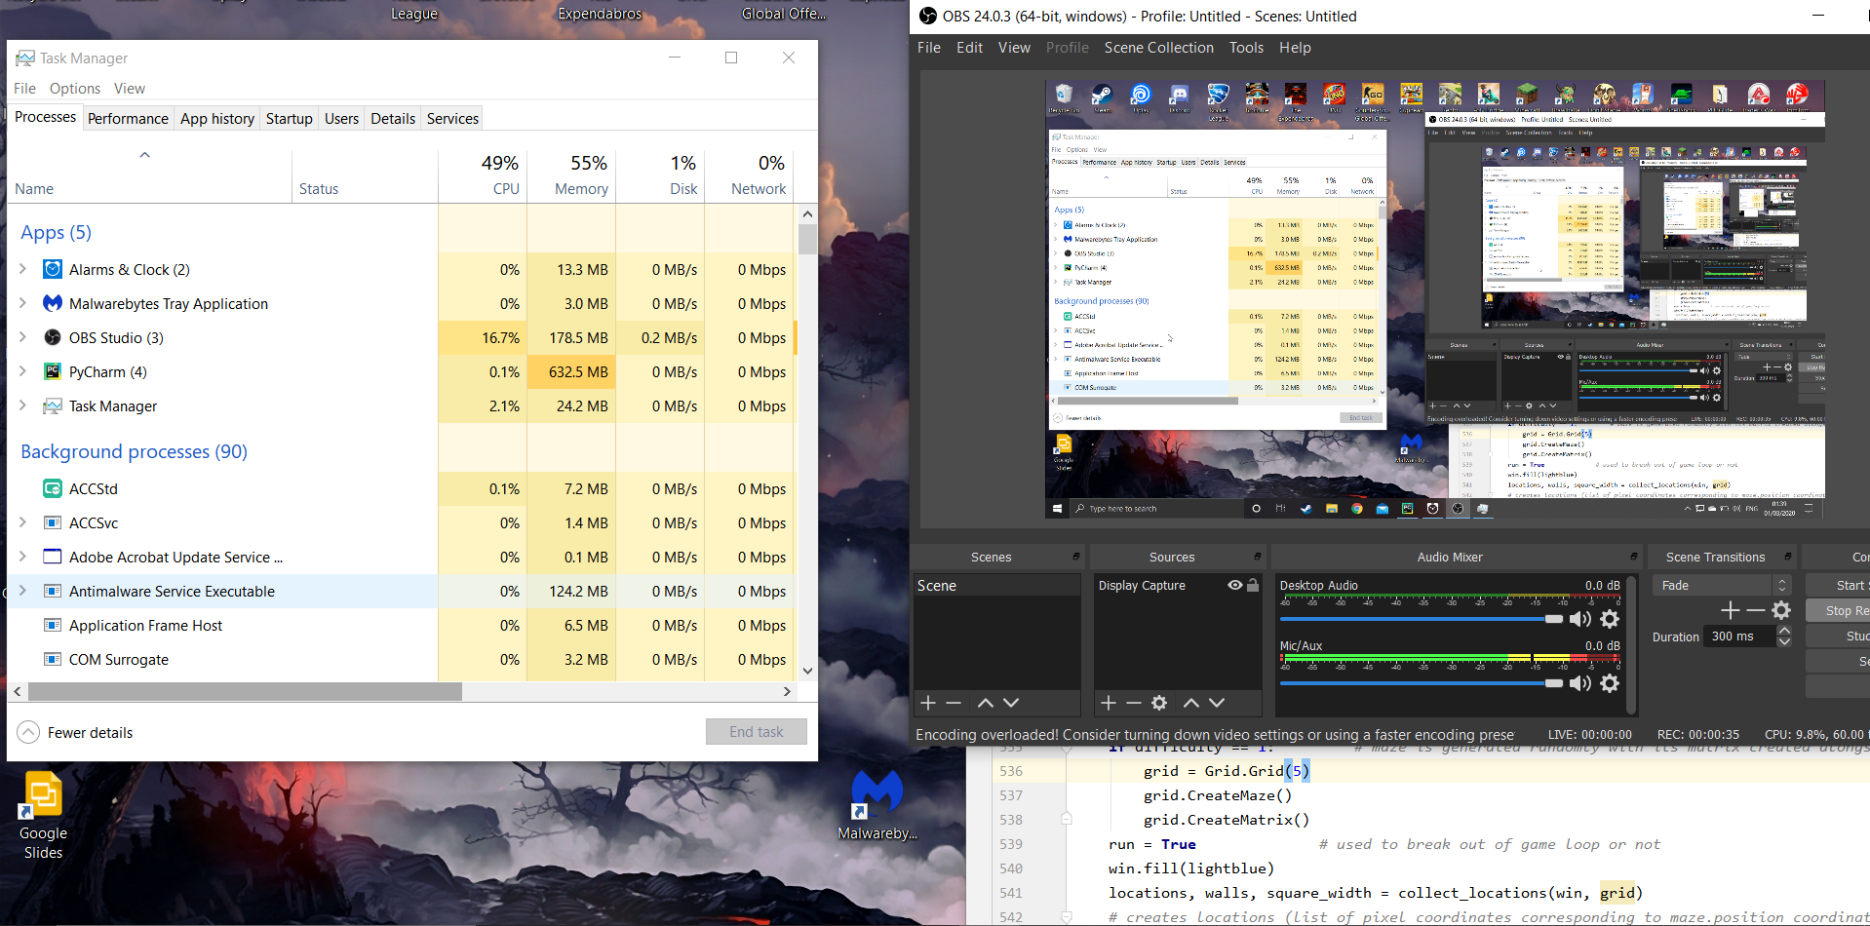

# 5 - Evaluation

## 5.1. Main objectives

As predicted my biggest constraint was time since many optional objectives where missed however the main objectives and core functionality of the game itself is entirely complete with a fully working game.

* A user interface (menu system and inventory / options / game control system)
  + I have created a working main menu system alongside options and a control scheme for the game using the mouse and left mouse button which is simple to use.
  + However, since there are no items that could be used in the game there was no need for inventory management system. And as a result, no inventory was created. Perhaps if offensive items where to be added to the game then an inventory system would be necessary to sort weapons and use them
* Turn based movement that works as intended
  + This has been successfully implemented with no bugs. Turns alternate between the player and enemy and movement during these turns contains no bugs through extensive testing with relatives, friends and teachers
  + Turns work based on the number of steps you can take each turn for both enemies and players and pathfinding is used to create player and enemy paths
* Clear indication of game objectives / how to win and a win scenario in every level
  + A dungeon key is shown on each level and a golden location is highlighted on the map to indicate where the exit is.
  + Although this is clear there is no verbal indication as to how to win the game it is implied therefore a future consideration would be to add a prompter telling the player the objective.
* Working HUD
  + There is a HUD to the side of the map showing player health score and the current turn which is about as much information required since all of information as to player locations fields of view and item/ exit locations are visible on the grid
* Enemy AI that doesn’t make the game impossible to beat but still provides a challenge
  + The number of enemies is based on the size of the map
  + The number of steps enemies can take is two less than the number of steps the player can take allowing the player to have a chance of escaping
  + The enemies will follow a player they can see and will move to the last location the player was spotted if they cannot see the player (individual memory).
  + The enemies move randomly when they cannot see the player which dumbs them down. Also, they forget about the player once they reach the last known location of the player and then will move randomly from there still creating a sense of a hunt but making the game a bit easier
  + However, having different types of enemies that have different ways of sensing the player and approaching may have increased the strategy involved in the game a bit more
* Multiple difficulty levels or some form of challenge the longer the game goes on
  + The game can continue forever if the player can survive forever however if they lose health and continue onto a new map they (continuing onto a new map reduces score but gives players the chance to create a higher score) keep the same level of health with no regeneration increasing the intensity of the game as it progresses
  + However, an increase in map size every time a new game is started would make the game become a lot more progressively harder. This would have been implemented had there been enough time
* Procedural map generation and enemy/ player placement algorithms
  + This objective has been completed perfectly with procedural map generation working flawlessly and allowing for the functionality to change map sparsity and even create a perfect maze map type (as described in documented design)
  + Enemies are placed on different locations in the map apart from each other
  + Player is placed away from enemies and out of line of sight using ray casting algorithm so that the player isn’t immediately attacked
  + Also, as a design choice enemies can only see you whilst it is their turn to make the game much more accessible to beat since without this the game would be extremely difficult
* Low hardware requirements high performance
  + The game has many efficiency improvements listed below which allows the game to be run on the majority of modern and some outdated hardware including an old Lenovo ThinkPad containing an Intel Pentium g4560
  + A heap is created for the walls around each enemy (priority queue) that stores the walls in order of closest to furthest from the enemy. As a result calculating the 60 rays coming off of the enemy is much more efficient since the ray casting only has to be done until a wall with an intersection is found when searching through the heap since the closest wall is the wall that the ray hits first increasing efficiency by a factor of 75x (from 16 seconds to 0.2 seconds (using time.time()) on a 200 * 200 perfect maze)
  + When running Dijkstra path finding for players mouse the pathfinding is only run if the mouse changes which block it goes over which prevents the path finding from being run once every frame dramatically improving performance during players turn
  + However, a relatively large proportion of ram is taken up by the maze matrix graph representation (however it is in the below 100 MB as a result not affecting performance of modern and semi-recent computers)
  + The program is mainly CPU intensive as a result there is no requirement for any GPU
* No game breaking bugs / software issues
  + Through testing no game breaking bugs have been found that make the game unplayable which as a result means the game isn’t tedious to play
  + However, one graphical bug has been found where the enemies final state is shown (in ray colours) before they move but this is reset once they start moving
  + This doesn’t affect gameplay however since it is all within the enemies turn so players can’t use this to make predictions helping them win
* Playable on at the very least a Windows 10 PC
  + The game is playable on windows machines and has been tested on those machines

## 5.2. Optional Objectives

Optional objectives where neglected the most since these where ambitious objectives only set if there was any surplus of time to complete these objectives after main objectives where completed. Again, the biggest issue was time constraints.

* Clear user interface
  + The main menu is clear and self-explanatory including the options menu and the after-win game menu (continue or quit options)
  + Also, a HUD helps the player understand their in-game situation. Furthermore, the user interface for in-game player movement was very simple to understand and use (just point and click)
  + Although if there was time verbal indication may have been helpful to include the objective is still clear and the end goal is also clear after a single playthrough
* Remappable Controls
  + Unfortunately, there was no time to meet this objective for players (since it had relatively high demand) this wasn’t core to main functionality and the standard controls are very commonly used and easy to grasp
* Simple non-intrusive HUD (takes up small part of screen and doesn’t get in the way of game)
  + This objective was met reasonably well with health score and turn displayed on the side of the game screen away from the play area but simple and easy to understand
* Tile weightings and different terrain types
  + There was no time to add this unfortunately however it wasn’t essential to the game (it would have increased the amount of strategy involved)
* Enemy alertness levels
  + This was fulfilled to an extent since enemies had an alert and searching mode as well as a hunting mode where they move to the location that they last spotted the enemy
  + However no “hivemind” alertness level was added since in hindsight this would make the game very hard for smaller maps.
* Smooth animation/ pleasing graphics
  + Although the assets (sprites) used where not appealing to many, the colours chosen where chosen through feedback from users saying purple and orange colours for instance where ugly. As a result, background colours where chosen to please users and create a better aesthetic appeal.
  + Smooth animation for players and enemies was achieved very well with players and enemies using interpolation to animate movement as described in the technical solution
  + Also, the background for menus is animated to an extent and lose and win screens are animated somewhat with a fade in affect
* Resizable windows with scalability
  + This was thought to be a fairly simple task however dealing with different aspect ratios caused complications and it was deemed unnecessary to implement this in particular
  + However, in better news, the game works at any resolution that is 16:9 aspect ratio since all buttons sprites animations background and fonts are scaled with the width and height of the screen
  + The framework is there just not the option in game
* Cheating prevention
  + This wasn’t an objective that is accomplished separately. The game works with no way to exploit the game mechanics other than intended with no game breaking bugs so cheating isn’t possible through the testing conducted
* Fog of war
  + In hindsight implementing this would have made the game very difficult and less strategic since players wouldn’t be able to plan ahead of enemies. Furthermore, time constraints meant that this wasn’t prioritised
* Save files / pause functionality/ leader board system
  + There was no time to implement this, so this objective was not met alongside high score storage unfortunately
* Accessibility settings
  + These where not implemented
* Music and volume settings
  + Music settings was implemented to turn background music on and off however volume is pre-set with no option to change it

## 5.3. User Feedback

Users amongst my friends’ group and family members where asked to provide and criticisms they have of the game and any praise or features they enjoyed. Here are the most common responses.

* The background animation and colours were very nice and pleasing
* The responsive buttons where a nice touch (in terms of colour changes when pressing and hovering over)
* Maze generation worked well and made the game unrepetitive
* Enemy placement was good, and many praised the fact that the maze was able to generate different sizes with number of enemies and steps based on that size
* The option to turn music on and off was praised also however I was criticized for having a fixed volume and no choice of songs
* Animation was noted and the interpolation made the game slightly better for users
* The score system was enjoyed since it created competitiveness at a low level between play testers however a lack of a leader board had made it annoying to try remember the highest score
* Players didn’t notice the lack of a save system likely owing to the fact that each level was short and quick, and players lost before they considered saving to continue later
* The sprites where criticised however the colour scheme of backgrounds where approved of.
* The lack of powerups to fight against the enemies was also another criticism
* Some called it too easy and some too hard so a difficulty system may have helped remedy this for users
* The majority of play testers understood the objectives with trial and error after one playthrough but others did struggle to grasp it without assistance so some verbal information may have been useful
* The movement in game was satisfying as it created situations where players had to place themselves strategically to avoid being spotted but collect as much loot as possible.
* Music choice was requested as the chosen background music was loved by some and hated by others
* Adding different terrain when asked was agreed upon by the play testers to increase the strategic complexity of the game
* The fact that players couldn’t have a way to increase health made the game challenging over longer periods of time since players had to become more and more careful when going for higher and higher scores

## 5.4. Potential improvements

* **Sprites and colours**
  + Choice of colours for buttons and backgrounds may have allowed users to have a better aesthetic experience
  + Animated sprites that fit the game background would have improved the user experience
* **Difficulty**
  + Although difficulty naturally increases as the game goes on (due to lower health) difficulty options and the option to set the number of steps and health of enemies of players
  + Options to set maze size and maze sparsity etc
* **Gameplay**
  + Add powerups
  + Add animations such as sprites legs moving
  + More enemy types with different movement strategies
  + More terrain types to create a higher level of strategy for the game
  + Option to set speed of animation since some found it to take too long and some found it to fast
  + Add a leader board system of high scores all time
  + Add a save file systems for players who have to leave the application but wish to return to it in the future
  + Add effects for damage taken and animation for when enemy spots player (other than ray colour change)
  + Add character customisation with each character having different perks
* **Settings**
  + Add volume options for music and choices of music
  + Add resolution and scalability options
  + Add option to see highest scores
* **Multiplayer**
  + Add a co-op mode where players must work together to solve a problem to progress in the maze
  + Add local and online game modes
  + Add online leader boards and games

## 5.5. Analysis and Conclusion

Overall, my project met all its main requirements with no major bugs. It works as I had described it would and had all the core functionality it required to be a fully working game users can enjoy on their PC’s. Furthermore, I had made efficiency improvements to make sure the game was playable on older hardware with limited capabilities.

Users enjoyed the games strategy elements finding the game challenging but always beatable and never putting the player in a situation where they are not in control and capable of escaping or winning. However, the game was a bit slow based since the user had to wait for every enemy to complete their movement before moving. The objective of the game was clear implicitly however some users struggled to figure it out.

The main criticism was the way the game looked in terms of sprites and difficulty settings since users wanted the choice of different difficulties. The enemy ai worked well in making the game challenging and strategic especially hunt mode where some players used the hunt mode to their advantage to lure enemies away from loot then escape and collect loot. Users did want more customisation options and music options however the majority of their requests where not core to the functionality of the project

The biggest challenge I was faced with whilst creating this game was the fact that I had to learn how to program using classes and had to use many complex algorithms which I had to graph out onto whiteboards to be able to grasp and tackle such as Dijkstra, ray casting maze generation and all the efficiency improvements that came with it such as sparsity controller for maze generation which doubled as an efficiency improver since the program didn’t have to run as long. Also, there were a couple of issues with the python programming language that caused a lot of time to be spent diagnosing such as lists being passed by reference and iteration issues.

Time constraints where what held this project back the most preventing quality of life improvements from being created.

To conclude I was successful in creating a fun strategic complete arcade game with many mechanics and procedural refreshing maze generation however as a game there are some quality of life improvements that can be added to improve the user experience.

## Bibliography

Here is a list of resources used in my project.

Pygame: <https://www.pygame.org/>